**Shoulder rehabilitation post immobilisation**

1. Pendulum exercises

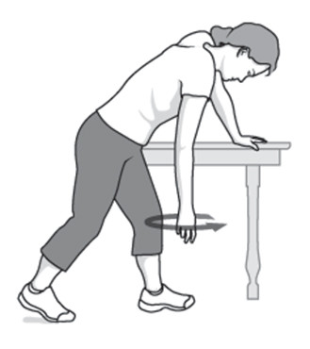

1. Climbing the wall exercises

1. Assisted elevation exercises

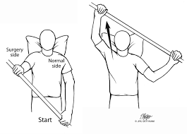

1. Assisted rotation exercises

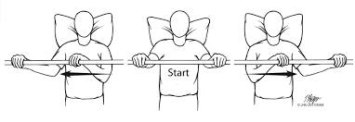

1. Theraband stretches

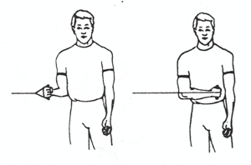

1. Theraband strengthening

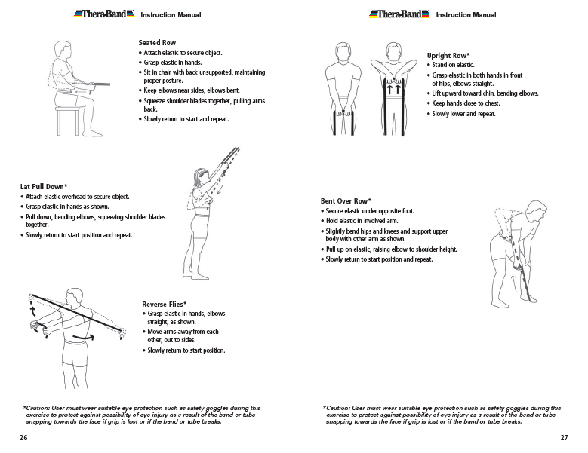

1. Toweling the back exercises

