Knee ROM and strengthening exercises

Isometric quads strengthening

Hamstring co- contraction

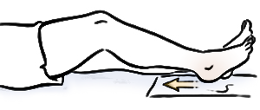

Calf stretches and strengthening

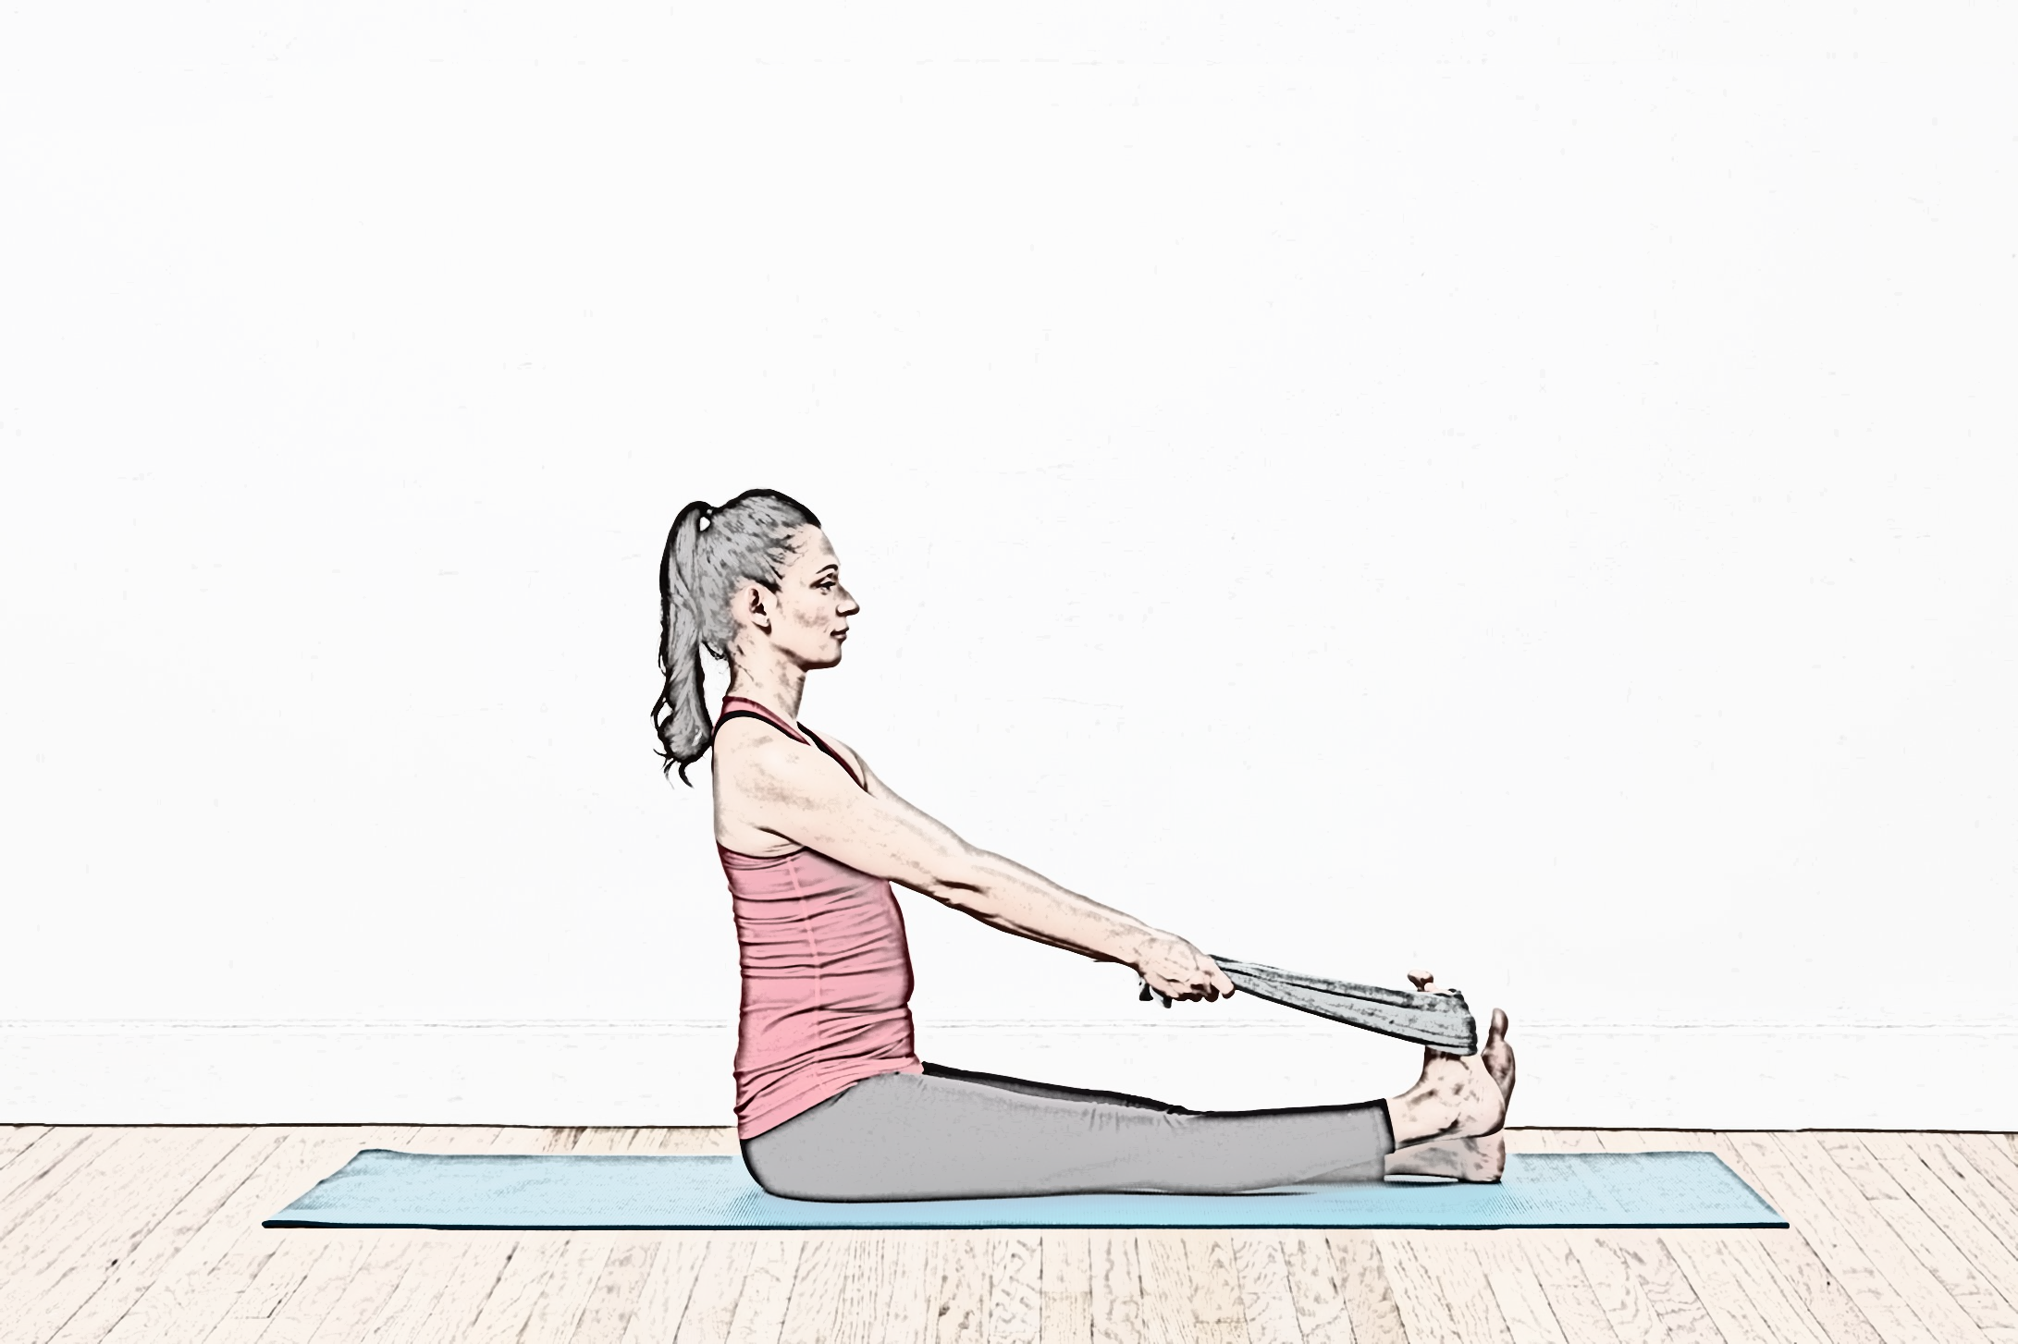

Hip abductor and extensor strengthening

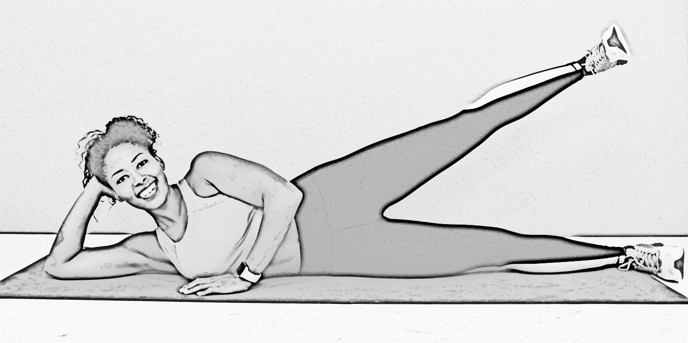

Core strengthening

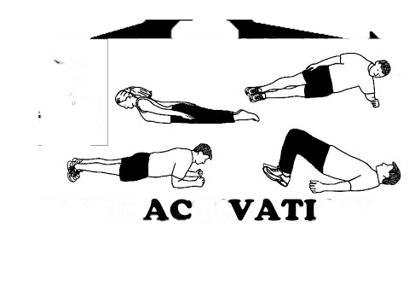

Short arc quads

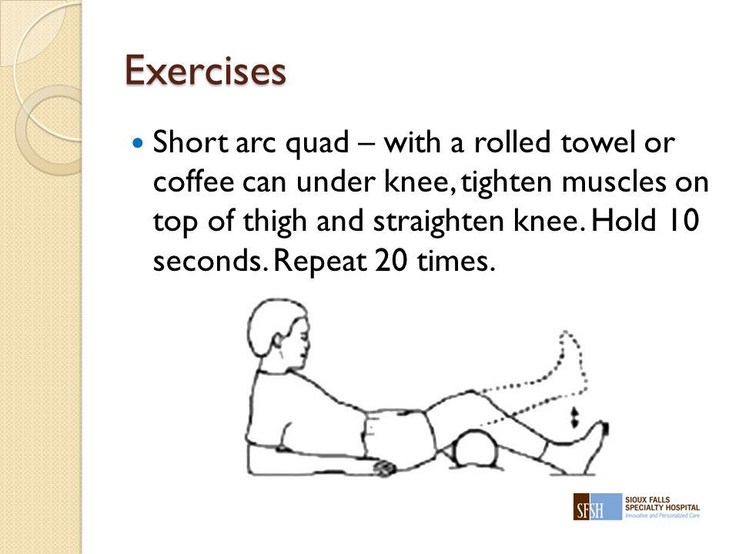

Single leg squats

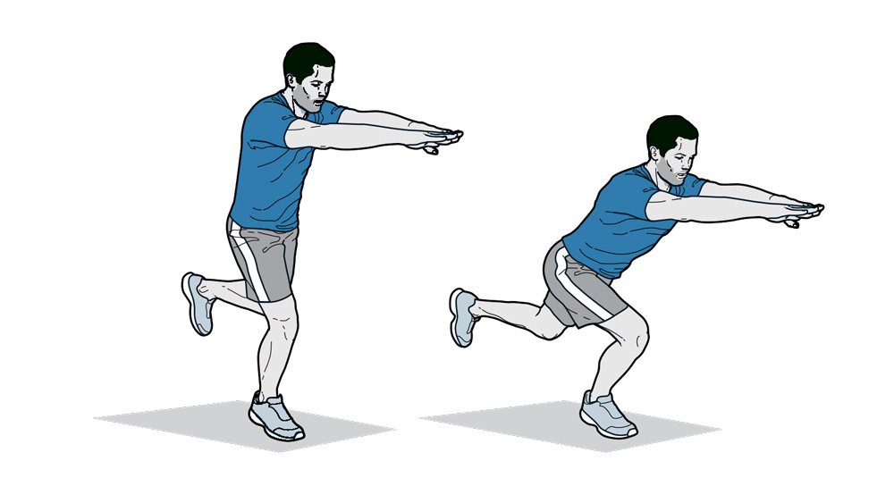

Single leg press

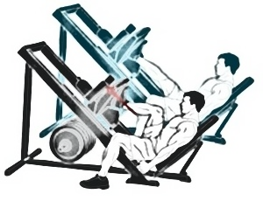

Wobble board

Proprioception

