SUMMER 2026
YOUTH LEAGUE Team Registration
Games: June 6/7, 13/14, 20/21 July 11/12, 18/19,25/26

June
Birth Years: 2018-2014 (Ages 6-12/13)

Team Name: ________________ Birth Year: _______ Boy/Girl: _________

Coach Name: ____________________ Phone: (_______) ______________________

Registration fee: $440.00 Deadline to register: May 10th 2026 Mail or drop off: 181 Industrial Circle East, Tontitown, AR 72762

Total Payment: ___________ Date Received: ________ Cash or check preferred!

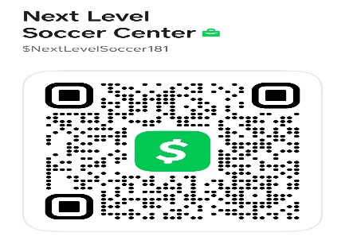

Please text or call us with any questions or concerns and we would be happy to assist you! Kendall Spencer: (479)713-0853 Or Melissa Spencer: (479)713-0278 NWANEXTLEVELSOCCER.COM

