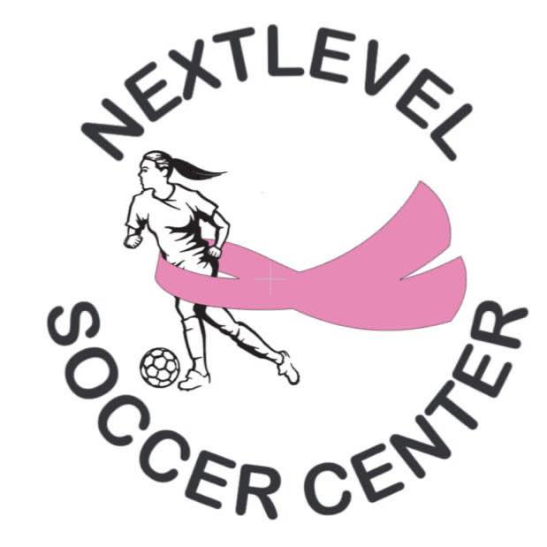
Seasonal Meeting:
Women’s Leagues of NLSC
Sunday, July 12th, 5PM in the NLSC Lobby.
Be prepared to fill out registration form, pay team fee/deposit and roster names. Bring your list of players you want to add to your roster.
This is your chance to get registered and contribute to your women’s league experience.
New women’s leagues start: July 19th

