Team Waiver 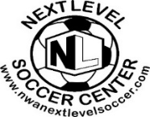 Roster
__________
Team Name
Waiver/Release: This is to certify that I assume all risks.
and hazards incidental to participation in indoor soccer league, and I do hereby agree to hold harmless the staff of the Next Level Soccer LLC, referees, and administrators from any and all claims arising out of any injury to myself. Furthermore, this verifies that the player is Healthy and able to participate in all soccer activities. In the event of injury my permission is granted for treatment as required at the nearest medical treatment facility.
- Rosters CLOSE after Game 2!! Be sure every player signed by game #2. All players Must Read the Release and Sign the Waiver/Roster Prior Playing in first game of the current Season
Player Ñame  (Nombre del Jugador) | Player/Parent Signature  (Parent Signature required for Players under 18)  (Firma del Jugador) | Telephone Number  (Número de Teléfono)
1.
2.
3.
4.
5.
6.
7
8.
9.
10.
11.
12.

