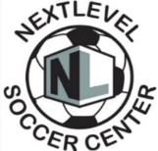ST. NICK 3v3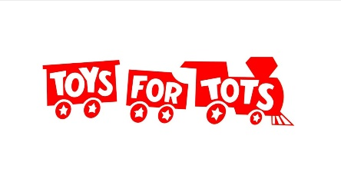
18th Annual Tournament Benefiting Toys for Tots
*Registration Due: 11/30 Youth Tournament: 12/06 & Adult Tournament: 12/07

*Games are played 3v3/ 2-10min halves/ 2 min halftime
3v3-No goalies/6 Maximum per roster
Price: $190.00 AND Unwrapped Toy Donation ($20 range)

Team Name: _____________________ Coach Name: ___________________

Boys/Girls OR Men/Women: ________________ Team Birth Year: ___________
Phone: (______) _________________ Email: ________________________
Waiver/Release: This is to certify that I assume all risks and hazards incidental to participation in indoor soccer league, and I do hereby agree to hold harmless the staff of the Next Level Soccer LLC, referees and administrators from any and all claims arising out of any injury to myself. Furthermore, this verifies that the player is Healthy and able to participate in all soccer activities. In the event of injury my permission is granted for treatment as required at the nearest medical treatment facility.
Player Name | Youth  Birth Date | Guardian Signature | Shirt Size
1
2
3
4
5
6

Soccer Center Location: 181 East Industrial Circle, Tontitown, AR Kendall Spencer: (479)713-0853 Or Melissa Spencer: (479)713-0278 Please contact us with any questions or concerns we will be happy to assist you!

