
Section 4 – Health and Safety Policy
Lagan Warrior Paddlers

HEALTH AND SAFETY POLICY STATEMENT (Date reviewed 4/5/26):
“Lagan Warrior Paddlers is strongly committed to encouraging our members and participants to take part, however the health, wellbeing and safety of each individual is always our paramount concern. We recommend the level/nature of training and activities to be dependent on age and ability and expect our members and participants to participate within these boundaries. This policy aims to comply with current legal requirements for health and safety legislation and follow Paddle NI standards of deployment.”
CLUB HEALTH AND SAFETY OFFICER:
Mary McGahon
SAFETY POLICY:
To support our Health and Safety policy statement we are committed to the following duties:
● Undertake regular, recorded risk assessments of the Club premises and all activities undertaken by the Club.
● Create a safe environment by putting health and safety measures in place as identified by the assessments.
● Ensure that all members and participants are given the appropriate level of training and engage in activities/competition commensurate with the individual’s ability depending on age, maturity and development.
● Ensure that all members and participants are aware of, understand and follow the Club’s health and safety policy.
● Appoint a Club Safety Officer to assist with health and safety responsibilities.
● Ensure that normal operating procedures and Emergency Action plans are in place and known by all members and participants.
● Provide access to adequate first aid facilities, telephone and a qualified first aider for the duration of club activities.
● Report any injuries or accidents sustained during any Club activity or whilst on the Club premises and keep a record of all such incidents (see relevant section below).
● Ensure that the implementation of the policy is reviewed regularly and monitored for effectiveness. Date of next review 5/5/27

AS A CLUB MEMBER YOU HAVE A DUTY TO:
● Take reasonable care for your own health and safety and that of others who may be affected by what you do or not do.
● Cooperate with the club on health and safety issues, respect club rules and policies.
● Correctly use all equipment provided by the Club and of paddlers own equipment.
● Not interfere with, or misuse, anything provided for your health, safety or welfare.

AS A CLUB Lagan Warrior Paddlers (LWP) WILL DEPLOY OUR VOLUNTEERS (or PAID COACHES) UNDER THE FOLLOWING TERMS:
- Coaches, Leaders and Instructors deployed by LWP hold a valid qualification for their role and remit and have been assessed for competence in the venue to which they have been deployed.
- Adult Coaches, Leaders and Instructors will have a valid REC2 1st aid certificate (16hrs outdoor) and have been access NI checked.
- Junior (u18) Instructors will be deployed under the direct supervision of a qualified adult autonomous paddlesport instructor or above.
- Coaches, Leaders and Instructors deployed by LWP will operate under the appropriate LWP risk assessment for that venue, and will supervise sessions at the correct ratio for the experience of the Leader/instructor, the level of experience of the paddlers and the type of activity taking place.
- For any newly qualified instructors there will be a period of supervision under a Level 2 coach (or similarly qualified Coach award coach) for a minimum of 10 sessions, during which the instructors’ competency to run sessions within the framework of this document and the risk assessment is assessed. When the instructor is deemed competent, they will be deployed in accordance with the risk assessment and this Health and Safety policy. For previously qualified instructors new to the club, their competency will be assessed by a Level 2 coach (or similarly qualified Coach award coach) in a minimum of 1 session prior to deployment.

FIRST AID:
Location of first aid facilities:
Pool Side & Reception (Shankill Pool)
At the boat ramp (main ingress/egress point; Shaw’s Bridge)
At reception Moira lakes.
Location of telephones:
Mobile phone with Coaches/Leaders/Instructors (Shaw’s Bridge, Moira Lakes & Shankill pool), Reception (Shankill Pool, Moira Lakes), on land support (Shaw’s Bridge)
All adult Coaches, Leaders and instructors hold a current outdoor specific (16hr) 1st aid qualification in order to be deployed
LWP qualified 1st aiders (Level, Name & date of renewal):
- Leader; Tony Armstrong (REC2; 27/4/28)
- Instructor; Thomas McGahon (REC2; 27/4/28)
- Instructor; Toby McCrea (2-day 1st aid; 6/8/26)
- Instructor; Bertie McCrea (2-day 1st aid; 6/8/26)
- Member; Mary McGahon (REC2; 27/4/28)
The club will hold a list of other qualified 1st aiders who may be called upon to assist with the provision of 1st aid as and when necessary.

REVIEW AND IMPLIMENTATION OF RISK ASSESSMENTS
1 month after deployment the risk assessment will be reviewed by all Coaches, leaders or instructors deployed in conjunction with the health and safety officer, then yearly thereafter unless any infringement occurs which results in a near miss or hospitalisation where upon the risk assessment will be revised as soon as practicable.
All members and participants agree to implement and abide by the appropriate risk assessment governing the safe undertaking of activities within the remit of the Lagan Warrior Paddlers club.

MINIMUM SAFETY COVER REQUIREMENTS: Personal Protective Equipment (PPE)
All paddlers must wear sufficient PPE to participate in any club activities. Minimum standards for general paddling are a well fitted buoyancy aid which is sufficient for the weight and size of the participant.
For canoe polo activities the participant must wear a helmet which is sufficient to cover the occipital bone (B on image below) and has a faceguard which protects the entire face beginning at the lower level of the chin, and jawline and covering the surface between the two temples (A on the image below) to ensure that no contact is possible between the face or skull and a blade of a horizontally held paddle.
There must be a minimum distance of 10mm between the facemask and the nose of the wearer. The facemask must be of a strong material such as steel or other equally strong material. The facemask must be securely fixed to the helmet, without any sharp edges or dangerous fixings. The facemask must have no horizontal or vertical opening any larger than 70mm.

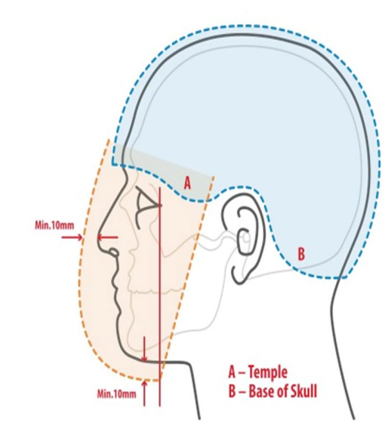

Canoe polo paddles must be double bladed with no sharp projections, edges, holes or other dangerous features. Metal tipped blades are not allowed.

The body protection in the form of a Personal Floatation Device (PFD) must be at least 20mm thick for canoe polo activities. The body protection must protect against any impact from other players equipment, which may be reasonably anticipated during the course of a game.

Club helmets and personal flotation devices (PFDs) shall be inspected for compliance with the International Canoe Federation (ICF) Canoe Polo Competition Rules, specifically regarding fit and safety, at intervals not exceeding three months or immediately prior to any competition, whichever occurs first. Personally owned equipment shall be subject to the same inspection requirements. Owners are responsible for the maintenance of their equipment to ensure ongoing compliance. Any equipment found to be defective shall be withdrawn from service and may not be used until it has been repaired or replaced and subsequently deemed safe for use.
For further information and guidance see Chapter 16 of the ICF canoe polo competition rule book 2025 https://www.canoeicf.com/sites/default/files/2025_icf_competition_rules_canoe_polo_-_final.pdf
MINIMUM SAFETY COVER REQUIREMENTS: supervision on the water
As per Paddle NI/UK standard of deployment, at all club venues, paddlers can only be on the water in the presence of a qualified coach, leader or instructor at the maximum ratios outline below, for the appropriate environmental conditions and activity, AND only after the paddler has received safety information via on-land briefing.
The Coach or Leader in charge must use their own judgement regarding the need to reduce further the ratios, taking into account the prevailing and predicted weather conditions and the particular group they are leading AS WELL AS the experience level of the Coach/Leader/Instructors involved.
When a Paddlesports Instructor is in the lead role: if conditions exceed that for very sheltered water or the group presents with additional needs, the instructor must cancel the session and/or seek the advice of a suitably qualified coach.
All Instructors deployed in the lead role must abide by the Standard operating procedures for the club before, during and after the session as outlined in the LWP Paddlesports Instructor SOP.

VENUE AND ENVIRONMENTAL CONDITIONS
• Shankill pool has been rated as Swimming pool/very sheltered waters
• Belfast Royal Academy (BRA) pool has been rated as Swimming pool/very sheltered waters
• Lagan River at Shaw’s Bridge (within polo pitches) is rated as ‘ungraded’ ‘Very Sheltered Inland Water’ (<50m to boat ramp egress point).
• Lagan River at Shaw’s Bridge (from polo pitches upriver until Gilchrist Bridge) is rated as ‘ungraded’ ‘Sheltered Inland Water’ (<200m to boat ramp/pontoon points with suitable banks along riverside at all times for egress)
• Lagan River at Shaw’s Bridge down stream of bridge is excluded from our Home Waterways as it is rated as ‘grade 2’ ‘moderate water’ due to the presence of small weirs with regular waves requiring some manoeuvring.
• Moira Lakes are regarded as very sheltered waters with egress via beach/pontoon access as well as being surrounded by sloping banks.
Supervision ratios:
Activity | Location | Recommended minimum level of qualification | Supervision Ratios coach/leaders/ instructors: paddlers
Taster/beginner session | Swimming pools, very sheltered | Paddle NI Paddlesport Coach | 1:8
Taster/beginner session | Swimming pools, very sheltered | Paddle NI Paddlesport Leader | 1:8
Taster/beginner session | Swimming pools, very sheltered | Paddle NI Paddlesport instructor (Adult) | 1:8
Taster/beginner session | Swimming pools, very sheltered | Paddle NI Paddlesport instructor (Junior) under direct supervision of a qualified adult | 1:4
Taster/beginner session | Sheltered inland water | Paddle NI Paddlesport Coach | 1:8
Taster/beginner session | Sheltered inland water | Paddle NI Paddlesport Leader | 1:8
General paddling | Swimming pools, very sheltered | Paddle NI Paddlesport Coach | 1:8
General paddling | Swimming pools, very sheltered | Paddle NI Paddlesport Leader | 1:8
General paddling | Swimming pools, very sheltered | Paddle NI Paddlesport instructor (Adult) | 1:8
General paddling | Swimming pools, very sheltered | Paddle NI Paddlesport instructor (Junior) under direct supervision of a qualified adult | 1:8
General paddling | Sheltered inland water | Paddle NI Paddlesport Coach | 1:8
General paddling | Sheltered inland water | Paddle NI Paddlesport Leader | 1:8
Canoe Polo | Swimming pools, very sheltered inland water | Paddle NI Paddlesport Coach | 1:10
Canoe Polo | Swimming pools, very sheltered inland water | Paddle NI Paddlesport Leader | 1:10
Canoe Polo | Swimming pools, very sheltered inland water | Paddle NI Paddlesport instructor (Adult) | 1:8
Canoe Polo | Swimming pools, very sheltered inland water | Paddle NI Paddlesport instructor (Junior) under direct supervision of a qualified adult | 1:8

MAPS OF OUR HOME WATERWAYS
Lagan river at Shaws bridge
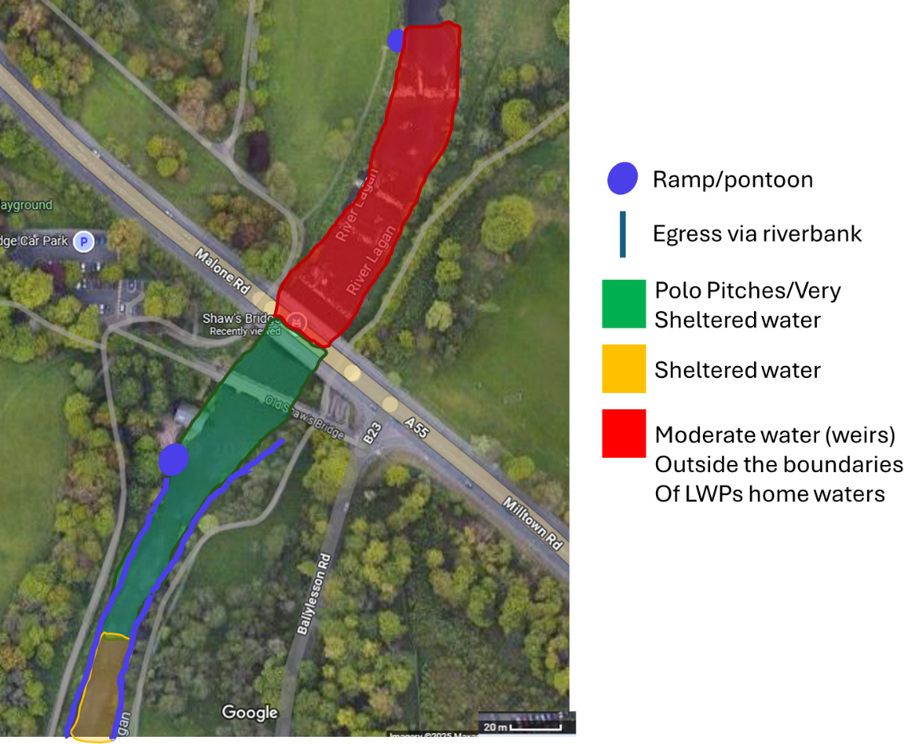
Paddlers will not pass beyond the middle of the new road bridge over the Lagan at Shaws bridge due to the presence of weirs beyond this area.
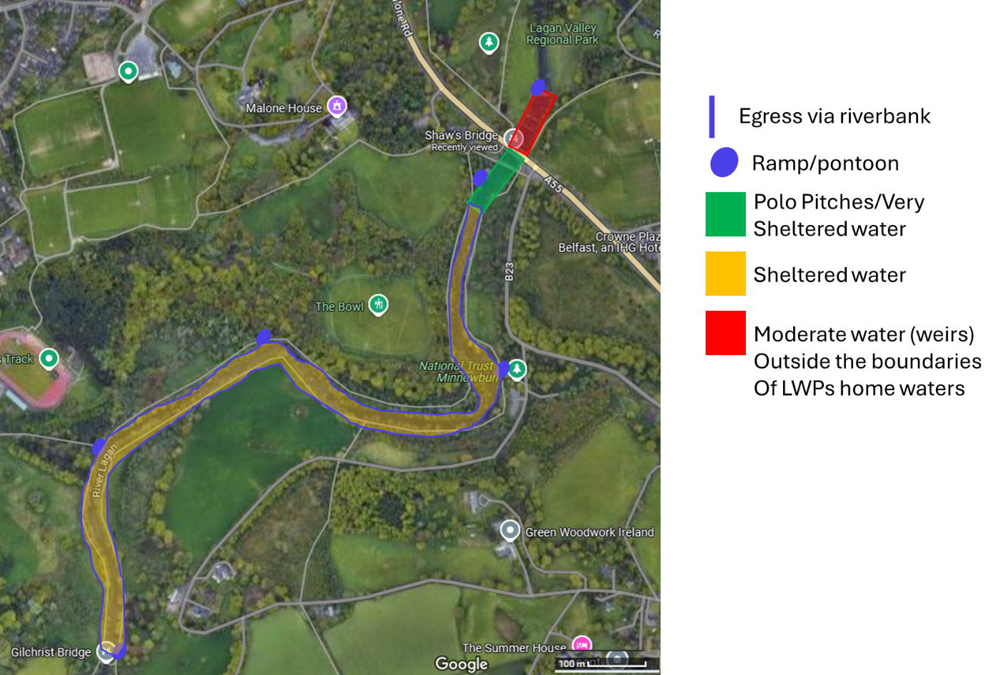

Shankill pool
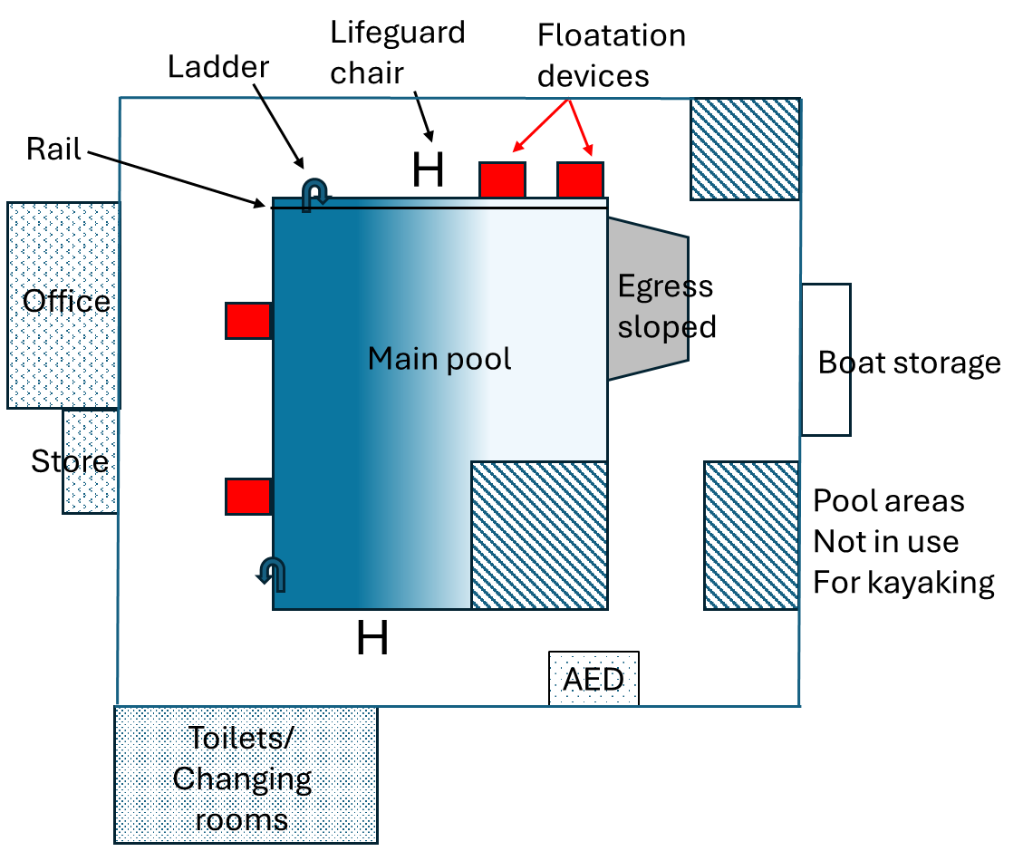

Moira Lakes
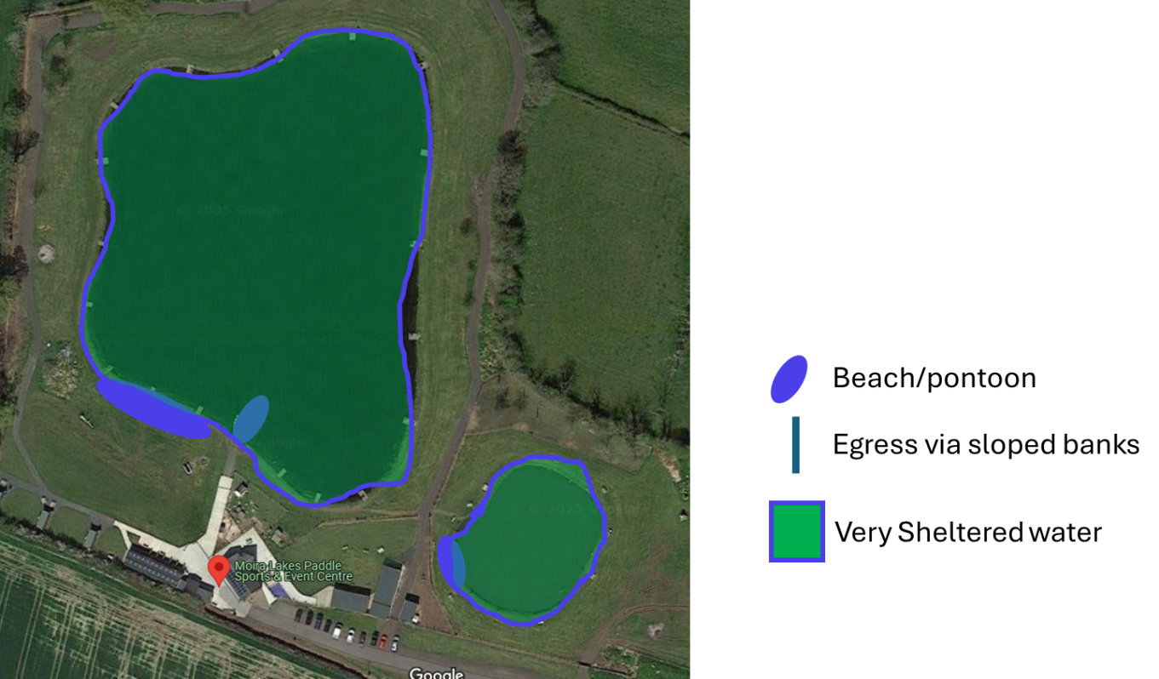
REPORTING OF INCIDENTS
Reports of injuries can be submitted by anyone supervising a session or by the Health and Safety officer.
Injuries of paddlers, Coaches/leaders/instructors, members of the club, participants and the general public which occur in conjunction with a club activity that require 1st aid will be reported to PaddleUK as a near miss via their reporting system https://paddleuk.org.uk/online-incident-reporting/
Any injuries requiring a hospital visit are reported through RIDDOR (Reporting of Injuries, Diseases and Dangerous Occurrences Regulations) via the following link https://www.hse.gov.uk/riddor/ in addition to reporting to PaddleUK.
An internal log of all incidents will be retained by the club via the activity log.

TRANSPORTATION OF CLUB MEMBERS
All club members are responsible for their own transportation to and from training venues. If minibuses are hired by LWP for competition travel, drivers will have the correct licensing (minimum D1 UK driver’s licence or D1E if towing a trailer). When transporting under 18s or vulnerable adults, drivers will have access NI checks (or be accompanied by another suitably scrutineered adult). Drivers will not receive compensation/payment for this voluntary undertaking.

EMPTYING OF WATERLOGGED BOATS
As canoe polo boats are not fitted with flotation bags, there is no safe method for emptying these boats on the water by another paddler. Emptying of canoe polo boats must never be performed on the water by anyone.
Boats and paddlers will be returned to the poolside or designated egress point for emptying and re-seating, with assistance from on-land volunteers. For heavily waterlogged boats, two individuals should carry out the emptying process.
Only boats equipped with additional flotation devices (e.g. river boats used by instructors) may be emptied and re-seated on the water, and only by suitably qualified individuals (e.g., PSRT/FSRT holders) following standard on-water rescue techniques.

