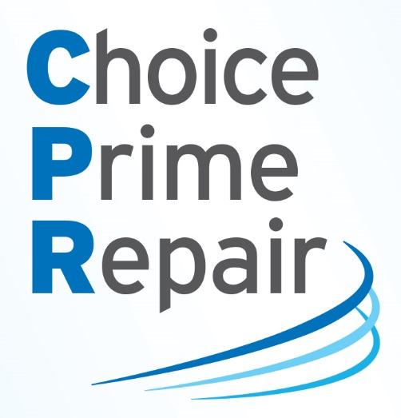

CPR Marketing Plan:

Step 1) 100 Mailers

Step 2) 100 Outbound Calls

Step 3) 100 Follow-up Visits

Step 4) Evaluate Results

Step 5) Any Follow-up Calls or Visits as determined by first attempt and contact

Step 6) Move on to an additional 100 and perform Step 1-4

Note:

1-4 Ops = $59/mo.

5-7 Ops = $99/mo.

8+ Ops = $169/mo.

Required Items:

1. Organized Route Management per Zip Code/Office Location/Contact
2. “Handwrite” Doctors Name and address on CPR Mailer
3. Must Track and Measure all contacts and appropriate responses
4. CPR Handout
5. CPR Contract
6. CPR CC Authorization Form