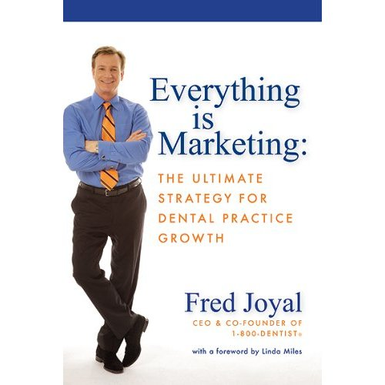
THE DENTIST’S CHOICE
www.thedentistschoice.com
Dear: (place Dr.’s name here)
I purchased this book as a way to learn more about the marketing and operational aspects of my customers, namely dentists just like you. It didn’t take long to realize that this is a must read for all dentists. It is chock full of proven ways to boost patient loyalty and word of mouth and includes secrets to building a strong (and happy) team that your patients will fall in love with and ultimately improve your profitability. Please accept this book as a gift from me and The Dentist’s Choice, the nations’ leading dental handpiece repair network with offices in over 100 locations serving more than 10,000 dentists.
I understand how valuable your time is so I took the liberty of personally preparing my version of CliffsNotes of the book that captures, in my opinion, the essence of the strategies and tactics suggested by the author Fred Joyal.
As awesome as the book is, what you won’t find are maintenance tips and other factors you should consider in order to optimize the life of your handpieces. If you’re interested in a no-obligation maintenance clinic for you and your staff or a free HP Maintenance Booklet, call me anytime. I welcome the opportunity to be of service to you and your team.
Your name
Your phone number
Your location

Optional: Your picture here

