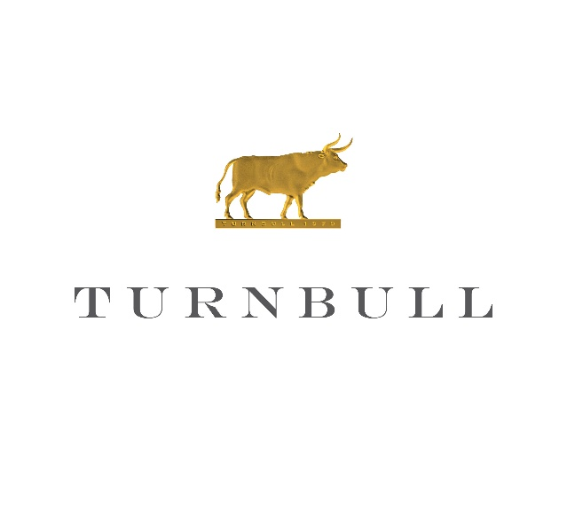
Turnbull Wine Cellars
2025 Sauvignon Blanc

Appellation: Napa Valley, California

Varietal: Sauvignon Blanc

Vintage Notes
The 2025 growing season in Napa Valley delivered a well-balanced harvest with steady ripening conditions and strong acid retention. Sauvignon Blanc fruit developed clean, expressive aromatics while maintaining freshness through picking. The resulting vintage shows excellent equilibrium between ripeness and natural acidity, yielding wines with both vibrancy and depth.
Vineyards
The fruit is sourced from Turnbull’s estate vineyards in Napa Valley, with a focus on a dedicated Sauvignon Blanc block on the home ranch. These sites are characterized by well-drained alluvial soils that promote moderate vine stress and concentrated fruit expression. The vineyard selection emphasizes purity of site and consistent quality from vintage to vintage.
Winemaking
The wine is crafted through gentle whole-cluster pressing followed by cool fermentation to preserve aromatic intensity. Fermentation and aging occur in a combination of neutral oak and stainless steel to balance texture and freshness without overt oak influence. Extended lees contact with periodic stirring builds mid-palate richness while maintaining a bright, focused finish.
Tasting Notes: Radiating with aromatic precision, our 2025 Sauvignon Blanc bursts across the palate with grapefruit, Meyer lemon, and ripe guava layered with floral passionfruit. A soft kiss of French oak lends quiet notes of brioche and blanched almond, adding dimension without softening its edge. Its saline minerality and vibrant acidity drives a finish that is undeniably compelling, sleek, and oh-so refreshing.

ALC: 12.3%

