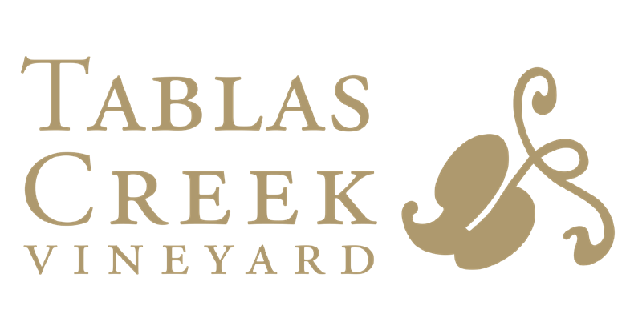
Grenache “alouette” 2023

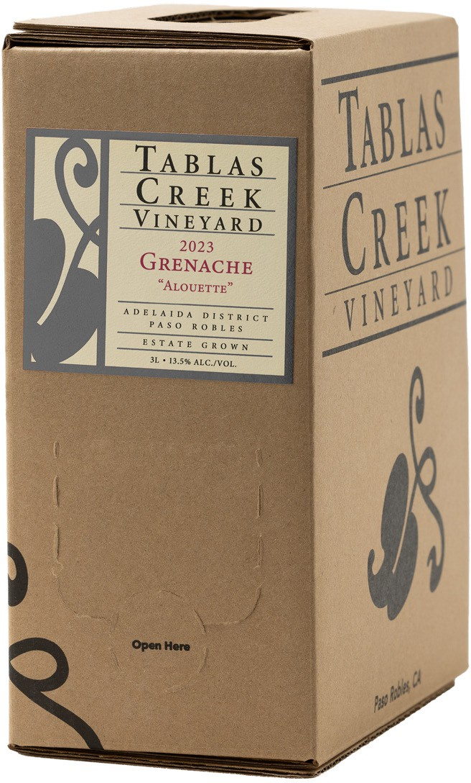

2023 is the first vintage of our Alouette Grenache, a chillable red featuring the highest-toned, palest, and juiciest lots of Grenache from the vintage. Alouette means “lark” in French, with both its English language meanings: the songbird, but also something done spontaneously, or for fun. Learn more on the Tablas blog about how Alouette came to be.
Alouette is our first wine that is not packaged in glass bottles. We are offering it for home consumption in three-liter boxes. For restaurants and wine bars, we’re putting it into 19.5-liter kegs that are available through our distribution network.

TASTING NOTES
A high-toned nose of peppermint stick, cranberry, and grenadine. On the palate, juicy and appealing with flavors of watermelon, red cherry, and candied orange. Medium-bodied, with gentle tannins and refreshing acidity. Should be delicious lightly chilled.

PRODUCTION NOTES
In 2023 we had a prolific and outstanding vintage for Grenache. We used it in all our blends, as usual, and made an increased quantity of our traditional varietal Grenache that will be bottled and released in 2025. We also identified some of the highest-toned, palest, and juiciest lots that would be perfect for near-term drinking, chilled. We named this new wine Alouette. The lots for Alouette were selected in May 2024 and aged in stainless steel tanks until boxing and kegging in August 2024. The wine is not available in bottle.
Because our box-filling partner is still in the process of getting their organic certification, we cannot put the organic or ROC seals on its label. But the Grenache grapes for this Alouette bottling were 100% grown on our Regenertative Organic Certified™ and biodynamic estate vineyard.
The 2023 vintage began with our wettest-ever winter, replenishing ground water and delaying budbreak. It continued with our coolest growing season in more than a decade, which combined with the late start to produce a harvest roughly a month later than most recent years, beginning in mid-September and not concluding until mid- November. Warm, sunny weather starting in October allowed the later-ripening varieties to reach full maturity. The exceptionally long hangtime and gradual ripening combined to produce fruit with deep colors, remarkable intensity, and noteworthy vibrancy. We believe 2023 has all the hallmarks of a blockbuster year.
Organic Practicing

APPELLATION
Adelaida District Paso Robles

BLEND
100% Grenache
13.0% Alcohol by Volume 696 3L Cases Produced
95 19.5 Liter Kegs Produced

FOOD PAIRINGS

- Roast pork loin
- Spicy sausages
- Charcuterie
- Grilled vegetables
- Mixed tapas

