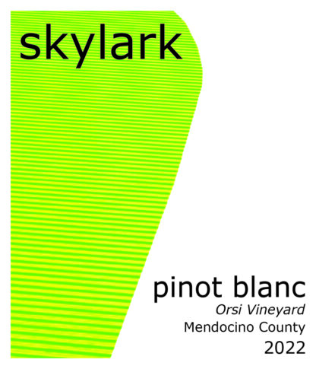
2022 Skylark Pinot Blanc, Orsi Vineyard, Mendocino
2022 is a beautiful rendition of Orsi Vineyard Pinot Blanc. We have been farming this Mendocino vineyard with Bernie Orsi since 2005, watching this heritage site deal with the fickle harvest weather with stubborn grace. The 2022 year began with a difficult flowering where frost reduced yields in April. Summer was warm but not hot until late August, when daily 100 degree temperatures scorched the North Coast. We picked on August 31, right before the heart of the heat spike, preserving natural acidity with plenty of phenolic ripeness. 2022 will be remembered as a small harvest in California with memorable wines – Orsi Vineyard Pinot Blanc will fit right in that category.
Light straw yellow. Aromas of green apple, lemon skin and tangerine. The palate is sleek and refined, with a mineral component lending structure to the fleshy fruits of apple and citrus. The beautiful interplay of fruit and acidity results in a silky fruit impression folding into a fresh and palate-cleansing finish.

