


2021


the odyssey
california

Inspired by the muscular red blends from France’s Rhone Valley, The Odyssey is made using intense mountain-grown fruit.

With a berry fruit-driven profile laced with leather and cedar notes, this wine was made to drink now or within five years of the vintage. Pair with your red meat of choice.

APPELlATION
Napa, Paso Robles & Mendocino

BLEND
43% Grenache
33% Mourvedre
16% Syrah
7% Counoise
1% Cinsault

HARVEST
September 22nd - October 22nd, 2021 Picked at 23.5 Brix

VINEYARD
Terra Bella, Bovino, Fortunati & Gibson Ranch Vineyards BARREL AGING
13 months; 20% New French Oak

ANALYSIS
Alcohol 12.8%
pH 3.56
TA .59

PRODUCTION
443 cases

BOTTLED
February 24th, 2023

RELEASE DATE
Fall 2024

SUGGESTED RETAIL
$50

H I S T O R Y

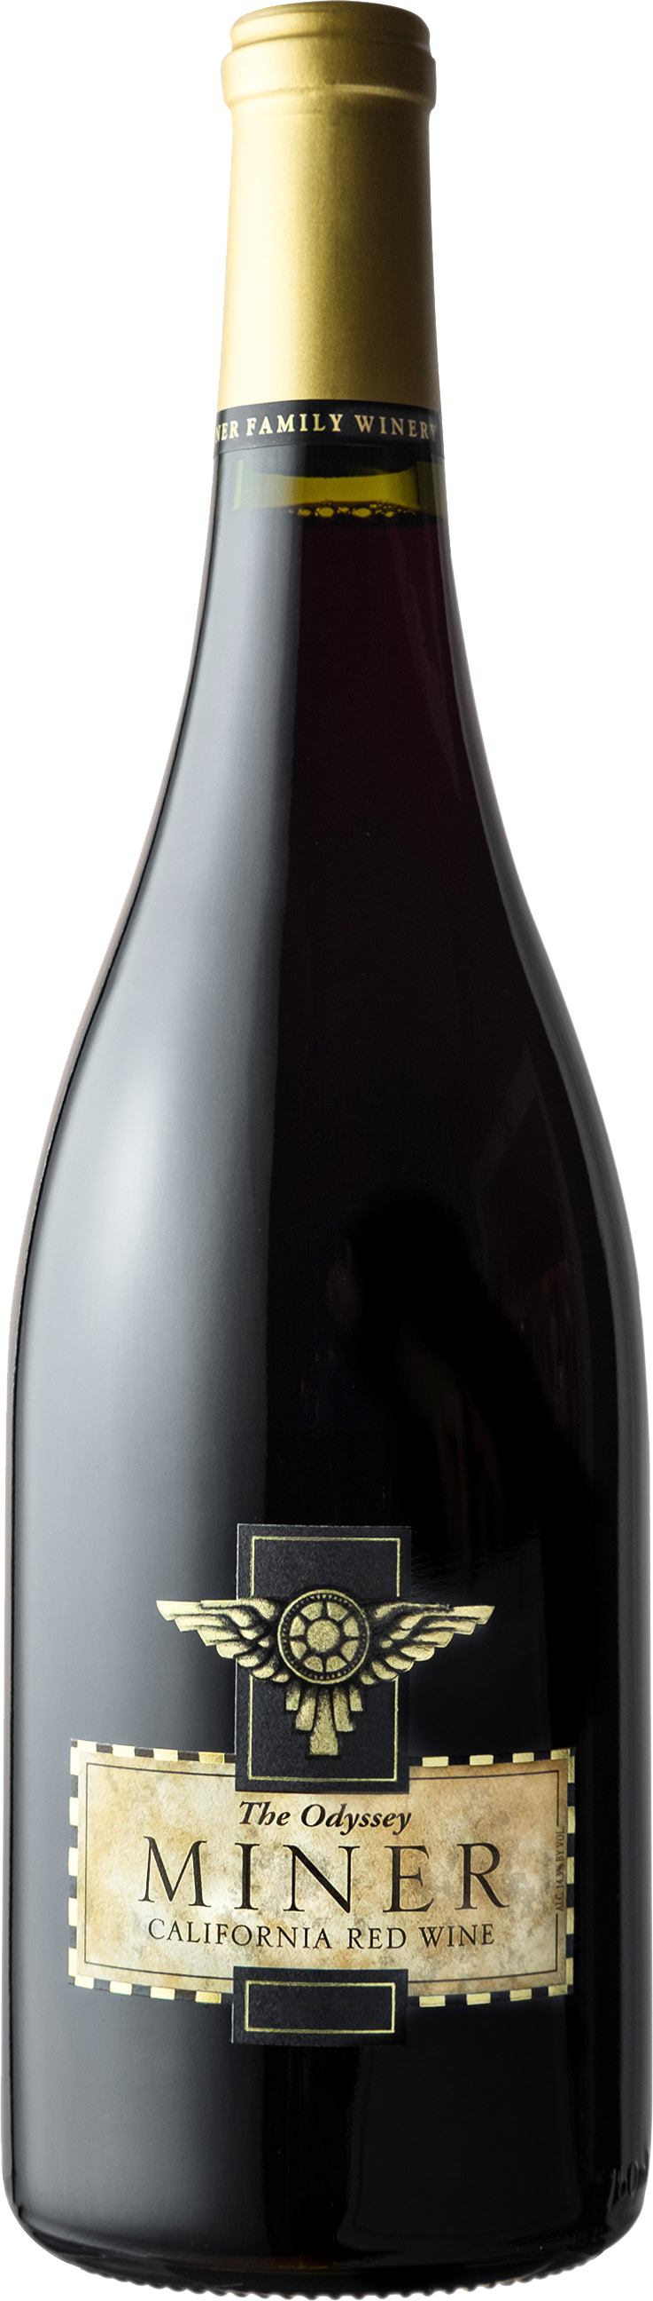
Minerisadynamicfamily-ownedwinerytuckedalongtheeasternhillsofthe Oakville appellation in the heart of Napa Valley. Founded in 1998 by Dave and Emily Miner, Miner Family Winerycraftsreserve-stylewinesbysourcing fruit from Napa Valley and other specially selected California vineyards.

Our winemaking team uses a combination of old world winemaking techniques and modern technology to make wines that reflect the unique characteristics of individual vineyards or “terroir” where specific varietals grow best. This fusion of superb vineyard sites and thoughtful winemaking allows Miner to deliver elegant, expressive wines.

PO BOX 367 • 7850 SILVERADO TRAIL • OAKVILLE, CA • 800.366.WINE • MINERWINES.COM

