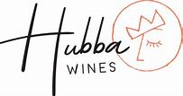

**2023 Shell Creek Vineyard Valdiguie**

**Varietal:** 100% Valdiquie

**AVA:** Paso Robles Highland District

**Vineyard:** 100% Shell Creek

**Alc. By Vol:** 12.6%

**Winemaking:** Aged for 12 months in 100% neutral French Oak. Wild Yeast. Unfined. Unfiltered

Planted on a gentle hillside beneath limestone cliffs, the soils of this dry farmed and organic vineyard are a mix of alluvium and marine limestone. Producing since 1977, Shell Creek gets its name from the layers of marine fossils it sits atop, as well as the seasonal creek running the length of the canyon. Farmed by the Stinton Family