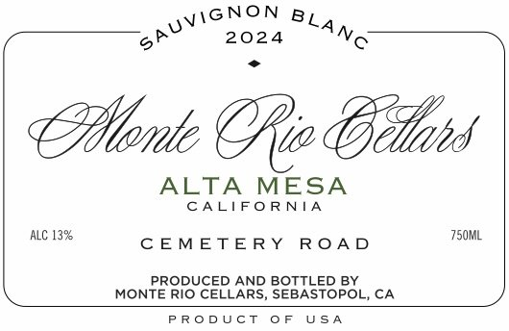

Sauvignon Blanc 'Cemetery Road' Alta Mesa 2024

Our single vineyard Sauvignon Blanc comes from Cemetery Road in Alta Mesa. Fermented half in stainless steel and half in neutral wood. It’s light, crisp and refreshing. This wine has a salty backbone and mineral finish. Perfect for oysters by the pool.
Appellation: Lodi
Varietals: 30-year-old Sauvignon Blanc
Winemaking: Whole cluster fruit hand harvested directly to our press. Fermentation took place in a combination of stainless-steel tanks and old wood barrel. Natural yeast fermentation.
Farming: Organic
Aging: Aged in old wood barrels for 5 months
ABV: 12.5%
Production: 800 cases

