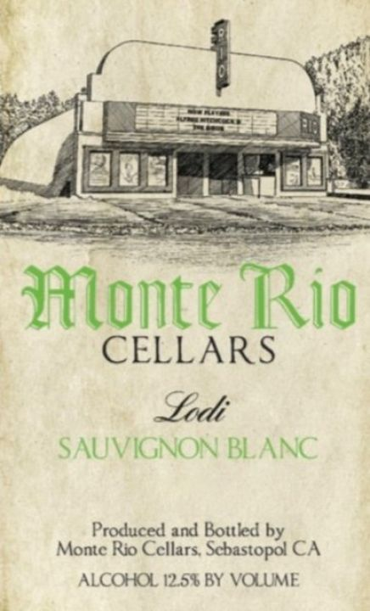

Sauvignon Blanc, Lodi 2022

Light, crisp and refreshing. This wine has a salty backbone and mineral finish. Perfect for oysters by the pool.
Appellation: Lodi
Varietals: 30-year-old Sauvignon Blanc
Winemaking: Whole cluster fruit hand harvested directly to our press. Fermentation took place in a combination of stainless-steel tanks and old wood barrels. Natural yeast fermentation.
Farming: Organic
Aging: Aged in old wood barrels for 5 months
ABV: 12.5%
Production: 100 cases

