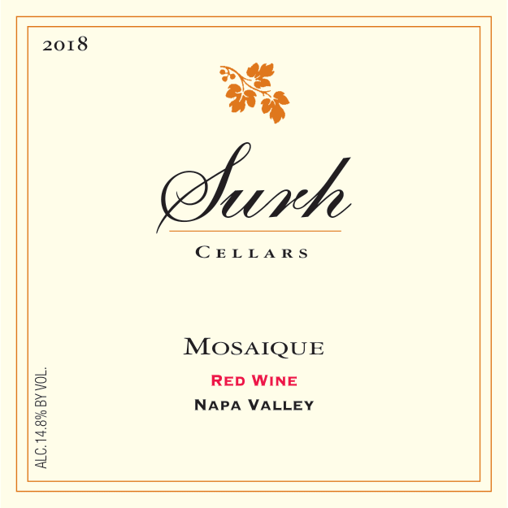

SURH CELLARS
N A P A V A L L E Y
MOSAIQUE
2018 VINTAGE
VINEYARD LOCATION  Yountville, Oak Knoll, Mt Veeder | FINAL COMPOSITION  73% Cabernet Sauvignon, 12% Petite Verdot, 10% Cabernet Franc, 5% Merlot

ALCOHOL  14.8% | PH  3.80 | TOTAL ACIDITY  6.0 g/L

BARREL TYPE  30% new French oak, 70% once-used French oak | BARREL TIME  20 months

TASTING NOTES
In many ways this wine follows our 2017 Mosaique, again led by Cabernet Sauvignon, but it shows differently: massive, dark, and intense. Merlot and Cabernet Franc play their usual supporting roles, while Petite Verdot sets this vintage apart. Given its intensity, this bottle rewards cellar time — at least a few years — to show its full potential, placing it closer in character to our Cabernet Sauvignon than to a typical Mosaique.
On the palate it is full-bodied, with ripe blackberry, cherry, vanilla, and herbs. A few hours of aeration — or better, twenty-four — opens the wine into a more expansive, less grippy expression. Best enjoyed after roughly five years in the cellar; like the 2017, this Mosaique is built to age.

SURH CELLARS · NAPA VALLEY, CALIFORNIA · WWW.SURHCELLARS.COM

