
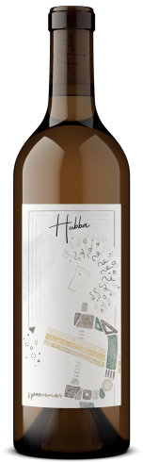

Chenin Blanc

Vintage: 2025

AVA: Paso Robles Highlands District
Varietal: 100% Chenin Blanc
Vineyard: 100% Shell Creek Vineyard
Cases Made: 175

Alc. by Vol.: 12.6%

Fermented and aged for 6 months in 59% once used French Oak and 41% neutral French Oak. Wild yeast. Unfined. Unfiltered.

