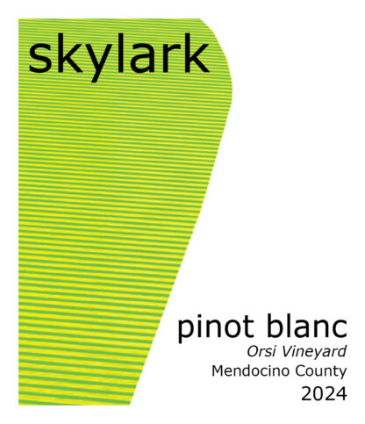

2024 Skylark Pinot Blanc, Orsi Vineyard, Mendocino
Skylark Pinot Blanc is sourced from Bernie Orsi’s old vine plot in Mendocino County. Planted in Russian River alluvial soils, this vineyard dates back to its original inception in the 1970s, created by Mendocino legend John Fetzer. We barrel ferment this pristine fruit in Mueller stainless steel barrels to capture the essence of this unique site. While the July 4th holiday weekend provided scorching temperatures across the entire North Coast, the summer that followed was warm and moderate. After a cooling trend in mid-August gave the crop a welcomed respite from the heat, ripening was nearly perfect for the remainder of the harvest. Pinot Blanc was picked in the early morning hours on September 3rd under ideal conditions.
Aroma: Pale yellow. High-toned citrus notes with roasted lemon, tangerine and green apple emerging with aeration. Very aromatic and perfumed, with a stoned fruit accent adding a layer of fragrant complexity.
Tasting Notes: The palate is sleek and supple, with the lemon and apple fruits leaning into a tangy and dry finish. This refreshingly dry finish belies the fruit density of the midpalate, where the interplay of textured fruit and natural acidity are in beautiful harmony.

