
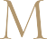

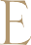
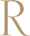
Sauvignon Blanc
2023
Napa Valley

This crisp Napa Valley Sauvignon Blanc is fermented and aged in stainless steel.

With aromas of stone fruit and freshly cut herbs followed by grapefruit-melon flavors on the palate, this wine is best enjoyed in its youth.

APPELlATION
Napa Valley

BLEND
100% Sauvignon Blanc

HARVEST
September 8th & 11th, 2023 Picked at 23.1 & 21.4 Brix VINEYARD
Sage Creek & Shartsis

FErMENTATION
Stainless Steel Fermentation

ANALYSIS
Alcohol 13.3%
pH 3.39
TA .6

PRODUCTION
1,680 cases

BOTTLED
February 20th, 2024

RELEASE DATE
Spring 2024

SUGGESTED RETAIL
$30

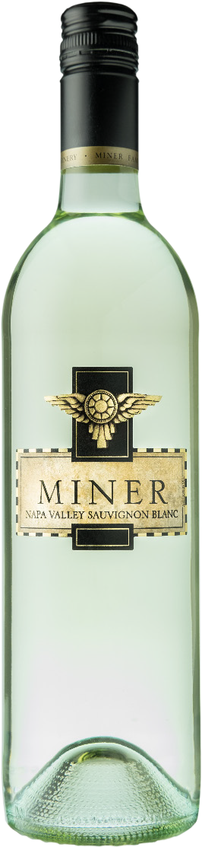

H I S T O R Y
Miner is a dynamic family-owned winery tucked along the eastern hills of the Oakville appellation in the heart of Napa Valley. Founded in 1998 by Dave and Emily Miner, Miner Family Winery crafts reserve-style wines by sourcing fruit from Napa Valley and other pecially selected California vineyards.

Our winemaking team uses a combination of old world winemaking techniques and modern technology to make wines that reflect the unique characteristics of individual vineyards or “terroir” where specific varietals grow best. This fusion of superb vineyard sites and thoughtful winemaking allows Miner to deliver elegant, expressive wines.

PO BOX 367 • 7850 SILVERADO TRAIL • OAKVILLE, CA • 800.366.WINE • MINERWINES.COM

