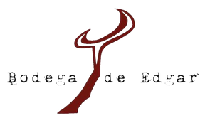

2020 TARRAGONA

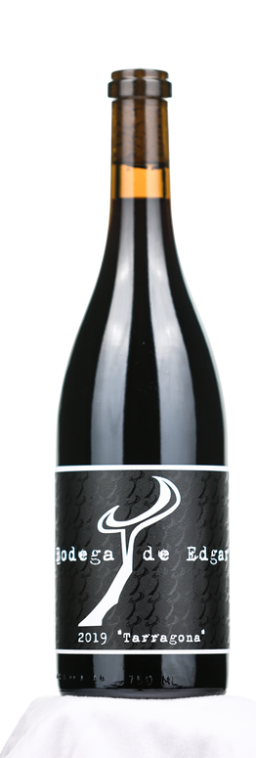
VISION
My vision has always been to show new wine drinkers and seasoned connoisseurs alike that their favorite wine might be one they haven't tried yet, made with fruit they might not have ever heard of. My passion for wine has enabled me to travel to Spain many times, and explore their many wine regions extensively. The history there is incredibly vast and deep, with each region honoring their own unique traditions and the land upon which they sit. The wines they make are incredible and serve justice to their unique composition of soils and climate. Each time I come back home to Paso, I realize that while our buildings and culture are very different here in California, the land is eerily similar. Our climate, soils, and vineyards feel much the same to Spain than different.

"Wines made for people who work hard but enjoy playing harder."
E D G A R T O R R E S

ABOUT TARRAGONA

34% Grenache, 33%Carignan, 33%Tempranillo

Vineyard & AVA: Paper Street Vineyard, Willow Creek District, Paso Robles CA.

Alcohol: 15.5%

Aging: Drink now through 2030.

VINTAGE NOTES

2020 is showing exceptional quality amid a challenging year. Yields were varietally dependent, with an average of 10-30% down.
Grape quality across the board is excellent with intense flavor development and great color. Budbreak came a little on the late side due to late-season rainfall. Zero frost issues hampered the beginning of bud break which was followed by a temperate May and June. July proved to be cooler than average, which helped flowering happen under good conditions and strengthen vine health. Conditions changed in August and September, which were warmer than average. Harvest began in the last week of August.

VINIFICATION

Fermented on native yeast, 30% whole cluster, on skins for 14-18 days. Aged for 22 months in 265L Hungarian oak and 228L French oak barrels , 30% new.

TASTING NOTES

Roughly equal parts Grenache, Tempranillo, and
Carignan. The 2020 Tarragona leads with aromas of fig, black cherry, and smoked meats. Upon further aeration the wines further opens up revealing exotic whiffs of hoisin, old leather and black licorice.
Very old world in style with a firm acid and a rustic tannin
profile. The Grenache component brings abundant freshness while both Carignan and Tempranillo provide structure and savory spice nuances on the pallet.

