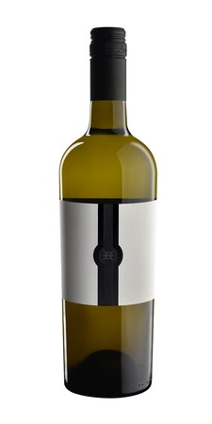

Bottom of Form

Wine Specs

**Vintage:** 2023

**Varietal:** 84% Chardonnay 16% Viognier

**Appellation**: Templeton Gap District

**Alcohol: 13.5**%

**Tasting Notes:** Caelesta 2023 White Wine is a pale-yellow wine with a subtle effervesce. It has a fresh scent of herbs and lemon peel, with a distinct mineral note. On the palate, it is silky with a prominent citrus flavor, specifically tangerine. Aromas of crushed rock, which give depth to the white melon, pear soda, and coconut scents on the nose.