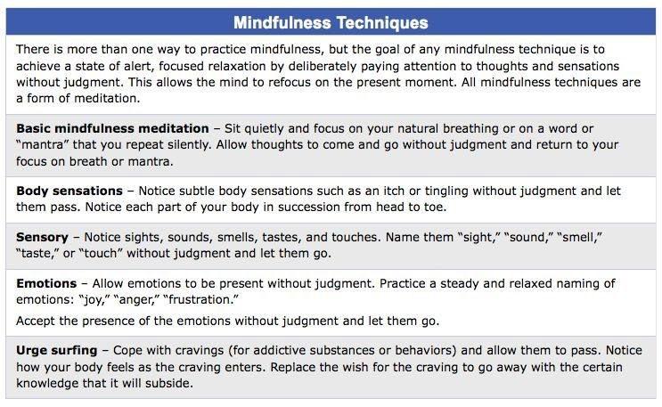

Take 10 minutes each day to practice one of the above. Remember that these techniques are to help you focus on the here and now. Practice them with NO JUDGEMENT to yourself and just take a personal inventory of the emotions you feel or physical feelings you have. If practiced every day you will start to cultivate an awareness of yourself that will improve your mental health. Thinking too much in the future breeds anxiety and thinking too much about the past breed depression. You do both which is causing a lot of mental health symptoms that are hard to control. This is not a fix all method but it will get you closer to stability.

\*Mindfulness Meditation- constantly focus on your breath and when thoughts continue to flood your mind acknowledge them and tell yourself to return back to the breathing. It helps to count as you breath…1,2,3,4 breath in…1,2,3,4 breath out

\*When you notice the sensations in your body the goal is to not try and fix them or change them. The goal is to acknowledge them and sit with the feeling. If you have a sensation or pain that is difficult to endure then focus your attention on another part of your body that feels better or less stressed. This 10-minute practice will help you build endurance in your body and tolerance in your mind.

\*Sensory meditation helps you to focus on the here and now…we pass every minute of the day not noticing all the things around us. When you intentionally focus your attention on all sensory input you are able to recognize things you haven’t noticed before. This can be a more pleasant practice than some of the others.

\*Emotional Mindfulness allows you to feel your feelings without judgement. If you are frustrated then accept the feeling of being frustrated and resist the urge to fix it or think of a way to make it better. Once that feeling is acknowledged then let it go. It’s the practice of accepting feelings and letting them go that will allow us to better manage them.

\*Urge Surfing- Challenge yourself to resist your urges for food, cigarettes, alcohol, acceptance, sexual pleasure, attention, etc. Notice how your body reacts to this challenge and recognize how sitting with the discomfort becomes easier and easier as time goes by. Instant gratification causes us to be more impulsive and less patient.