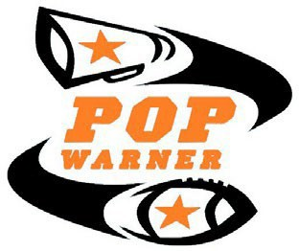

**2025**

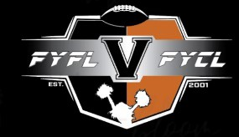

**Fernley Youth Football League - Pop Warner**

**Participant Information**

Last: First: Middle:

FOOTBALL SIZING

Jersey # Jersey Size T Shirt Size Shoe Size

Football Division

6u 7U 8U 9U 10U 11U 12U 13U 14U

**ODD DIVISIONS MAY PLAY UP IF NOT ENOUGH TEAMS TO MAKE A COMPLETE DIVISION**

Returners With good league standing get to keep their number from last year. In the event you can move up but chose to stay down, or move up a division when you can stay down, you lose the rights to the number if there is a returner who can't move divisions.

|  |  |  |  |  |  |
| --- | --- | --- | --- | --- | --- |
| CHEER DIVISI  Jr Tiny Mites | ONS  Tiny Mites | Mighty Mites | Jr Pee Wee | Pee Wee | JR. V. Varsity |
| 3-4 | 5-6 | 7-8 | 9-10 | 11-12 | 12-13 13-14 |

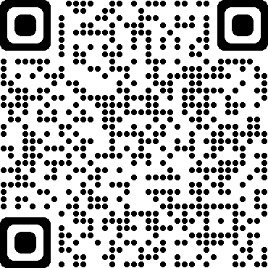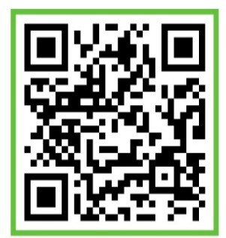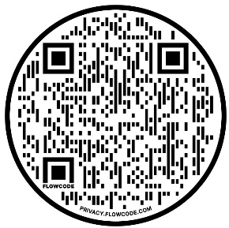**CHEER SQUADS WILL BE ASSIGNED BASED ON THE FYCL CHEER AGE MATRIX, BUT MAY USE THE POP WARNER AGE MATRIX BASED ON PRACTICE LOCATIONS, COACHES AND NUMBER OF PARTICIPANTS**

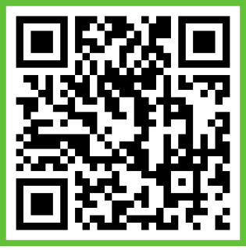

**FERNLEY YOUTH CHEER BAND PAGE**

**FERNLEY YOUTH FOOTBALL AND CHEER WEBSITE**

**THESE PAGES ARE OUR MAIN SOURCES OF COMMUNICATION. IF YOU ARE NOT FOLLOWING THESE PAGES, THE LEAGUE IS NOT RESPONSOBLE FOR LACK OF COMMUNICATION**

**FERNLEY YOUTH FOOTBALL AND CHEER FACEBOOK**

**FERNLEY YOUTH FOOTBALL BAND PAGE**

# KEEP THIS PAGE FOR FUTURE REFERENCE

**FYFL/FYCL BOARD MEMEBERS INITALS**

# Pop Warner Little Scholars, Inc.

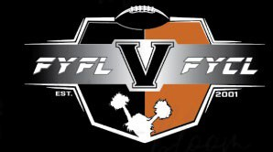

**2025 PARTICIPANT CONTRACT AND PARENTAL CONSENT FORM**

**Special Note**: **This form must be dated after January 1, 2025, and is APPLICABLE ONLY FOR THE 2025 SEASON.**

**This form must be submitted to your LOCAL organization before the athlete participates in Pop Warner. No other forms are acceptable. Every Pop Warner Association must have a fully completed and signed original of this form before allowing the athlete to participate.**

**Legal Name of Participant (must match birth certificate):**

Last First Middle Also known as

Address

City Phone No:

State Zip Birth date

Gender:

Male Female

Sport: Football Cheer

School: Grade Level

Grade Point Average: Alternative Form Participant:

(Must meet Scholastic Fitness Requirement of 2.0/70% or else fill out the Scholastic Eligibility Form or Home School Eligibility Form).

Mailing Address if different from above:

Name of Parent/Guardian Relationship to Athlete:

Address (if different from above)

City State Zip

Contact phone No: Email Address:

**Emergency Contact Information (if the parent/guardian can not be reached):** Name

Relationship to Athlete

Home Telephone No:

**FYFL Official Use Only:**

Jersey Number Preference (3): Witnessed By: Amount Paid $ Receipt #

Type of Transaction: Cash

Check

Credit Card Other (please explain)

CHEER

Traditional Divisions

6u 7U 8U 9U 10U 11U 12U 13U 14U

FOOTBALL

Age –Based Division:

Special Request :

**WE WILL DO OUR BEST TO ACCOMDATE REQUEST HOWEVER SPECIAL REQUEST ARE NOT GUARENTEED**

|  |  |  |  |  |  |
| --- | --- | --- | --- | --- | --- |
| Jr Tiny Mites | Tiny Mites | Mighty Mites | Jr Pee Wee | Pee Wee | JR. V. Varsity |
| 3-4 | 5-6 | 7-8 | 9-10 | 11-12 | 12-13 13-14 |

 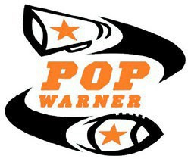

**2025-2026 PARTICIPANT CONTRACT AND PARENTAL CONSENT FORM**

**Special Note:** This form must be completed, signed by the youth participant's parent or legal guardian, and dated after January 1, 2025. The form applies only to the 2025 Fall - 2026 Spring season. It needs to be submitted to your LOCAL Pop Warner organization prior to participation in any programs. **By signing this form, the parent or legal guardian agrees to the terms and conditions outlined below.**

**Section I: POP WARNER AFFILIATION**

League: Sagebrush Pop Warner Association:

Fernley Youth Football / Cheer League

**Section II: YOUTH PARTICIPANT INFORMATION (must match birth certificate)**

Last: First: Middle: Date of Birth: Age: Male □ Female □ Sport: Football □ Cheer/Dance □

**Section Ill: PARENT/GUARDIAN INFORMATION**

Last: First:

Address: City: State: Zip: Mobile Phone No: Alternate Phone No:

Email: Relationship to Child:

**Section IV: EMERGENCY CONTACT INFORMATION (if parent/guardian cannot be reached)**

Name: Relationship to Child: Phone No:

**Section V: PARENT/GUARDIAN PERMISSION AND WAIVER**

1. **PERMISSION:** I am the parent or legal guardian of the above-named participant. I acknowledge that my

child is in good health. I give permission for my child to participate in any and all Pop Warner national, regional, league/conference, association and team/squad activities, including transportation to and from the activities. I give permission for and assume any and all risk of my child's use of various playing surfaces including natural and artificial grass, cheer mats, hard dirt, and under varying conditions, including, dry, wet and muddy, and I hereby understand that any surface may be regular or irregular.

1. **RISK INFORMATION:** I acknowledge the inherent risk and danger of participation in any sport and I

understand that participation in football, cheerleading and/or dance may result in **BODILY INJURY, including by not limited to PARALYSIS, BRAIN INJURY, PERMANENT DISABILITY AND/OR DEATH.** I acknowledge that protective equipment does not prevent all participant injuries and Pop Warner makes no representations or warranties regarding the equipment or its fitness for use. I release, indemnify, hold harmless and waive any claim against the coaches, local, league and regional Pop Warner organization(s), Pop Warner Little Scholars, Inc., and all organizers, sponsors, supervisors, participants, and persons transporting my child to and from activities, for any injury to my child whether the result of negligence or for any other cause.

1/25/2025 PWLS, INC.

 

**2025-2026 PARTICIPANT CONTRACT AND PARENTAL CONSENT FORM**

1. **EMERGENCY MEDICAL AUTHORIZATION:** I give permission for emergency medical/dental treatment

or first aid to be administered to my child for any illness/injury/accident resulting from participation in Pop Warner activities.

1. **EQUIPMENT RESPONSIBILITY:** I acknowledge my responsibility for all equipment/uniforms

loaned to my child and I agree to promptly return, upon request, the uniform and other equipment in good condition except for normal wear and tear. If I fail to comply, I will be responsible for the cost of such equipment/uniform.

1. **INSURANCE DISCLOSURE:** I am aware that my local Pop Warner organization carries group accident medical

insurance which is secondary or excess to my insurance which is considered primary insurance. Further, I agree to notify in writing my head coach and local Pop Warner organization of any medical claim from participation in Pop Warner as soon as reasonably possible. I understand that the registration fee is not premium for insurance and that deductibles may apply.

1. **SCHOLASTIC FITNESS:** I confirm that my child is scholastically fit, having met the requirement of 2.0/70%,

or that I have completed the scholastic eligibility form or the Home School Eligibility Form and will adhere to all rules and regulations therein. Further, I authorize my child's school to release grades, report cards, and all other scholastic information to the local Pop Warner organization to comply with scholastic fitness requirements.

1. **FINANCIAL RESPONSIBILITY:** I acknowledge that my rights, if any, to a refund depends on the local

Pop Warner Organization policies, and I have also been advised of my fundraising obligations for the entire season and agree to fully comply with those obligations.

1. **COMMUNICATIONS, PROMOTIONS, AND CONSENT:** As a condition to my child's participation, I consent

to receive communications by email and mail from Pop Warner Little Scholars, Inc. and its sponsors. I understand that Pop Warner Little Scholars does not sell its contact list. Communications may contain program information or special offers. I may "opt out" by instruction in the communication or by my written request to the Pop Warner National Office. Further, I grant Pop Warner the right and permission to make, reproduce, broadcast or otherwise use in perpetuity my child's name and likeness including photograph, films, videos, recordings, or other depictions or images in any form or media throughout the universe, for promotional material, advertising, editorial, trade or other purpose. To the extent that any benefit may accrue therefrom, I forever waive any interest in or claim to such benefit and acknowledge that Pop Warner is under no obligation to exercise any rights granted herein.

1. **ADHERENCE TO POP WARNER RULES AND PROCEDURES:** I understand that it is my responsibility to

comply with all rules and regulations of Pop Warner Little Scholars Inc and its affiliated organizations and understand that non-compliance may be cause for discipline and/or dismissal of my child, myself, and/or other persons affiliated with me or my child. I further understand that my child must meet Pop Warner age and/or weight requirements on their official certification date as established by Pop Warner without exception and that the decision of the Weigh Master is final. I agree to furnish an authentic certified copy of my child's birth certificate to local Pop Warner officials and understand that valid proof of age, a current calendar year's signed medical form, scholastic fitness form and this form must be presented by date of certification to participate in Pop Warner activities. I hereby hold Pop Warner harmless of any financial loss as the result of any disciplinary action.

1. **DISPUTE RESOLUTION POLICY; SEVERABILITY:** I understand and acknowledge that all disputes with

Pop Warner and all affiliated parties will be subject to binding arbitration in Langhorne, PA in accordance with Pennsylvania law. I hereby agree that this binding arbitration shall be in lieu of any litigation. I also understand and agree that if I contest any decision or ruling of Pop Warner and seek other recourse, that I will reimburse Pop Warner for all legal fees and expenses it reasonably incurs. If any portion of this form shall be deemed unenforceable, the reminder shall remain in full force and effect.

1/25/2025 PWLS, INC.

 

**2025-2026 PARTICIPANT CONTRACT AND PARENTAL CONSENT FORM**

**Section VI: GENERAL CODE OF CONDUCT**

Pop Warner Little Scholars, Inc. is committed to cultivating a safe and welcoming environment for its regional and national events and programs that encourages and promotes good sportsmanship by student-athletes, parents, coaches, administrators and other spectators. We ask that event participants and attendees cooperate in being respectful at all practice and competition venues, partner hotels and/or ancillary venues throughout the course of the event. All those involved with the event are expected to refrain from the following behaviors:

* 1. Acting in a way that is unruly, disruptive or illegal in nature.
  2. Intoxication or other signs of impairment that may potentially result in bad behavior.
  3. Excessive use of profanities and other vulgar language that that interfere with other attendees' ability to enjoy the event.
  4. Using bigoted, demeaning or abusive or other disruptive and intimidating language and/or gestures.
  5. Verbal or physical harassment of officials, participants and coaches before, during and following the competition.
  6. Disrupting the progress of competition (including physically entering or throwing objects onto the playing field or competition mat).
  7. Interfering with or failing to abide by security or emergency procedures or response
  8. Displaying signs that contain offensive language, or any graphic art that may be deemed disrespectful.
  9. Defacing, destruction or theft of property associated with the event, including property of the opposing team or other participants, including officials, as well as official venues.
  10. Violence or threats of violence against other individuals at any official venue.
  11. Publicly criticizing or making derogatory statements of an official, opposing teams, event personnel or its policies, or other individuals associated with the event. This includes comments with respect to their conduct, character, competence, integrity or appearance. Note: social media is deemed a public forum.
  12. Failing to follow instructions of event personnel.
  13. Any behavior which otherwise violates conduct codes set by partner venues, hotels or ancillary venues including but not limited to theme parks, as enforced by those properties.

Failure to abide by these expectations are grounds for removal from competition. Pop Warner reserves the right to remove individuals or the entire team. Depending on the infraction, a one-year ban from Pop Warner events and programs will be considered. A repeat offense of the same infraction may result in a permanent ban. All removals will be without refund.

**Section VII: PARENT /GUARDIAN AUTHORIZATION**

In consideration of participation in Pop Warner activities and by my signature below, I confirm that I have read, fully understand and voluntarily agree to be bound by all of the above and that all information provided by me is true and accurate.

**Signature of Parent/Guardian:** Date:

1/25/2025 PWLS, INC.

# SAGEBRUSH EMPIRE POP WARNER PARENTS MEDICAL RELEASE

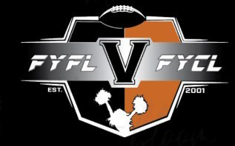

In the event of a medical or traumatic emergency, I hereby grant permission for my child,

to obtain necessary treatment at the nearest available hospitalor treatment facility. I further agree to hold the hospital, treatment facility or Pop Warner Football and Cheer harmless of liability for granting or making available such treatment.

**Note any allergies, medications or medical information we should be aware of**

*I understand that I am responsible for the cost of treatment, subject to available Pop Warner insurance coverage and my own medical insurance coverage.*

Parent or Guardian Signature Date

Name of above, please print clearly

Phone (days) Phone (evenings/weekends)

Name of Physician:

Name of Dentist:

**Primary Insurance Information**

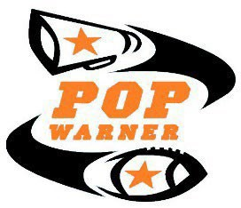

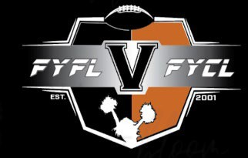

 

### 2025-2026 YOUTH PARTICIPANT MEDICAL HISTORY FORM

**Special Note:** This form must be completed thoroughly and honestly and signed by the youth participant's parent or legal guardian. It is to be completed and dated after January 1, 2025. This form applies to the 2025 Fall - 2026 Spring season and needs to be submitted to your LOCAL Pop Warner organization. This form and its contents will be available to authorized Pop Warner personnel and kept confidential. **By signing this form, the parent or legal guardian agrees to the terms and conditions outlined below.**

**Section** I: **POP WARNER AFFILIATION**

League: Sagebrush Pop Warner Association: Fernley Youth Football League

**Section** II: **YOUTH PARTICIPANT INFORMATION (must match birth certificate)**

Last: First: Middle

Date of Birth: Age: Male Female Sport: Football Cheer/Dance

**Section** Ill: **PRIMARY AND SECONDARY CONTACT**

*Primary Contact: Parent or Guardian*

Last: First:

Address: City: State: Zip: Mobile Phone No: Alternate Phone No:

Email: Relationship to Child:

*Secondary Contact:*

Last: First: Mobile Phone No: Alternate Phone No:

Email: Relationship to Child:

**Section IV: INSURANCE INFORMATION**

Primary Insurance Company: Primary Group/Policy#: /

Does primary insured have Medicaid? Yes No Does primary insured have Medicare? Yes No Family Doctor Name: Doctor Phone No:

**Section V: MEDICAL HISTORY OF THE YOUTH PARTICIPANT**

Please identify and elaborate on any medical conditions which we should be aware (if none, write none):

1/25/2025 PWLS, INC.

 

### 2025-2026 YOUTH PARTICIPANT MEDICAL HISTORY FORM

Please list any medications currently being taken (if none, write none):

In the past 24 months, has the participant been tested, diagnosed and/or treated for a concussion: Yes___No___ If yes, provide the specific date and detail on the diagnoses/treatment and the outcome:

List any known allergies (if none, write none):

Date of last Tetanus Toxoid Booster:

*The purpose of the above information is to ensure that medical personnel have details of any issues which may interfere with or alter medical treatment.*

**Section VI: PARENT/GUARDIAN CONSENT AND MEDICAL RELEASE**

Recognizing the possibility of serious injury, illness or death, and in consideration for Pop Warner Little Scholars, Inc. and its members accepting my child as a participant in its official programs, I consent to my child participating in Pop Warner tackle football, flag football, cheer and/ or dance. Further, I hereby release, discharge, and otherwise indemnify Pop Warner, its member organizations and sponsors, their employees, associated personnel, and volunteers, including the owner of fields and facilities utilized for the Programs, against any claim by or on behalf of my child as a result of participating in the Pop Warner programs.

My child has received a physical examination by a licensed health care provider within the past two years and has been found physically capable of participating in the sport of football and/or cheerleading & dance. I have provided written notice, which is submitted in conjunction with this release and attached hereto, setting forth any specific issue, condition, or ailment, in addition to what is specified above, that my child has or that may impact my child's participation in the programs. I give my consent to have an athletic trainer and/or licensed health care provider, including a medical doctor or dentist, provide my child with medical assistance and/or treatment and agree to be financially responsible for the reasonable cost of any such assistance and/or treatment.

**Signature of Parent/Guardian:** Date:

1/25/2025 PWLS, INC.



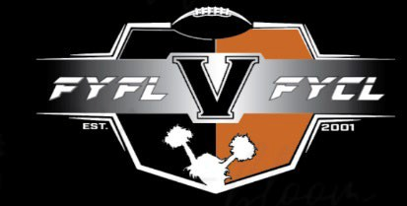

**Pacific Northwest Region Sagebrush Empire Code of Conduct**

**2025**

|  |  |  |
| --- | --- | --- |
| **Sagebrush Empire Participant’s Code**  **I WILL:**  Emphasis the ideas of sportsmanship, ethical conduct and fair play.  Show courtesy to my opponents and officials.  Recognize athletic contests are serious educational endeavors.  Give complete allegiance to my coaches who are the instructional authority for my team.  Discourage fans, fellow teammates and parents from undercutting my coach’s authority.  **I WILL NOT:**  Use profanity or talk “trash” before, during or after any game.  Use drugs, alcohol or tobacco. Criticize my teammates.  Act in any way that may incite spectators. | **Sagebrush Empire Parent’s Code**  **I WILL:**  Support my child’s team/squad and teach the value of commitment to the team/squad emphasis the ideals of sportsmanship, ethical conduct and fair play.  Help my child and Pop Warner make athletic contests a positive educational experience.  Show courtesy to opponents and officials.  Direct constructive criticism of my child’s athletic program to the athletic director or association officials and work towards a positive result for all concerned.  **I WILL NOT:**  Criticize officials, direct abuse or profane language toward them, or otherwise subvert their authority.  Undermine, in word or deed, the authority of the coach or administration.  Use any tobacco, smoking paraphernalia or alcohol products at any Pop Warner Event | **Sagebrush Empire Coach’s Code**  **I WILL:**  Respect the integrity and judgment of contest officials/judges and work with them to promote positive experiences.  Establish and model fair play, sportsmanship, and proper conduct.  Hold in highest priority the establishment of the child’s safety and well fair.  Always provide proper supervision of the athletes.  Use discretion when providing constructive criticism and when reprimanding the athlete. Maintain consistency in requiring athletes to adhere to established rules and standards of the contest to be played.  Follow the Pop Warner rules of behavior and the procedures for responsible crowd control.  Vigorously encourage and support athletes.  **I WILL NOT:**  Suggest, provide, or encourage athletes to use non-prescription drugs or substances.  Promote acts that will in any way incite spectators in a negative manner. |

**Head Coaches, Parents and Participants must sign** this form and by signing he/she is assuring the Sagebrush Empire League Directors/staff that he/she will always review and follow the “code of conduct” with his/her relatives/fans.

|  |  |  |  |
| --- | --- | --- | --- |
| **HEAD COACH:** |  |  |  |
|  | **Print Name Clearly** | **Signature** | **Date** |
|  | **_Fernley Youth Football League** |  | **SAGEBRUSH** |
|  | **Association** | **Team/Squad Name** | **League** |
| **PARENT:** |  |  |  |
|  | **_ Print Name Clearly** | **Signature** | **Date** |
| **PARTICIPANT:** | **Print Name Clearly** | **Signature** | **Date** |

**\*\*\*\* PLEASE READ AND SIGN THE PAGE \*\*\*\***

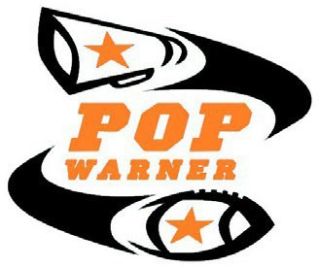

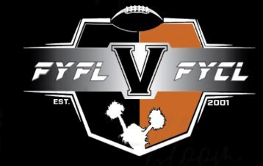

**Pacific Northwest Region Sagebrush Empire**

**Code of Conduct Consequences**

**2025**

# Consequences for Violation of the Code of Conduct

## Adult Behavior:

1. At any Pop Warner event, practice or competition, any adult who: 1) verbally abuses; 2) attempts to intimidate; 3) is flagrantly rude, or 4) cannot control their language or actions with an official, coach or Pop Warner volunteer will be asked to leave the Pop Warner event. He or she will receive a written warning regarding their behavior. His or her child (ren) will be immediately removed from the Pop Warner event.
2. Any adult that commits a second similar offense will be banned from Pop Warner events for the remainder of that season and their child(ren) removed from Pop Warner for the remainder of that season. Association will refund registration monies pro-rated based on the percentage of the season remaining.
3. Any adult who physically assaults an official, coach or Pop Warner volunteer will be banned from Pop Warner and their child(ren) removed from the Pop Warner program for one year from the date of the offense. The child(ren) may not participate in another Pop Warner Association during the sanction period. After one year, the parent may apply for re-instatement of his or her child. If the adult commits a second offense, he or she will be permanently banned from Pop Warner and the child(ren) permanently removed from Pop Warner.

The term physical assault includes, but is not limited to: hitting, slapping, pushing, spitting, kicking or striking in any way with any part of the body or any physical implement.

## I have read the above three (3) paragraphs I understand and will agree to abide by them.

|  |  |  |
| --- | --- | --- |
| **HEAD COACH:** |  | |
| **Print Name Clearly** | **Signature** | **Date** |

|  |  |  |
| --- | --- | --- |
| **PARENT:** |  | |
| **Print Name Clearly** | **Signature** | **Date** |

|  |  |  |
| --- | --- | --- |
| **PARTICIPANT:** |  | |
| **Print Name Clearly** | **Signature** | **Date** |

**DIVISION (CIRCLE ONE) FOOTBALL 6U 7U 8U 9U 10U CHEER: JR-TM TM MM**

**11U 12U 13U 14U JPW PW JV V ODD DIVISIONS MAY PLAY UP IF NOT ENOUGH TEAMS TO MAKE A COMPLETE DIVISION**

(Copies) ASSOCIATION - TEAM BINDER



**FERNLEY YOUTH FOOTBALL / CHEER LEAGUE ZERO TOLERANCE POLICY**

Recent seasons have shown an increase in unacceptable and violent behavior from spectators, coaching staff and parents. **NO** circumstances allow for any adult to behave in such a manner. It is because of serious violations to our already in place Code of Conduct that we are implementing a Zero Tolerance Policy in our enforcement of the National and Local policies.

**THIS IS YOUR ONE AND ONLY WARNING!**

It is the responsibility of all coaches, players, parents, relatives, siblings, and any other attendee or participants to maintain the highest standards of conduct for their behavior at all events including, but not limited to practices, games, fundraisers, and competitions. **This also includes any social media posts.**

Abusive and obscene language, abusive or negative comments to the officials, violent conduct of any kind, fighting, and other behaviors detrimental to the event, the organization, Pop Warner, and the safety of our participants will not be tolerated. We expect **EVERYONE** hold themselves to the highest standards and behave accordingly.

Violation of this policy **can** result in a $500 fine to be paid by the offending team. Any violation can result in suspension or removal of the player/coach and their family/spectators for the remainder of the season or if necessary, a lifetime ban from Pop Warner. If the behavior continues, the entire team will forfeit the remainder of their season and that team will be dissolved.

If you witness or are involved in a situation that causes you to be tempted to "take matters into your own hands" contact a member of thee-board immediately. FYFL / FYCL Board will investigate and handle the situation in the best interest of the Association and the League.

Understand that we can no longer tolerate the violent behavior that compromises our program and its objectives. Again, this is the only warning you will receive reminding you to do the right thing.

There will be an additional Football, Cheer Athlete, and Parent Code of Conduct to sign once teams are formed.

Parent Signature Head Coach Signature Date