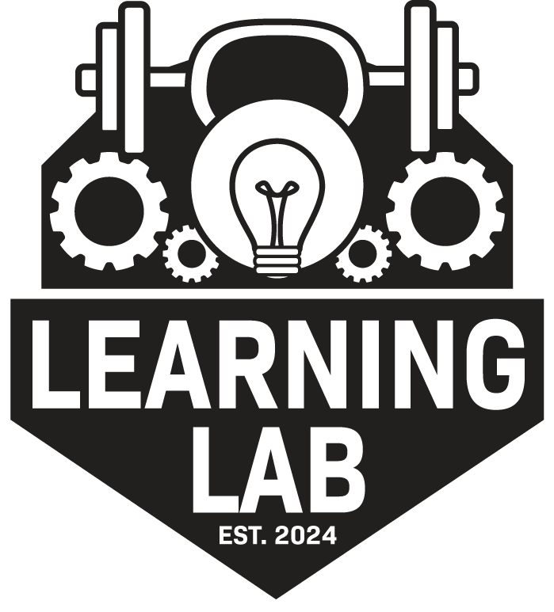 **Learning Lab Retreats Terms and Conditions**

By registering for a Learning Lab Retreats event, you acknowledge that you have read and agreed to the following terms and conditions. You will be required to sign a physical copy upon arrival.

**GENERAL RELEASE AND WAIVER**

The undersigned acknowledges that participation in Learning Lab Retreats’ activities is voluntary and may involve physical exertion and inherent risks, including but not limited to injuries, accidents, environmental hazards, and other unforeseen circumstances. Activities may include but are not limited to guided movement, wellness workshops, nature excursions, recreational activities, and relaxation sessions.

By participating, the undersigned:

* Assumes full responsibility for any risks, injuries, or damages, known or unknown, which may result from participation.
* Agrees to follow all safety instructions and guidelines provided by Learning Lab Retreats staff.
* Acknowledges that Learning Lab Retreats and its affiliates are not liable for any injury, illness, loss, or damage that may occur during the retreat.
* Releases and discharges Learning Lab Retreats, its owners, instructors, employees, and affiliates from any claims, demands, or causes of action arising out of participation.

**IMAGE RELEASE AND WAIVER**

The undersigned grants Learning Lab Retreats permission to use photographs, video recordings, and/or audio recordings taken during the event for promotional purposes, including social media, website content, and marketing materials. No compensation will be provided for the use of such materials.

**MEDICAL RELEASE AND WAIVER**

The undersigned acknowledges that Learning Lab Retreats does not provide on-site medical personnel. In the event of an emergency:

* Participants are responsible for their own medical care and transportation.
* Any costs incurred for medical treatment or hospitalization will be the sole responsibility of the participant.
* The undersigned certifies that they are in good physical and mental health to participate in all retreat activities.

**REPRESENTATION AND WARRANTY OF AUTHORITY**

By signing this waiver, the undersigned represents that they are of legal age and have the capacity to provide this release on their own behalf or, if applicable, on behalf of a minor participant for whom they have legal responsibility.

**REFUND POLICY**

Learning Lab Retreats understands that unexpected situations may arise. Our refund policy is as follows:

* **100% refund** if cancellation occurs within 24 hours of booking.
* **50% refund** if cancellation occurs at least **two months** before the retreat start date.
* **25% refund** if cancellation occurs at least **one month** before the retreat start date.
* No refunds will be issued for cancellations made within **one month** of the retreat start date.
* In cases of emergencies, participants may transfer their registration to a future retreat instead of receiving a refund.

**REPRESENTATION AND WARRANTY OF AUTHORITY**

By signing this waiver, the undersigned represents that they are of legal age and have the capacity to provide this release on their own behalf or, if applicable, on behalf of a minor participant for whom they have legal responsibility.

**GOVERNING LAW**

These Terms and Conditions shall be governed by and construed in accordance with the laws of the applicable jurisdiction where the retreat takes place. If any provision is deemed unenforceable, the remaining provisions shall remain in full effect.

By registering for Learning Lab Retreats, the undersigned affirms that they have read, understood, and voluntarily agreed to these terms and conditions.

**SIGNATURE SECTION**

Participant Name: ________________________________  
Participant Signature: ______________________________  
Date: ______________