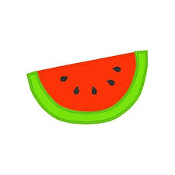
2019 Watermelon Producers

WL Lewis 337-463-8318
Bobby Harper 337-328-2213
Brian Calcote 337-249-3196
James Nolan 337-452-5562
Chuck Melsheimer 337-328-8200
Sugartown Watermelon Stand 337-208-2422
Charles Mc Donald 318-358-5434
Teddy Welch 337-207-9651

