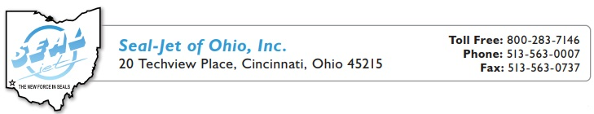
Elastomer Family | ASTM | Shelf Life
Aflas |  | Unlimited
Butyl Rubber, lsobutylene lsoprene | llR | Unlimited
Chloroprene (Neoprene®) | CR | 15 Years
Epichlorohydrin (Hydrin®) | ECO | N/A
Ethylene Acrylic (Vamac®) | AEM | 15 YEARS
Ethylene Propylene, EPDM or EP | EP | Unlimited
Fluorocarbon (Viton®) | FKM | Unlimited
Fluorosilicone | FVMO | Unlimited
Hydrogenated Nitrile, HNBR or HSN | HNBR | 15 YEARS
Nitrile (Buna-N or NBR) | NBR | 15 YEARS
Perfluorelastomer | FFKM | Unlimited
Polytetrafluoroethylene (Teflon®) | PTFE | N/A
Polyacrylate | ACM | 15 YEARS
Polyurethane (Polyester or Polyether) | AU / EU | 5 Years
Silicone | VMO | Unlimited
Styrene Butadiene (Buna-S) | SBR | 3 YEARS


Seal-Jet of Ohio, Inc accepts no responsibility for results obtained. Each user of these products, or information, should perform their own tests to determine the suitability of the material. Seal-Jet does not guarantee that the user will obtain the same results. The data and information are subject to change without notice.

