

**Our Philosophy**

We believe early childhood is the most important and opportunistic time for children. Early learning is the foundation of a child’s development throughout life. It is a time in which they need to be free to create, explore and have fun; it is also the time to lay the foundational skills for each child to respect themselves and others, accept responsibility and think for themselves.

We believe that children learn through play; it is their means of communicating about themselves and making sense of the world around them. The children will have the opportunity to observe, explore and most of all, have fun. Our goal is to build children’s confidence, independence, and self-esteem by giving them the opportunity to learn and grow in a safe and nurturing environment.

We enjoy and respect the individuality of all children and families within our centre. We embrace diversity and strongly encourage the sharing of cultural traditions. Our goal is to support children in learning acceptance and respect for everyone by incorporating diversity and multiculturalism into our program.

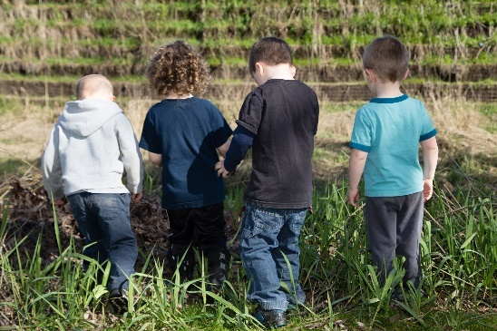**Program**

Curriculum

Our program embraces a RESPONSIVE approach to learning. We believe this approach is the most developmentally appropriate and consistent with our understanding of how children learn. A Responsive Philosophy is one that builds upon the interests of children. Educators follow the children’s lead and based on observations, introduce new and exciting activities to sustain their interests and deepen their explorations. We are forever learning as we follow our children’s footsteps.

Our program is guided by principles to enhance children’s learning through play, storytelling and nature. We offer three playgroups. Two multiage rooms with a capacity for 8 children each and a 3-5 group room with a capacity of 22 children.

We hold great value and respect for each child as a unique individual. Our early childhood community gives us the tools and resources to utilize many different teaching strategies to enhance our children’s learning experience.

Our goal for the children is that they are learning constantly through everything they participate in at our centre. We use a variety of developmentally appropriate materials to teach children with varying abilities, interests, needs and learning styles.

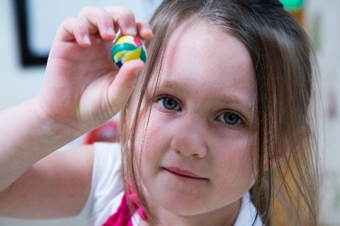

**Our Centre Policies**

Diversity and Inclusion

Parkview Academy strives to be a safe place for all children of all ability, race, culture, beliefs or economic status. Our program embraces the multicultural diversity within our classroom staff and families as well as our Indigenous community partners.

Staff are responsive to individual abilities and look to reduce or eliminate barriers to fully support children’s’ learning and engagement with others. Our efforts are ongoing to create programming an maintain an environment that reflects an anti-biased view and creates dialog with children to explore diversity, inclusion and Truth and Reconciliation.

*“We envision and are committed to a childcare system that reflects, respects and honours diversity. We believe that the early childhood community can significantly contribute to cultural competence and anti- bias practice.” (Coalition of Child Care Advocates of BC, June 2020)*

Behavior Guidance

The Community Care and Assisted Living Act in accordance with Childcare Licensing Regulations prescribe standards of behaviour management which must be followed by all staff, students and volunteers in a licensed childcare centre. We strive to meet the needs of each individual and encourage peaceful solutions between children.

What to expect from our behavior guidance:

* Establishing clear, consistent, and simple limits
* Stating limits in a positive way
* Focusing on the behaviour, rather than on the child
* Allowing time for children to respond to expectations
* Reinforce appropriate behaviour, with both words and gestures
* Encourage children to use the teachers as a resource when they cannot resolve issues on their own
* Gain attention in a respectful way
* Acknowledge feelings
* Redirect or divert when appropriate
* Model problem-solving skills
* Offer appropriate choices

Health Policy

How do you know your child is too sick for daycare? The Public Health Authority has outlined guidelines for sick children with symptoms of fever, vomiting and diarrhea.

We follow guidelines directly with the BC Centre of Disease Control- Public Health Guidance [**www.bccdc.ca**](http://www.bccdc.ca)[**www.fraserhealth.ca**](http://www.fraserhealth.ca)

Children may not attend the program and will be sent home with any of the following conditions:

|  |  |
| --- | --- |
| Fever of 38 C or higher | Coughing and/or sneezing and/or runny nose |
| Difficulty breathing shortness of breath. | Sore throat |
| Diarrhea, vomiting, | Impetigo, conjunctivitis, and any other contagious disease (may require Doctor’s note) |
| Allergic reaction, unusual skin rash (care plan required) | Any child too sick or lethargic to participate in preschool program. |
| Complaining of aching/stiffness in joints/muscles | Head lice |

Snack Time and Nutrition

Please consider the new Canada’s Food Guide to be used as a tool for planning your child’s meals and snacks.

We ask that each child bring their own lunch and snacks in a lunch kit with ice pack

Snack and Meals are offered throughout the day in small groups as children request food and indicate they are hungry. Mealtimes will be a calm and pleasant experience, focusing on the social interaction between a small group of children and designated staff. We will model healthy eating, safe hygiene, cooperation, and pleasant conversation. We also practice zero waste - please consider the environment and use reusable containers and avoid single use packaged food when able. All containers, food waste and packaging will come home with your child as neatly as possible.

As weather permits, outdoor eating experiences for the children will be picnic style.

Rest Time (screen time)  
All children participate in quiet time from 1 pm -2:30 pm. Each child who naps will have their own mat and bedding must be supplied by you. Non napping children (3 to 5 group only) will be permitted 30 minutes of a film after quiet activities. Screen time is not recommended for any child under 3 years old.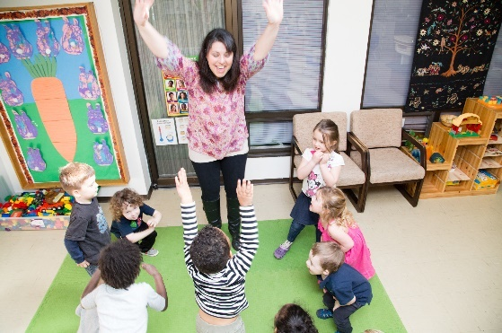

Outdoor Play Area (Active Play) We have a lovely outdoor tree shaded play area that allows us to change the type of play for the season. We use nature to encourage exploration and large motor development. We utilize loose play materials and planned activities for outdoor playtime. 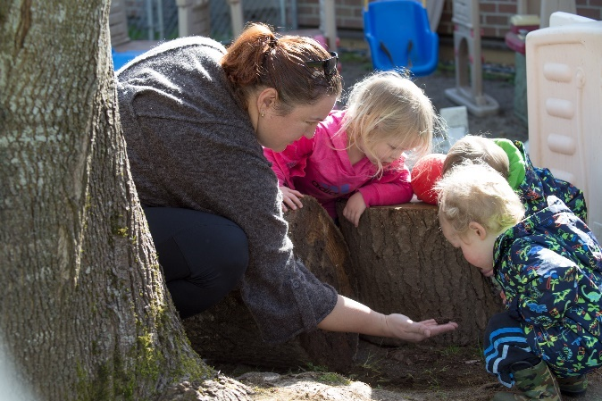

Registration and Fees

Registration is ongoing throughout the year. Children will be placed on a waitlist in order of enrollment, (no fee) and we will inform parents of available space in May for the following term. Priority will be given to siblings of children already enrolled.

Hours of Operation  
The Centre’s operating hours are from 7:30 am to 5:00 pm. Monday to Friday.

Please arrive on time so your child has the most out of his/her playgroup experience.

Please pick children up on time

Programs are as follows:

Morning Only (preschool activities) 9:00-1:00  
2 days $160/month

3 days $200/month

Full day Program (monthly rates include the CCFRI) The Affordable Child Care Benefit is accepted. Parkview Academy has opted into the Child Care Fee Reduction Initiative (CCFRI). 10-month Early Childhood Education Program is available (Sept to June)

**Under three years old**

|  |  |
| --- | --- |
| Full time | $230 |
| 4 days | $230 |
| 3 days | $198 |
| 2 days | $166 |

**Three years old to kindergarten**

|  |  |
| --- | --- |
| Full time | $227 |
| 4 days | $227 |
| 3 days | $211 |
| 2 days | $168 |

Closures

* Our Full Time Early Childhood Education program operate year-round and close all statutory holidays plus Easter Monday, Summer Break is 2 weeks (July 28-Aug 8, 2025) Winter Break (Dec 24, 2024, to Jan 3, 2025)
* Part day program operates from September to June