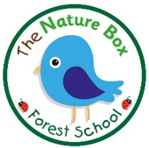
No Smoking Policy
Children’s health and well-being is of the upmost importance to us at The Nature Box. Smoking has proved to be a health risk and therefore in accordance with legislation, The Nature Box operates a strict no smoking policy within its buildings and grounds. It is illegal to smoke in enclosed places.
You are respectfully required to abstain from smoking whilst on the premises. This rule also applies to staff, students, parents, carers, visitors, contractors etc.
Staff accompanying children offsite are not permitted to smoke. We also request that parents accompanying children on outings refrain from smoking whilst caring for the children.
Staff must not smoke whilst wearing uniform as it is essential that staff are positive role models to children and promote a healthy lifestyle. If staff choose to smoke during breaks, they are asked to change in to their own clothing and smoke away from the main entrance.
We respect that it is a personal choice to smoke, although as an organisation we support healthy lifestyles and therefore help staff and parents to stop smoking by:
• Providing information of local help groups
• Providing details of the NHS quit smoking helpline - www.smokefree.nhs.uk

