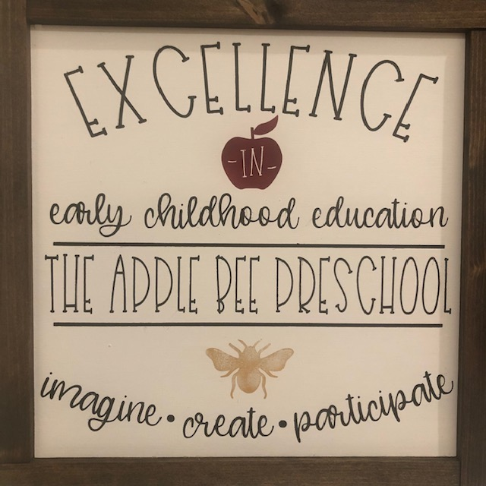
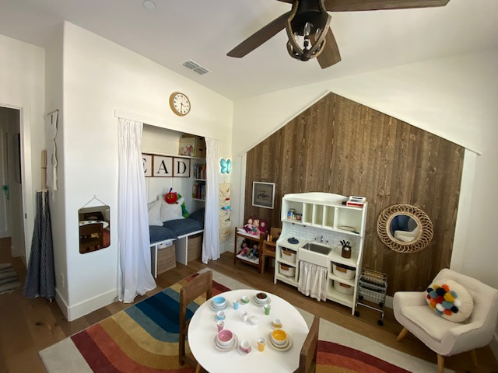
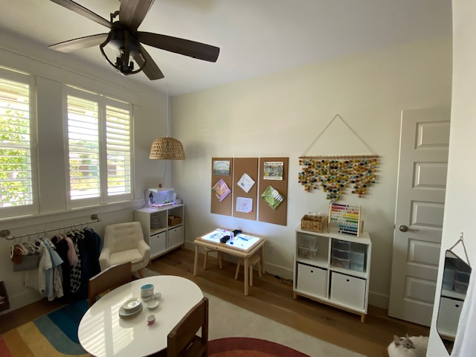
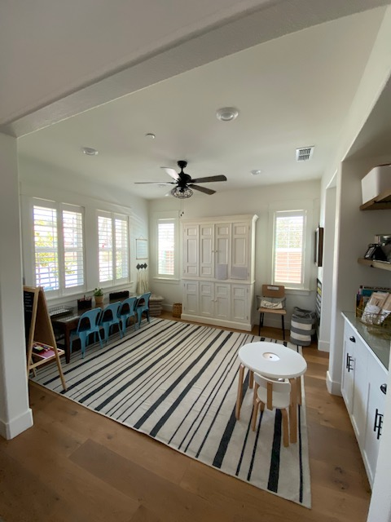
Summer is Coming!

The Applebee Preschool
  - Summer 2021
June 15th will mark Applebee’s first anniversary here in Folsom. It will officially mark the 25th year anniversary of the first day Applebee opened in Menlo Park. I cannot even begin to tell you how grateful I am that your family is a part of the Applebee Community here in Folsom. Leaving Applebee in Menlo Park was one of the hardest things I’ve done. You, putting your trust in me with your children here in Folsom, such a blessing!  This Summer we will “travel” around the world, well because we’ve surely all missed traveling. We will start in Italy and see where that leads us. While in Italy we will make pizza and pasta and learn about some of the most amazing sites to see there. Once we attain some new stamps in our passport’s. After this long trip, we will hit the Pacific Ocean to learn about what lies in the deep blue sea. After we explore the seashore we will dive into the world of Eric Carle. We will learn about his art and stories and even create our own. We will finish off this Summer with a camping trip here at Applebee! We will pitch a tent, make smores and learn what it takes to live outdoors for a few days! We may even catch a fish!  We look forward to spending the summer with your children. Joanie, Alyssa, Savannah and Hannah |  | Starfish are magical…

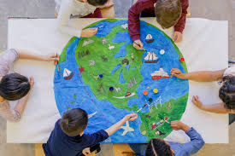 |  | Trip Around the World  Pack your bags as we are headed around the world. From North to South and East to West we will collect some stamps for our passports this summer. First stop is Italy where we will taste pizza, create flags and learn about the amazing history. From there who knows…France, Germany the sky is the limit!
Oceans Galore  Under the sea is where we will be for the next two weeks. We will discover what lies beneath the deep blue sea. We will make ocean playdough, learn about ocean animals, pretend we are at the beach. It will surely be warm enough to splash in some “ocean water” and more! |  | 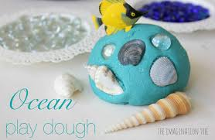
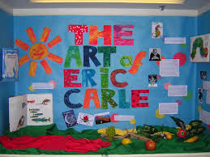 |  | Eric Carle Stories & Art  From “The Very Hungry Caterpillar” to “The grouchy Ladybug,” we will discover the magical world of Eric Carle. We will create our own stories as we read his. We will act out stories and learn what it takes to create a children’s book.
Applebee Camp Out!  Campfires, smores and more. Let’s hit the great outdoors! We will pitch a tent, create a campfire, make smores, learn how to fish and take a nature hike too. Don’t forget your swimsuits and sunscreen as we will surely enjoy some amazing summer weather. |  | 