The Applebee Preschool
2021-2022 Calendar
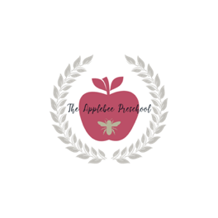
June
1st: First Day of Summer

July:
5th-9th: Closed for Summer Break

August:
2nd: First Day of Fall

September
6th: Closed for Labor Day
9th: Back to School Potluck in the Park

October
29th: Trunk or Treat

November
11th: Closed for Veteran’s Day
24th-26th: Closed for Thanksgiving Holiday

December
20th -31st: Closed for Winter Break

January
17th: Closed for Martin Luther King Day

February
14th & 15th: Closed for President’s Day

March
28th-31st: Closed for Spring Break

April
1st: Closed for Spring Break

May
30th: Closed for Memorial Day

