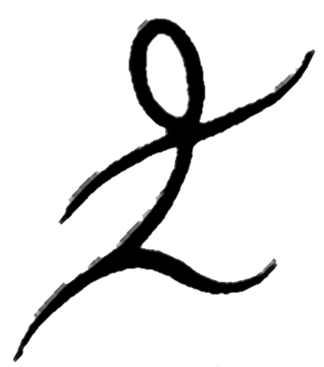
Paula Lynam M.Ed.

Developmental, Family & Educational Support
Supporting the healthy development of children, families & schools through movement, sensory integration, eco-psychology, creativity & therapeutic arts.

DEVELOPMENTAL EXERCISES

These activities follow the natural sequence of the early developmental movements and are most effective when used as an enjoyable daily activity to strengthen the Foundations for Learning.

- FUNNY FISH- on stomach, chin on the floor, arms beside the body, straight legs together, slowly bend sideways at the waist, lifting and turning the head to look at the feet, which slide to the same side; first to one side and then to the other. 3x each side
- TWISTING TADPOLE- on stomach, with arms crossed behind back, wiggle forward with the help of legs and feet, including toes. (Not for older girls 11+)
- CIRCUS SEAL– one or any combination of the following:
(Roll several turns to one side then the other).
- With ball held by hands above head, legs together
- With ball held between knees, hands above or at sides
- With ball held between ankles, hands above or at sides
- With ball held between feet, hands above or at sides
- CATERPILLAR /INCHWORM- on back with arms crossed on chest, legs bent, knees together, feet on floor, carefully inchworm forward pulling with heels against floor, allowing back to arch and flatten, then back, pushing with heels.
- LUMBAR LIZARD- on stomach, chest down, head up, move legs and arms to crawl forward, pushing off with feet and pulling with arms, eyes looking at leading hand. (The correct movement is cross lateral, with full involvement of hands and feet, including pushing off with toes. Avoid correcting the child to begin with. You can assist by placing your hand behind the pushing foot for the child to push off against).
- CREEPING CAT- on all fours, with forearms flat on floor and looking straight ahead, like a cat getting ready to stalk its prey, (a beanbag for example) creep forwards slowly, then backwards ever so slowly, with eyes on the prey straight ahead.
- CRAFTY CRAB- sitting on floor, place hands on floor behind back, lift hips up high and walk on hands and feet, forward, backwards, side to side.

paulailynam@gmail.com * 541.482.5543 * 782 Park Street, Ashland, OR 97520

