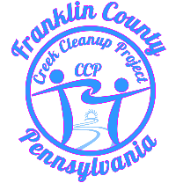 | Creek Cleanup Project  Eric Grace, President  4499 Valley Circle  Fayetteville Pa. 17222  (717) 552-4599
January 3, 2020
Dear Sir or Madam,
My name is Eric Grace and I am the president and founder of the Creek Cleanup Project. We are a local group established in 2017 with one goal in mind, to clean up the waterways of Franklin County.
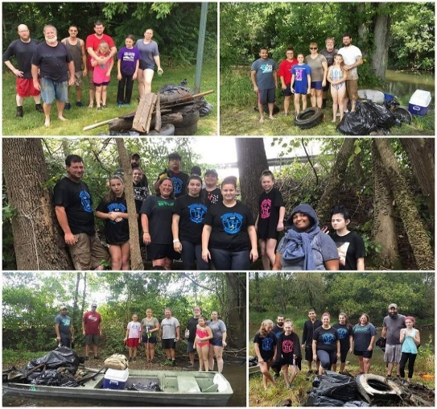
We are not your typical watershed or creek cleanup group, we have taken a very aggressive approach to cleaning up our creeks. In addition to doing monthly group cleanups, there is a very dedicated smaller group of us that go out almost every weekend year-round. We remove everything we find no matter how large or labor intensive; with the use of flat bottom boats, winches/come-a-longs, and a variety of other hand tools we dig and pry every item we find from the creek bed. As you can imagine this is a hard, manual process which takes a toll on our volunteers.
Once we have cleared a section we return every couple of months to maintain it. In 2020 we plan to establish satellite groups that will maintain these sections several times a year. We will deliver all the boats, tools, and supplies needed to clean the section. Once it’s done, we will return to collect everything and dispose of the trash, this is basically the same concept as adopt a highway but rather adopt a creek.
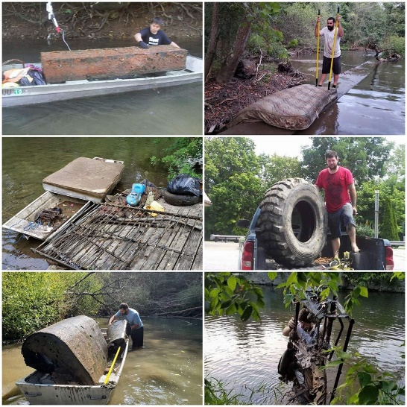
We realized quickly in 2017 that monthly cleanups would not be enough to get our creeks back to their natural state. There are several decades’ worth of trash to dispose of and in most cases, it takes countless hours and months to clean a few miles. Our creeks have been neglected for a very long time and we plan to fix that but we can’t do it alone.
Currently we are the only group in Franklin County working on the Conococheague and we are working hard to cover more area. We have plans to turn a month’s worth of cleaning into weeks. Until now we have relied on individual donations for all our expenses and equipment. Since we have obtained our 501c3 we’d like to ask for your help. With the proper tools, supplies, and equipment we could become more efficient and effective in our mission.
Removing trash and debris from the Conococheague has multiple benefits to all of us and to our future generations. Water quality is improved, safety is increased within stream channels where adult and youth recreational activities occur, aesthetics are enhanced, which leads to natural, economic, and human health enrichment.
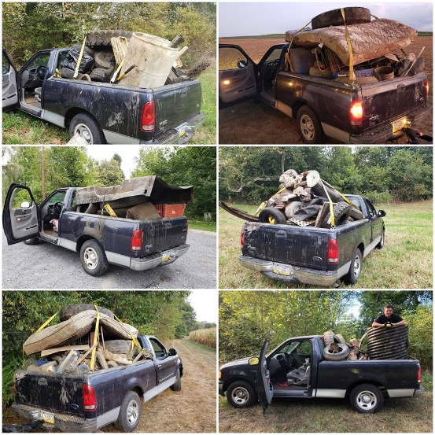
Please consider helping us so that we can transform our local streams and keep them healthy! After all, healthy communities depend upon healthy waterways! Please call me at 717-552-4599 with any questions or for more information.
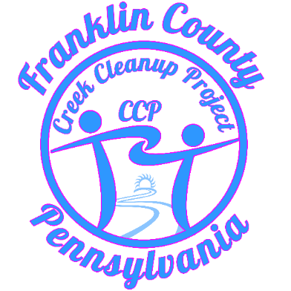

Sincerely,
Eric Grace
President
Creek Cleanup Project

Testimonials

Blyden Potts, Eric has done an amazing job with his CCP group doing stream cleanups and shown amazing initiative in all of it. He has pulled together a team of local volunteers, solicited donations of equipment -- starting with boats to put the trash in -- done the paperwork to make his group a formal 501(c)3 organization, and most of all done a huge number of stream cleanups of the Conococheague to remove debris, trash, and years' worth of accumulated object, some of them quite large.
It seems like his team is doing a cleanup almost every week during warm weather, and even doing some cleanups when the weather is not warm. That is a superlative pace. For comparison, cleanups on the lower Conodoguinet happen about once per month during the warmer months. Cleanups in the Middle Spring watershed typically happen 1-3 times per year.
I've only actually helped him on what I believe was his very first cleanup, but as part of the neighboring Middle Spring Watershed Association (MSWA) I've been following the progress of CCP since it was created, which was less than three years ago, in 2017, and offering what advice I could. In that time, I've been very impressed with the energy, initiative, and ability to involve other members of the community.
Eric really ought to get some civic recognition for this contribution to the community!

Tabatha Witmer. Amazing! To have such a passion for the waterways and continuously clean up trash from fellow humans or the winds is impressive. Great job!
Mary Dellane Case, this is a selfless contribution to our environment. I admire the hard work and the progress that has been made to cleaning up our waterways. Kudos!
Tara Whitsel, I had the pleasure of working with you in October. Even though it was extremely hard work, I can't wait to help again in the spring! It was a lot more than just picking up cans, bottles and other small trash. It really put into perspective the amount of work you have done to keep our creeks beautiful!! Great job to you and everyone involved!!
Kim Devor, While I haven't been out first-hand, I have been following your posts here. You are doing amazing things. I cannot believe there is that much junk in our creeks here in Chambersburg. I would hope all businesses would support you and hopefully you could get some grants to also help! Appreciate all of your efforts.
We have put together a list of suggestions, we don’t mind used items, we are grateful for any and all help we receive.

Vehicles:
- 4x4 Trucks, fleet side, flatbed, 4 doors preferred for hauling volunteer, standard will work just fine,
- Commercial Vehicles, Flatbed, Dump, Rollback, Wrecker, Boom Truck, Box Truck
- UTV-ATV, side by sides and or 4-wheelers to get into the areas where the trucks can’t go.
- Argo 8 wheeled, this would be a game changer for CCP, absolutely the most useful vehicle for our mission.

Trailers:
- Flatbed
- Tandem for hauling equipment.
- Dump
- Box

Boats & Supplies:
- 14’ to 16’ Aluminum Flat bottom Jon Boats, Narrow, Wide, Standard.
- Canoes & Scanoes 16’-17’
- Boat motors, mud motors are best suited for our work but anything from 4hp to 15hp would be suitable for some areas.
- Trolling motors
- Paddles
- Life vests
- Dry bags and Boxes

Tools :
- Trash Pump
- Winches, 4500lbs to 12000lbs
- Straps, chains, snatch blocks.
- Chainsaws
- Chest waders
- Gloves
- Trenching shovels
- Tool Kits
- Fixed Blade Knifes
- Welder
- Torches, acetylene or plasma, we fabricate many of our tools.
- Drill Press
- Miscellaneous power tools, drills, grinders, basic fabrication tools.
Office Supplies
- Pc, Desktop
- Printer/Copier
- Paper Cutter
- Tablet & Case, for meetings and along the creek
- Safe/Fire Box, for files and documents.
- Misc. office supplies
Miscellaneous:
- Inner tubes, taking groups floating the creeks to raise awareness and just learn a new appreciation for our waterways
- First Aid & CPR certification for our staff.

