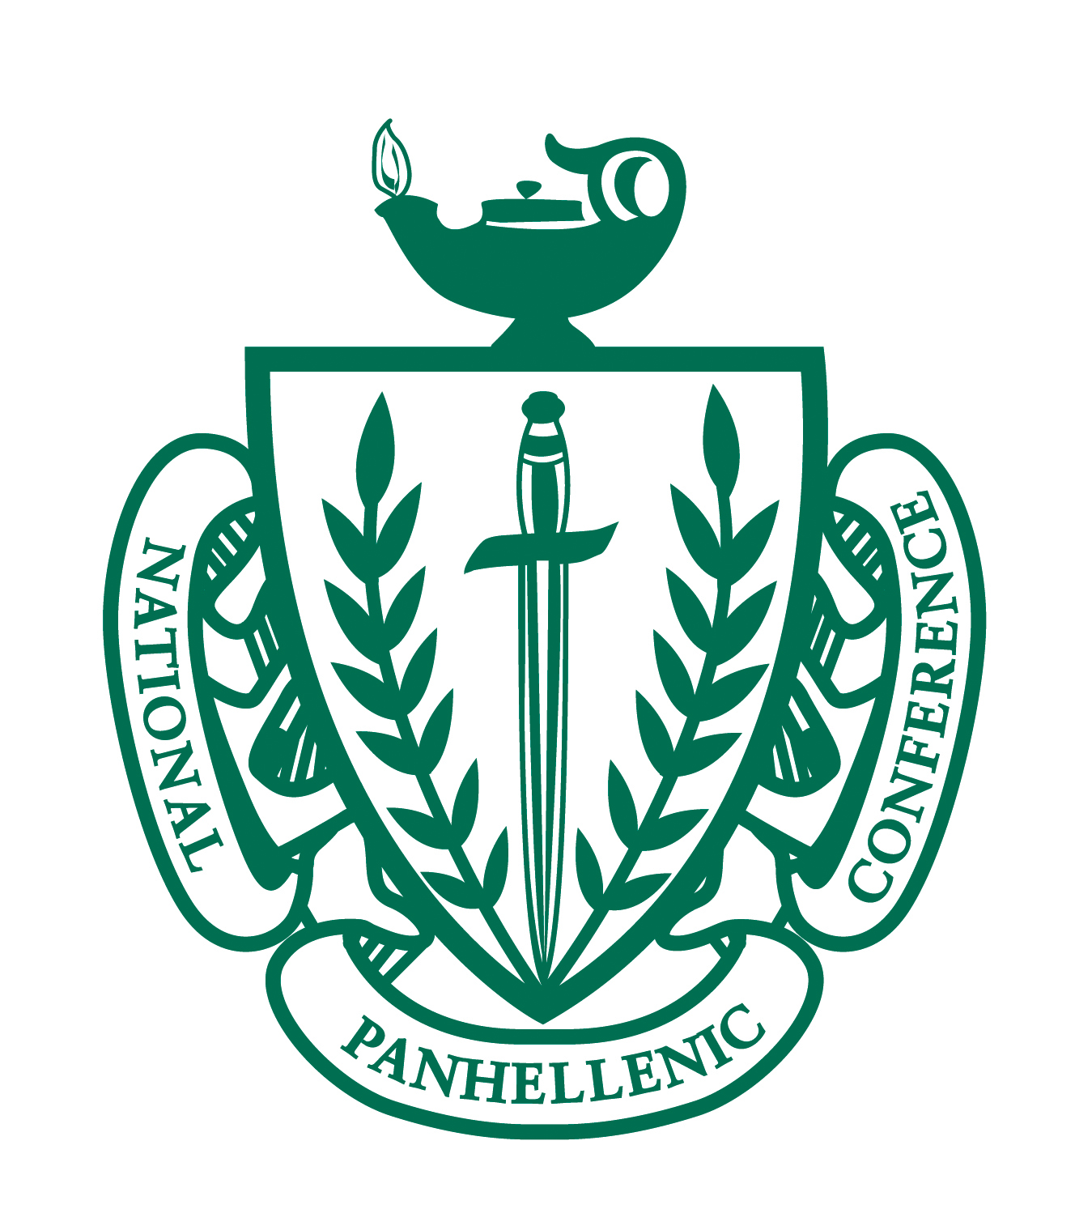

Panhellenic Association of San Antonio

NPC Scholarship

Application for 2021 - 2022 Academic Year

Panhellenic Association of San Antonio is pleased to announce
that a Sorority Collegiate Scholarship will be awarded for the
2021-2022 academic year. Applicants MUST have graduated from a Bexar County High School and be an active sorority member during the Scholarship disbursement period.
The application is attached.

Please note that the postmark/email deadline for the application is
April 15, 2021. Applications should be returned to:

Melanie Brandt
PASA Scholarship Chair
3740 Running Springs
San Antonio, TX 78261

For questions or further clarification, please contact
at
melanie@gvtc.com

1 of 3

Panhellenic Association of San Antonio
NPC Scholarship Application

INFORMATION AND INSTRUCTIONS

For the 2021-2022 Academic Year, Panhellenic Association of San Antonio will grant three $3,000 scholarships to three initiated NPC members from Bexar County attending a four-year college or university. Those attending a college in Texas shall be given preference. Scholarships will be announced in May 2021 and awarded at our annual Scholarship Luncheon.

ELIGIBILITY: Any initiated, active member of a National Panhellenic Conference member sorority with a cumulative GPA of 2.25 or better who is a graduate of a Bexar County high school shall be eligible. All applicants must have been initiated prior to application submission. Selection will be based upon college academic record, sorority involvement, college campus and community activities, candidate’s essay, financial needs, and recommendations submitted.

No high school grades or activities will be considered.

APPLICATION INSTRUCTIONS

A completed application includes the following:

- The completed scholarship application form
- One letter of recommendation from a person who can attest to your sorority, campus, and/or community activities
- Collegiate resume
- An essay not to exceed 500 words on the impact your sorority membership has had on your academic performance and the value that your sorority involvement has added to your undergraduate education
- Transcript(s) of all university academic work. An unofficial copy is sufficient during the application process; the winner will be required to provide an official transcript prior to the Scholarship Luncheon

FOLLOW INSTRUCTIONS CAREFULLY

- All information must be typewritten with complete answers. Applications not typed or complete will NOT be considered.
- Enclose the letters of recommendation, transcript (s), scholarship application, collegiate resume, and essay in one envelope to be submitted to the PASA Scholarship Chairman.
- Alternatively, the required items can be submitted in ONE .pdf and/or .doc via email to the PASA Scholarship Chairman.

SCHOLARSHIP STIPULATIONS

- The recipient must need a consecutive Fall and Spring semester to graduate.
- The recipient must be enrolled full time (12 hours minimum) per semester of scholarship receipt and be working towards completion of a degree. Cumulative GPA must be at least a 2.25, Fall 2020 Semester GPA must be at least 3.00 to receive the Spring semester disbursement.
- The scholarship of $1,500 sent per semester will be mailed directly to the recipient.

RESPONSIBILITY OF THE RECIPIENT

- Submit to the Scholarship Chairman a copy of your official university cumulative grade report including the immediate past semester AND a copy of your university bill (statement of registration fees) for the Fall 2020 semester. Scholarship award will then be mailed directly to the recipient. Every effort will be made for the check to be sent prior to the fall semester, but this cannot be guaranteed.
- Submit to the Scholarship Chairman a copy of your official university cumulative grade report including the Fall 2020 semester AND a copy of your Spring 2021 university bill (statement of registration fees). Scholarship award will then be mailed directly to the recipient. Every effort will be made for the check to be sent prior to the spring semester, but this cannot be guaranteed.

RESPONSIBILITY OF ALL APPLICANTS

Supply all information requested, including the application form, to the PASA Scholarship Chair.
Your application MUST be postmarked/emailed on or before April 15, 2021.

2 of 3

Panhellenic Association of San Antonio
NPC Scholarship Application

Name:

University:

Major:

Sorority: Date of Initiation:

Present Address:

Permanent Address:

Cell Phone:

Permanent Home Phone:

Email:

Anticipated Graduation Date:

High School Graduation Date

University/Collegiate Cumulative GPA:

University/Collegiate Hours Completed:

Applicant’s Certification:
I have examined this application and certify that all information given is complete and accurate to the best of my knowledge. I have attached all required documents. I have read the scholarship stipulations and recipient’s responsibilities.

Signature: Date:

Please provide the following information:

1. Attach a resume of your activities including significant contributions to your sorority, college campus activities, community service, organizational memberships, offices held, and honors and recognitions received.

2. Write a brief essay of 500 words or less on the impact your sorority membership has had on your academic performance and the value your sorority involvement has added to your undergraduate education. Please attach the essay to this scholarship application.

3. Enclose letter of recommendation and transcript(s).

Your application MUST be postmarked or emailed on or before April 15, 2021.

3 of 3

