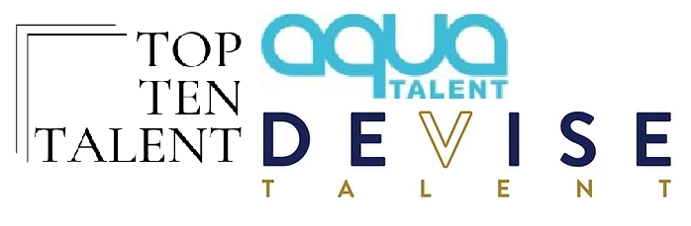
Michael Joseph Pierce
SAG-AFTRA
Height: 5’ 10.5”
Weight: 265
Top Ten Talent
Management
817.415.8917
Aqua Talent Agency
Los Angeles
310.859.8889
michaelpiercesd@gmail.com

Devise Talent Agency
Southeast
919.949.5607
Devise Talent Agency
Southeast
919.949.5607

TELEVISION (selected)
Coercion pilot Co-Star wiip Studios/ Showtime/ Dir: Susannah Grant
Harry Potter: Hogwarts Tournament of Houses Self Warner Media/ The Old School
Americas Most Wanted: Palmer Case Co-Star Fox Entertainment/ Dir: Ashley Gorman
American Gangster: Trap Queens Co-Star A. Smith & Co. /CCCD Prod./ Dir: Chris Dvoracek
Believers Guest Star Karga Seven, Travel Channel/ Dir: Clint Lealos
Murder for Hire Co-Star Wolf Films, Shed Media/ Dir: Jeff Venditti
People Magazine Investigates Guest Star/Co-Star Finch Prod., Discovery ID/ Dir: Stephen Schuster
Killing Time Guest Star Karga Seven, Discovery ID/ Dir: Clint Lealos
Declassified Co-Star CNN/All3 Media America/ Dir: Domini Hofmann
Very Important Person Co-Star HOT TV/ Dir: Shirli Mushoyef
Nuremberg Trials pilot Guest Star Karga Seven/ Dir: Kelly McPherson
Unusual Suspects Co-Star Discovery ID/ Dir: Robert M. Wise
Killing Time pilot Guest Star Karga Seven/ Dir: Doug Glover

NEW MEDIA
A Barman’s Aperitif Series Regular Four Dogs Production Company
Wicked Enigma Recurring Uh-Mysterious Productions/ Dir: Jake Doull
Confessions Series Regular Serrano Studios/ Dir: Ernest Serrano

FILM (selected)
Dognapped: Hound for the Holidays Supporting Hybrid / Dir: Fred Olen Ray
Unfrosted Supporting Netflix Studios / Dir: Jerry Seinfeld
Road to Terzetto Supporting Sandcastle Prods. LLC / Dir: Brian Shakti
A Lions Game Lead Brow Town Studios/ Dir: Travis Demarus Brown
New York State of Mind Lead Serrano Studios/ Dir: Philip Thornton
Catch the 57 Lead Falcon Pictures/ Dir: Ernest Serrano
Regionrat Supporting Grimester Pictures/ Dir: Javier Reyna
Gemini Supporting Film Science/ Dir: Aaron Katz

SHORT FILM (selected)

Year of the Rat Supporting Rush Hour Productions / Dir: Ricky Qi
Ruby’s Dad Supporting CSNU/ Dir: Joshua Zollo
Lloyd Supporting Antoinette Films/ Dir: Trae Whyte
The Little Blue Pill Lead Par 6 Productions/ Dir: Andrew Geisler
The Bail Out Supporting Black Vault Entertainment/ Dir: Christian Guiton
No Teeth Lead SDSU Film/ Dir: Benjamin Howard

MUSIC VIDEO (selected)

Pink Shabab ‘Run Away’ Lead Dir: Goldwing

Baby Keem/Travis Scott ‘Durag Activity’ Lead Dir: Eliel Ford/Simian.LA
Matoma, MNEK, Kiana Lede ‘Bruised Not Broken’ Lead Dir: Jeff Desom & Carlos Lopez Estrada
Machine Heart ‘Let You Down’ Lead Dir: Nathan Presley
Florian Picasso ‘This is our Time’ Lead Dir: Richard Selvi
Waterparks Band ‘Stupid For You’ Lead Dir: Ernie Gilbert

COMMERCIAL/INDUSTRIAL/PRINT/THEATER/VO (Available Upon Request)

TRAINING

The BGB Studio Acting Corey Parker / Los Angeles, CA
The Rehearsal Room Actors Studio Acting Carey Scott / San Diego, CA
American Academy of Dramatic Arts Acting Los Angeles, CA

SPECIAL SKILLS

Chef, Bartender, English Dialect, Southern Dialect, New York East Coast Dialect, Roller Skating, Bicycle, Snow Ski, Stick Shift, Dog Walker

