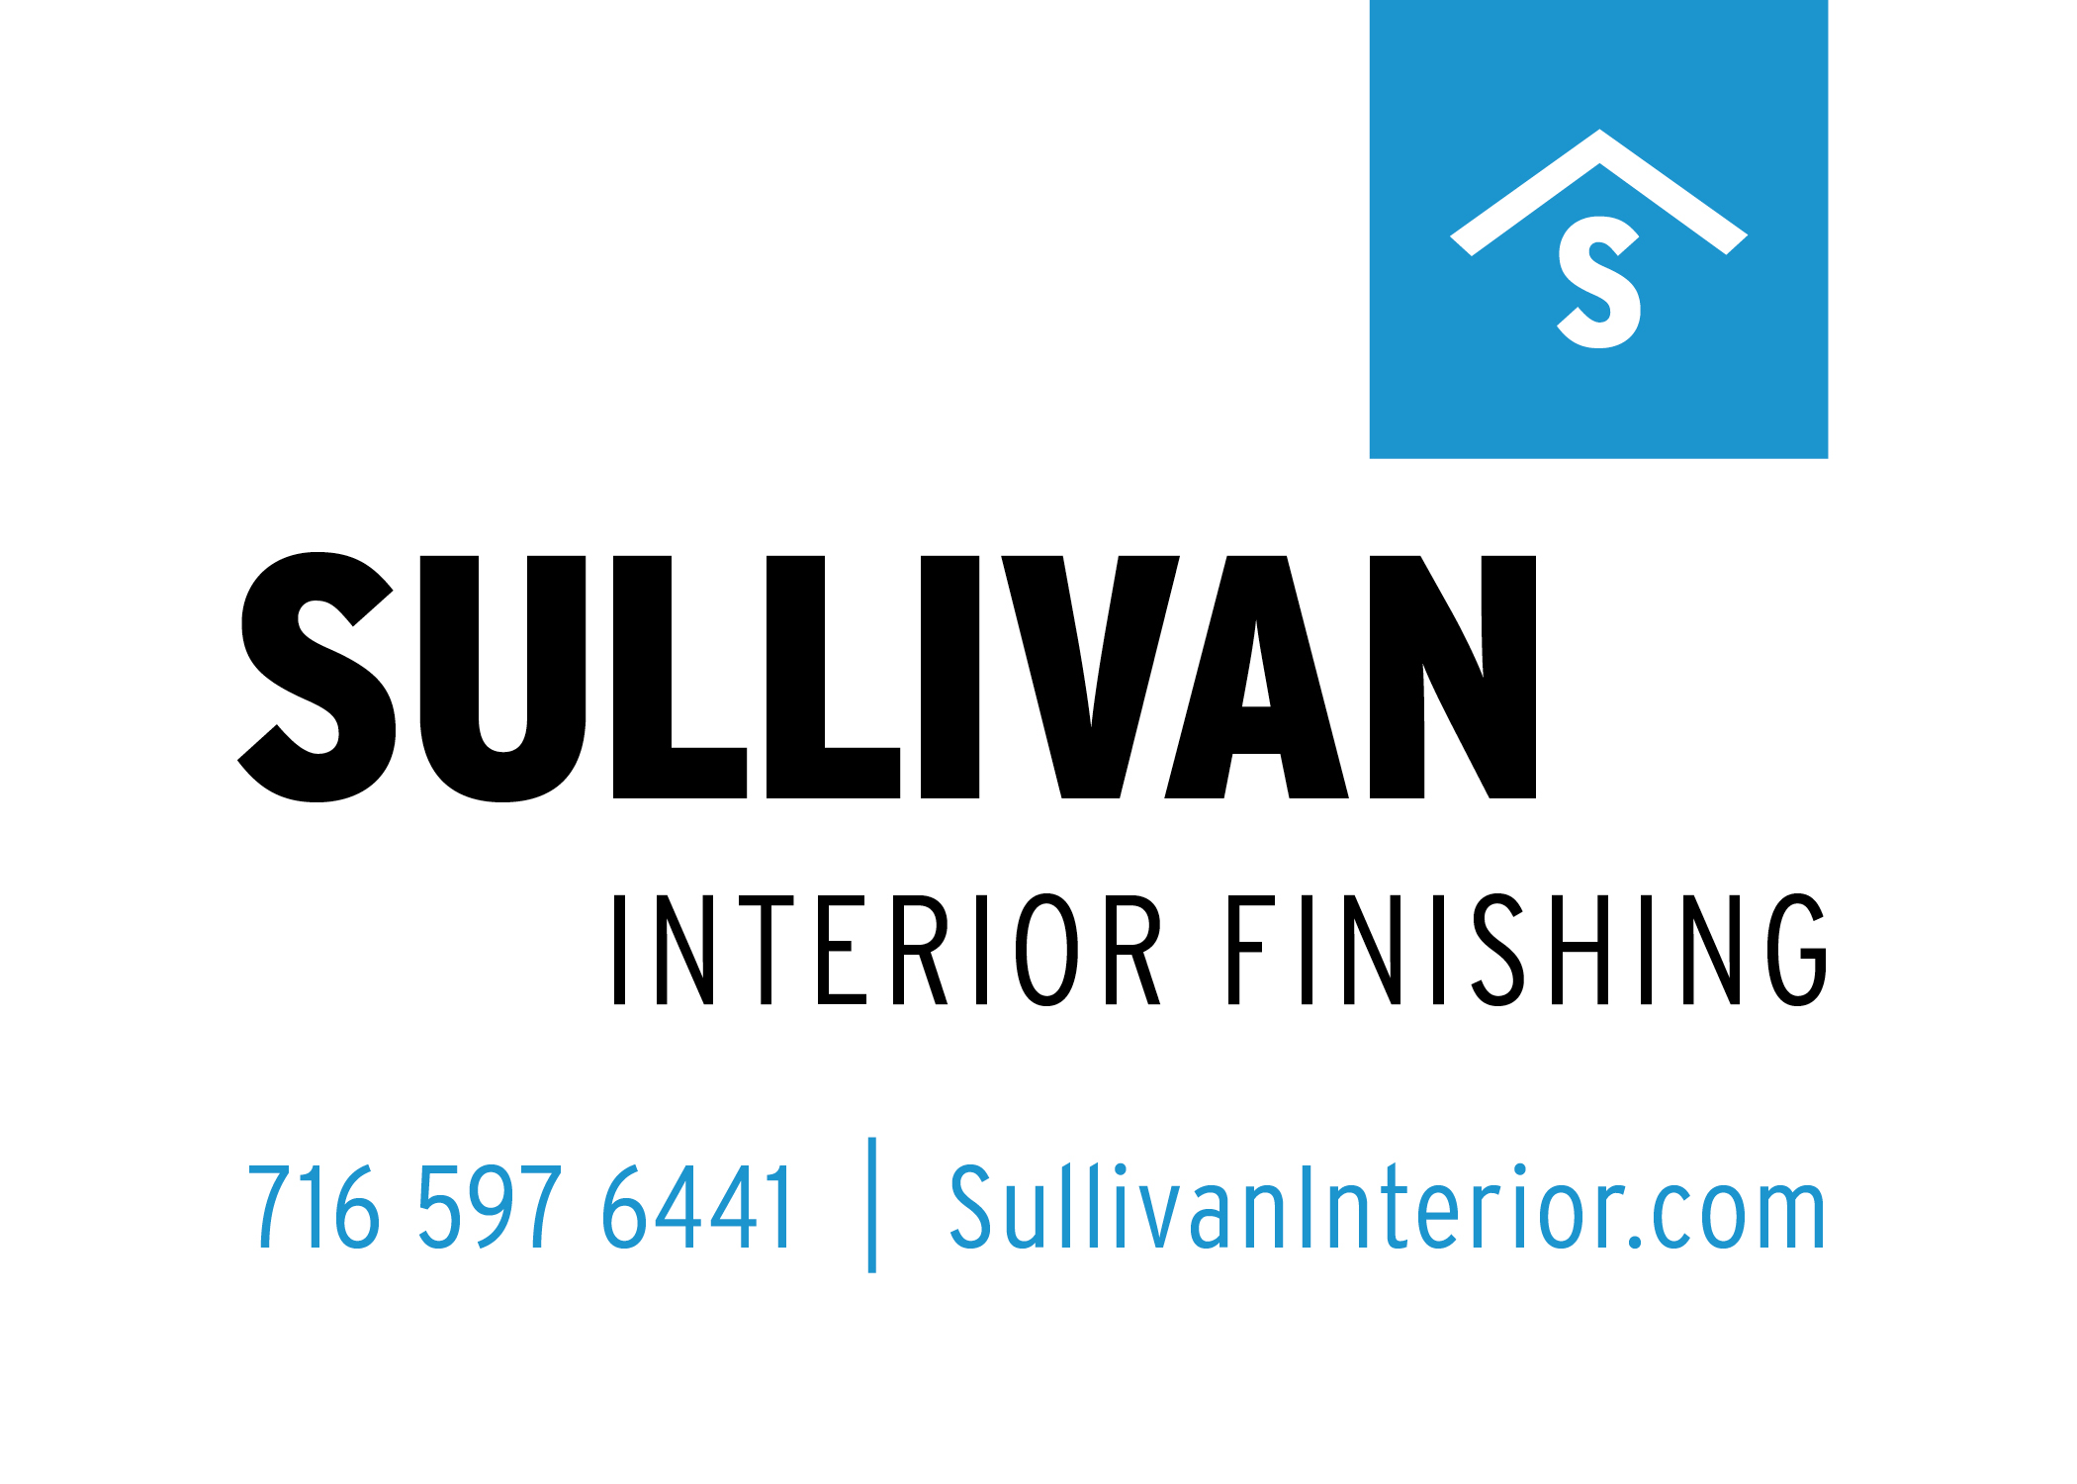
To our Prospective Customers,

Thank you for reaching out to Sullivan Interior Finishing! We’re a small firm and involve ourselves in a limited number of projects each year. Each project that we take on must fit the strengths and focus of our company in order to best serve our clients. We strive for quality craftsmanship, consistent communication, and trust. Please take a few minutes to fill out the following. Not every contractor is good fit for every client – this document helps determine if we would be a good fit for your needs.

Questions:

Name:

Email:

Phone:

What is the address of where the project will take place?

Tell us a little about the scope of the work that you want completed.

What is your budget for the project? A range is fine. (We ask this right away so that we can determine if the scope of work can fit within a realistic budget)

What is your projected timeline? Do you have an ideal or necessary start date? Necessary completion date?

Which is your driving factor when searching for a contractor? Please choose and explain. There is no wrong answer

Cost – As in, you are looking for the lowest possible cost to complete the project

Quality – As in, you are looking for a contractor that can create a high quality product, but will cost more

Timing – As in, you need someone who can start the project by a certain date – the sooner the better

Do you have any architectural or designer plans already completed? Are you working with anyone?

Have you remodeled a home before? How large of a project was it? What was the experience like? What was the best part of the experience? The worst part?

How did you hear about Sullivan Interior Finishing and what do you already know about our company?

Miscellaneous comments?

