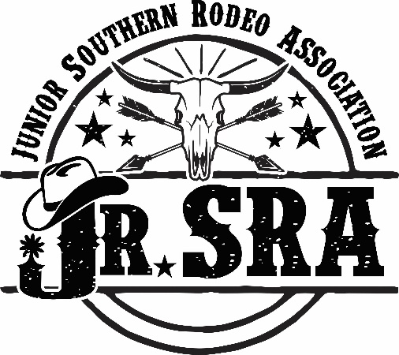

Jr. Southern Rodeo
Association
2026
SPONSORSHIP PACKET

Junior Southern Rodeo Association
WWW.JRSRARODEO.COM

|
531 Gilliland Rd. Siler City NC 27344

AbOuT THE JR. SOuTHERN ROdEO ASSOCIATION
The Junior Southern Rodeo Association is one of the largest youth rodeo associations in the United States. The Jr. SRA was established in the 1950’s as a “youth division” of the Southern Rodeo Association (SRA).
The Jr. SRA and SRA are the oldest rodeo associations east of the Mississippi and throughout the years, generations of families have competed and started their rodeo career with the Jr. SRA.
The Jr. SRA takes great pride in providing our young athletes with a platform to learn values, sportsmanship, and improve their rodeo skills to advance on to National, Collegiate, and International Events. Several World Champions got their start competing in the Jr. SRA.
Champions such as: JB Mooney, Jerome Davis, Robert Lloyd, Luke Brown, Boyce Knox, Codi Baucom, Corey Atwell, Adam Plyer, and Cory Kidd. In order to keep this tradition alive and continue to provide rodeos for our youth, we need the generosity and support from the community and sponsors.
We would like to ask for you to consider becoming a 2026 Jr. SRA Corporate Sponsor. As a sponsor, you will receive positive media exposure with your affiliation with the Jr. SRA, a 501 (c) (3) organization. With your generosity, the Jr. SRA will continue to fund rodeos, provide year-end awards to reward our young athletes for their hard work and dedication, as well as provide a strong rodeo foundation that will encourage our youth to move on to Collegiate and/or National Circuits.
We have enclosed a detailed sponsorship proposal for you to review. If you are interested in becoming a Jr. SRA sponsor, please complete the sponsorship form and email it to
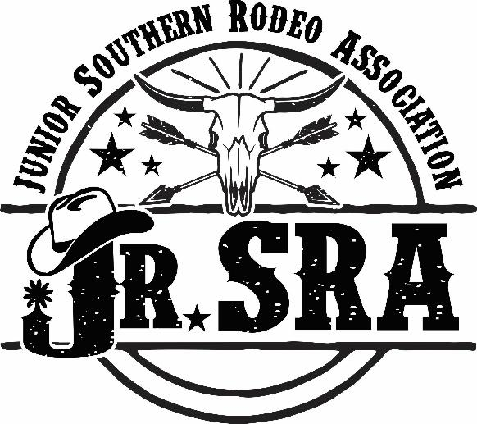
secretary@jrsrarodeo.com. If you have any questions or would like more information, please feel free to contact us.
Sincerely,
Jr. Southern Rodeo Association Board of Directors secretary@jrsrarodeo.com
919-548-7628

AbOuT OuR ROdEO EvENTS
The Jr. Southern Rodeo Association puts on an average of 12 rodeos each year and a 3-day championship finals rodeo at the end of the season. Contestants competing, range in age from 4 to 18 years old. Our rodeo events are broken down into divisions by age group.
Our Pee Wee Division Events are for contestants 4 to 8 years old. A simple foundation for our younger contestants to learn the rules and start to gain experience needed to be successful in their chosen rodeo events.
- Pee Wee Division Events are: Mutton Busting, Pee Wee Goat Tying, Pee Wee Barrel Racing, and Pee Wee Pole Bending.
Our Junior Division Events are for contestants between the ages of 9 and 13 years old. The junior events are designed for our middle age contestants to perfect their skills in a more competitive environment.
- Junior Division Events are: Jr. Boys Calf Riding, Boys/Girls Jr. Breakaway Roping, Jr. Girls Barrel Racing, Jr. Girls Pole Bending, Boys/Girls Jr. Goat Tying, Jr. Boys Chute Dogging, Team Roping
Our Senior Division Events are for contestants from 14 to 18 years old. The senior division is designed to help our older contestants gain more experience in a fast-paced competitive environment and get the ready for the professional and adult rodeo circuits.
- Senior Division Events are: Calf Roping, Chute Dogging, Team Roping, Bull Riding, Sr. Girls Barrel Racing, Sr. Girls Pole Bending, Sr. Girls Breakaway Roping, Sr. Girls Goat Tying.
Each rodeo offers an excellent opportunity for our sponsors to be recognized by our members as well as the community. Sponsors will have their company banner displayed at each rodeo event, announcement will be made for each sponsored rodeo event, website link to company from our organization’s website, ad space in our Championship Finals Rodeo Program, as well as name recognition on sponsored awards presented to contestants at finals and/or our year-end award banquet.
Please help us keep our rodeo tradition alive and take a moment to review the different sponsorship levels that meet the needs of your company. Please do not hesitate to contact us if you have any questions.

buCKlE AwARd SPONSORSHIP

Event Sponsor $800
- Four (4) Jr. SRA Year End Event Awards \
(Champion Buckle, Reserve Champion Buckle, plus 3rd & 4th place awards)
- Company’s Banner displayed at all rodeo events (Sponsor Provides)
- Half (1/2) page ad in Year-End Championship Finals Rodeo program and will be recognized as a sponsor in Rodeo Finals Program
- Company’s logo with link to company’s site on our organization’s website
- Two (2) tickets to Year-End Awards Banquet and get pictures taken with contestant winning event sponsored awards

Go-Round Sponsor $600
- Three (3) Jr. SRA “Go-Round” buckles which will display company’s name on buckle and be awarded during the Year-End Championship Finals Rodeo
- Company’s Banner displayed at all rodeo events (Sponsor Provides)
- Half (1/2) page ad in Year-End Championship Finals Rodeo program and will be recognized as a sponsor in Rodeo Finals Program
- Two (2) tickets to Championship Finals Rodeo per day and get pictures with contestants winning event sponsored awards

Average Buckle Sponsor $200
- One (1) Jr. SRA Finals Average Winner Buckle
- Quarter (1/4) page ad in Year-End Championship Finals Rodeo program and will be recognized as a sponsor in Rodeo Finals Program
- Two (2) tickets to Year-End Awards Banquet and get pictures taken with contestant winning event sponsored awards
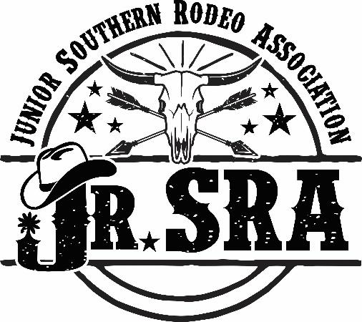

2026 Jr. SRA Sponsorship Form
Thank you for your generosity and your support of the Jr. Southern Rodeo Association. Please fill out the form and submit to your Jr. SRA Board Representative, or mail form with check to the address listed below. If you have any questions, please do not hesitate to contact us.
Company:_____________________________________________________________________
Address:______________________________________________________________________
City:____________________________State:______________Zip:________________________
Contact Person:________________________Phone #:__________________________________
Email:________________________________Website:_________________________________
Sponsorship Level
Please choose the following sponsorship level:

Buckle Sponsor Levels | “X”
Event Buckle Sponsor ($800)
Go-Round Sponsor ($600)
Average Buckle Sponsor ($200)

Each sponsor level comes with an advertisement page in our Yearly Finals Rodeo Memory Program Book. The following information is needed for your ad page:
- Please submit all images, logos, and/or text to make ad page or a completed ad.
- The dimensions needed for the following ads are needed:
Full Page 1700 pix wide x 2200 pix high/8.5” x 11” in 300 dpi or higher.
Half Page 1700 pix wide x 1100 pix high/ 8.5” x 5.5” in 300 dpi or higher.
Qtr. Page 1700 pix wide x 550 pix high/ 8.5” x 2.75” OR 825 pix wide x 1100 pix high/4.125” x 5.5”
- Please scan or take a close up picture of this form and email a copy of this form with your ad information to secretary@jrsrarodeo.com
****If you are submitting a completed ad for the program, please only a submit a PDF or jpeg of ad. If you need an ad created for you, please submit a word doc file with images, logo, and text information. Please do not submit any other file forms.
Any questions, please contact Stephanie Lowry at secretary@jrsrarodeo.com.
Important Information
**Please make a copy of this form for your records.
***Send completed form with sponsor check made out to JRSRA and mail to:
Address: JRSRA 531 Gilliland Rd. Siler City, NC 27344 Phone: 919-548-7628

