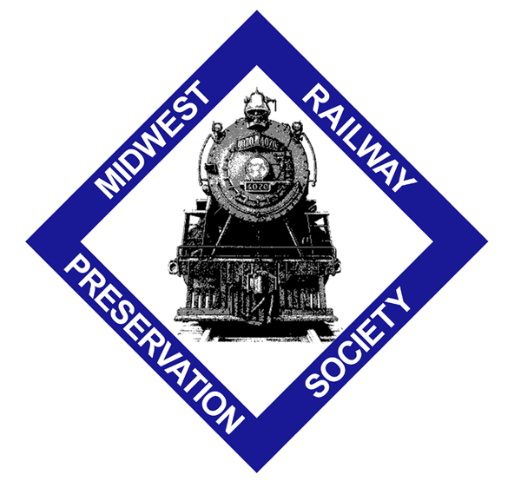 | Midwest Railway Preservation Society  Gift Membership Application  (Members must be at least 18 years of age)

Date _________________
Member’s Name (gift recipient) ______________________________________
Address ________________________________________________________
City ____________________________ State ________ Zip ______________
Home Phone ___________________ Other Phone ______________________
E-mail address: __________________________________________________

This gift membership is from:
Name __________________________________________________________
Address ________________________________________________________
City ____________________________ State ________ Zip ______________
Home Phone ___________________ Other Phone ______________________
E-mail address: __________________________________________________
1. Where would you like us to send the membership card and information packet?
_____ Send it to me _____ Send it to the gift recipient
2. If sending it directly to the gift recipient, do you want us to acknowledge your name in the Welcome Letter? _____Yes _____No (It’s a surprise…)

Please check a membership level below:
_____ Regular Membership: $35 per person, per year
_____ Senior (55+) Membership: $30 per person, per year
_____ Benefactor Membership: $100 or more per person, per year
_____ Platinum Membership: $500 or more per person, per year

I have also included an additional tax-deductible contribution of $ ___________
Midwest Railway Preservation Society is a 501(c)(3) not-for-profit organization
Please send your application and a check made payable to:

Midwest Railway Preservation Society
MRPS Membership
2800 West Third Street
Cleveland, OH 44113

09/11

