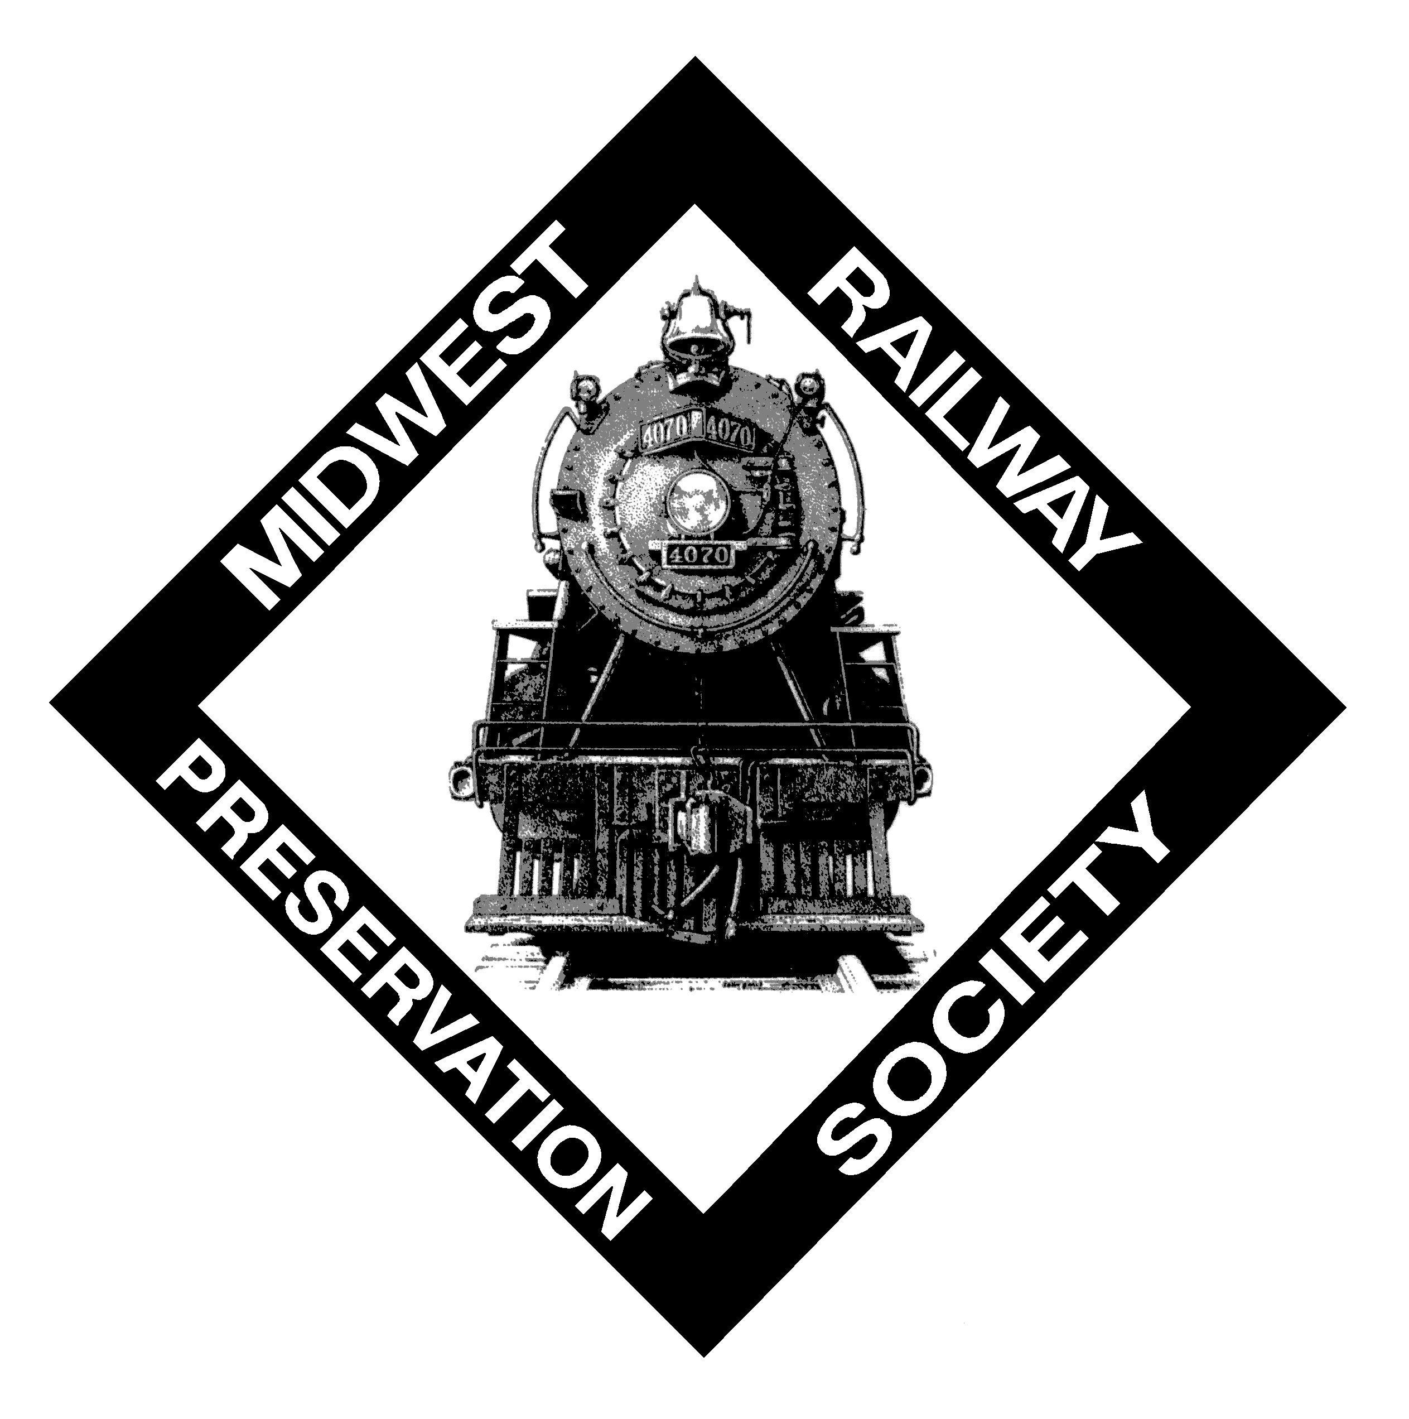 | Midwest Railway Preservation Society  Membership Application  (Members must be at least 16 years of age with Parents consent)

Date _____________________
Name ___________________________________________________
Address _________________________________________________
City ____________________________________________________
State _________________________ Zip ______________________
Home Phone _________________ Other Phone__________________
E-mail address: ___________________________________________

To volunteer, please circle your area(s) of interest:

- Administration  - Newsletter  - Open Houses | - Public Relations  - Fund Raising  - Excursions
- Locomotive & Train Car Restoration
- Building & Grounds Maintenance
- Support Vehicle Maintenance
- Other ___________________________________________
- Special Skills: ____________________________________

Please check a membership level below:

_____ Regular Membership: $45 per person, per year
_____ Senior (55+) Membership: $40 per person, per year
_____ Family Membership: $60 per household, per year
_____ Benefactor Membership: $100 or more per person, per year
_____ Platinum Membership: $500 or more per person, per year
I have also included a tax-deductible contribution of $ ____________
Midwest Railway Preservation Society is a 501(c)(3) not-for-profit organization
Please send your application and a check made payable to:

Midwest Railway Preservation Society
MRPS Membership
2800 West Third Street
Cleveland, OH 44113

09/11

