What is the Endowment Fund?
The Endowment Fund enables you to make a gift, or gifts, of cash, securities, or property that will sustain GFWC Virginia today, tomorrow and into the future. This perpetual fund will assure donors that their financial support will be extended beyond their lifetime.

How will the fund be used?
All income generated by the Endowment Fund will be used for the operation of the organization and for the promotion of its programs.

How will the fund be managed?
The Endowment Fund is administered and managed by the Endowment Committee. The membership of this committee is comprised of the GFWC Virginia Executive Committee, GFWC Virginia Budget and Finance Chair and the GFWC Virginia Endowment Fund Chair. The Endowment Committee is responsible for the management, investment and transfer of all funds and properties comprising the Fund.

How can I contribute to the Endowment Fund?
Gifts may be in the form of cash, Bequests by Will, Life Income gifts and Life Insurance Proceeds. If the gift is to honor, or pay tribute to the memory of a member, special recognition in The Virginia Clubwoman. Certificates for “In honor of…” and “In memory of…” are available free of charge from GFWC Virginia.

Where do I send my contributions?
Contributions to the GFWC Virginia Endowment Fund may be sent directly to GFWC Virginia, P.O. Box 8750, Richmond, Virginia 23226, or via PayPal – headquarters@gfwcvirginia.org.

All contributions are tax deductible.


What is the Dogwood Society?
Established in 2001, The Dogwood Society encourages ongoing endowment investment and principal growth. It is the designated fundraising campaign for the GFWC Virginia Endowment Fund.

How is this accomplished?
Clubwomen join the Dogwood Society and receive a dogwood pin reflecting their membership level.

What is the Dogwood Pin?
The pins are enameled pins in the design of a dogwood flower with the center stone (simulated gems) representing the different levels of giving.

What are the levels?
Topaz $250
Ruby $500
Blue Sapphire $1,000
Pink Sapphire $1,500
Amethyst $2,000
Emerald $2,500
Diamond $5,000

After the initial $250 contribution, the other levels are cumulative contributions.

Tell me more about joining the Dogwood Society.
Clubwomen may join the Dogwood Society by making a single contribution or participating in a payment plan. The information about the payment plan is in the yearbook or can be obtained by contacting the Endowment Chair at endowment@gfwcvirginia.org.
GFWC VIRGINIA ENDOWMENT CONTRIBUTIONS AND DOGWOOD SOCIETY MEMBERSHIPS

Name of Donor: _____________________________________________________________

Gift in Memory or in Honor of: ____________________________ Amt

Address of Donor: _____________________________ City ___________________State________Zip _______

Address where acknowledgement will be sent:

__________________________________ City ___________________State________Zip _______
Is there special recognition for Dogwood Society Members?
In addition to the honor of wearing the pin, Dogwood Society members are recognized in The Virginia Clubwoman and at the annual GFWC Virginia convention.

1907 Society
The 1907 Society, named for the year GFWC Virginia was organized, was established in 2011 to preserve our federation through the endowment fund. Since 2014, the 1907 Society funds have been used to support annual operating expenditures. This is a yearly membership. Members are entitled to special buttons and recognition at Annual Conventions.
General Federation of Women’s Clubs
of
Virginia


Endowment
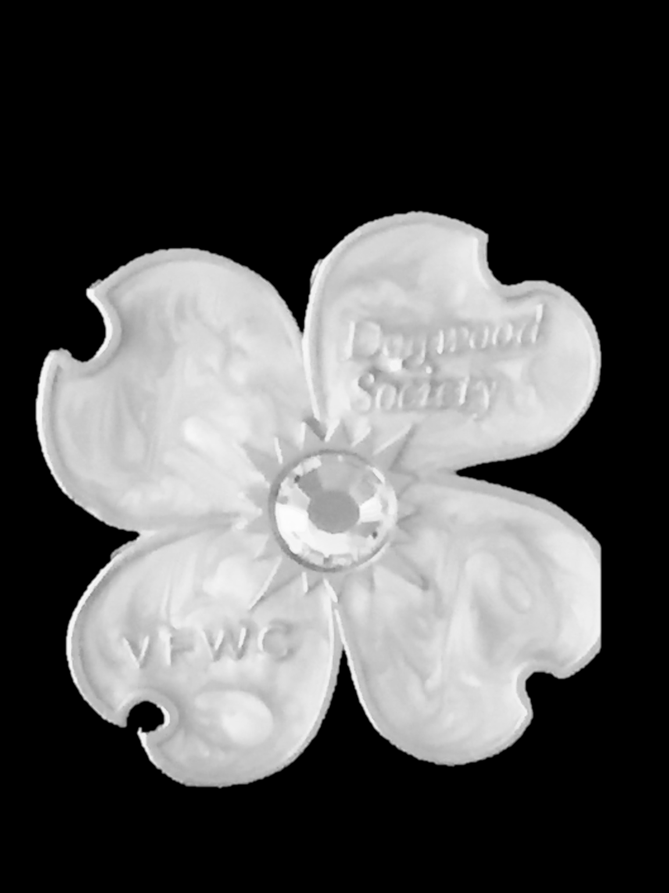
Fund
Dogwood
Society

