GFWC VIRGINIA LEADS

Leadership Education And Development Seminar

Objective: To identify GFWC Virginia members who have the potential to assume leadership positions beyond the club level and provide them with skills, confidence and commitment to become future Federation leaders.

Leadership is the key to building membership, preserving organizational continuity, enhancing image and identity and maintaining sound fiscal policies. The GFWC Virginia Leadership Education and Development Seminar (LEADS) is designed to develop, nurture and sustain a broad and deep pool of capable GFWC Virginia leaders well into the future. The program was initiated in 2007 for the purpose of finding, training, and encouraging clubwomen at the grassroots level to step up, pursue and accept leadership opportunities at all levels of Federation.

GFWC Virginia LEADS is held during the odd year of an administration in August. It is a full day (9am to 5pm) of activities, including lunch. The GFWC Virginia LEADS agenda may include:
- Presentations on conflict resolution and mediation; public speaking; time management; parliamentary procedure.
- Explanations of GFWC resources, programs, materials, assistance.
- Discussions on GFWC policies, protocol, parliamentary law.
- Tips and techniques for pursuing leadership opportunities.

GFWC Virginia is committed to supporting participation in GFWC Virginia LEADS by defraying part of the Seminar expenses. However, a registration fee will be expected from participants to cover the balance of those expenses.

GFWC Virginia, Districts and Clubs are responsible for promoting GFWC Virginia LEADS. Each District is responsible for distributing and soliciting applications, establishing a selection process, and selecting up to five participants to represent their District. Additional participants will be allowed from each District as space and supplies allow on a first come, first served basis. Each participant is asked to be responsible for a portion of their expenses as an affirmation of their personal commitment.

To Apply: By May 15, 2025, copy and submit to District President the Virginia LEADS Application Form found on the next page. An electronic copy is available on the GFWC Virginia website.

Deadline for District Presidents to turn in selected participant names, with contact information, to GFWC Virginia Headquarters (gfwcvirginia@verizon.net) and to Jenny Hinegardner, GFWC Virginia LEADS Coordinator (leads@gfwcvirginia.org) is June 15, 2025. Applications shall stay with the District President.

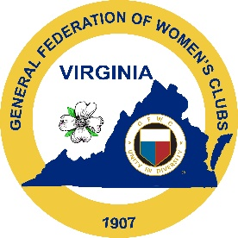 | GFWC VIRGINIA LEADS  PARTICIPANT APPLICATION  August TBD, 2025  TBD | 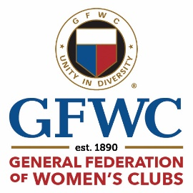

Name:
Address:
Phone: |  |  |  | Email:
Club: |  |  |  |  | District:

List all District offices and/or chairmanships held*

List GFWC club/district/state programs/projects in which involved:*

List positions at district/state/national level in which you are interested:*

Are you willing to:

Defray costs to attend GFWC VA LEADS not covered by GFWC VA? Yes ___ No___

Return to District and Club and share what you have learned at VA LEADS?

Yes ___ No ___

Deadline for submission is May 31, 2025. Applicants will be accepted on a first come, first served basis at the discretion of the District President and LEADS Coordinator.
*If more space is needed, please attach additional pages.
Return this form to: Your District President

