Waiver and release of liability

Because physical exercise can be strenuous and subject to risk or serious injury, even death, we urge you to obtain a physical examination from a doctor before using any exercise equipment or participating in any exercise activity, training, or coaching. You agree that by participating in physical exercise or training/coaching activities, you do so entirely at your own risk. Any recommendation for changes in diet including the use of food supplements, weight reduction and/or body building enhancement products are entirely your responsibility and you should consult a physician prior to undergoing any dietary or food supplement changes. You agree that you are voluntarily participating in these activities and use of facilities and premises and assume all risks of injury, illness, or death. We are also not responsible for any loss of your personal property.

I understand and agree that neither Red Line Personal Training nor it’s owners, operators, agents, instructors, trainers, coaches including but not limited to contracted trainers and/or contracted instructors, may be be held liable in any way for any occurrence in connection with my physical fitness and performance, which may result in injury, death, or damages to me or my family, heirs, or assignees. I further acknowledge and forever release Red Line Personal Training, its owners, trainers, instructors, coaches, and contractors in connection directly or indirectly with my physical fitness, training, and therapy as a result of Red Line Personal Training, owners, trainers, instructors, coaches, and contractors own negligence, which may result in injury, death or damages to me or my family, heirs, or assignees.

Please initial that you have read and understand the above section__________

(parent or guardian initials if under 18)

I, ___________________________________, through the purchase of membership, training sessions, physical classes or online classes, have agreed to participate voluntarily in a program of physical exercise, including, but not limited to, strength training, flexibility development, aerobic exercise (“activities”), and high intensity training, under the guidance of Red Line Personal Training, it’s authorized agents, employees, and contractors.

Please initial that you have read and understand the above section____________

(parent or guardian initials if under 18)

I understand and am aware the activities, including but not limited to the use of equipment, property, group exercise, private trainings, small group trainings, and/or online training, are potentially hazardous activities. I acknowledge the possibility that injuries and physical and mental changes (injury and changes) arising during and/or resulting from engaging in activities does exist. Injuries and changes include, but are not limited to abnormal blood pressure, fainting, disorders in heartbeat, heart attack, and , in some instances, death. I understand injuries and changes could result in my becoming partially or totally disabled and incapable of performing any gainful employment or having a normal social life. I am voluntarily participating in activities and using equipment with the knowledge of the dangers involved. I understand and take sole responsibility for any and all injuries and changes that may occur to myself and/or others, including but not limited to trainer/instructor, related to any and all activities associated with trainer/instructors instruction, even if not specifically set fourth in this document, whether or not they fall with in the scope of reasonably foreseeable injuries related to such activities, and whether or not undertaken in trainers presence. Although trainer/instructor will take precautions to ensure safety, I expressly assume and accept sole responsibility for my safety and for any and all injuries and changes that may occur.

Please initial that you have read and understand the above section________________

(parent or guardian initials if under 18)

Page1

Waiver and release of liability continued

I will not participate in any classes or training sessions if I’ve been in contact with any one who has been sick or if I’ve been sick with COVID-19 or suspected to be until after the proper quarantine time. Although proper sanitizing and precautions recommended by the State of Ohio will be followed, there is a risk of getting sick. I am aware of the risk of getting sick or being exposed to someone who is infected but not showing symptoms while participating in group classes or private training. Temperature readings may be required before participation of any activity.

Please initial if you have read and understand the above section_____________

(parent or guardian initials if under 18)

I do agree that my likeness or image while participating in classes or trainings may be used for adverting purposes on fliers or on Red Line Personal Training's website, or pages and will not be compensated in any way.

Please initial if you have read and understand the above section_________________

(parent or guardian initials if under 18)

Red Line Personal Training, its owners, contractors (trainers, coaches, instructors), strive to give you the information and workouts to help you attain your goals, but results do vary and are not guaranteed.

Participants name (print)_________________

Participants signature __________________

Parent/guardian signature _______________

If participant is a minor under 18

Participants address________________________________________________________________________________________________

Phone number (H)_________________(cell)________________

Email_____________________________

Date _______________

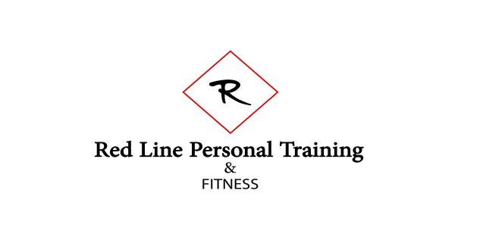

Page 2