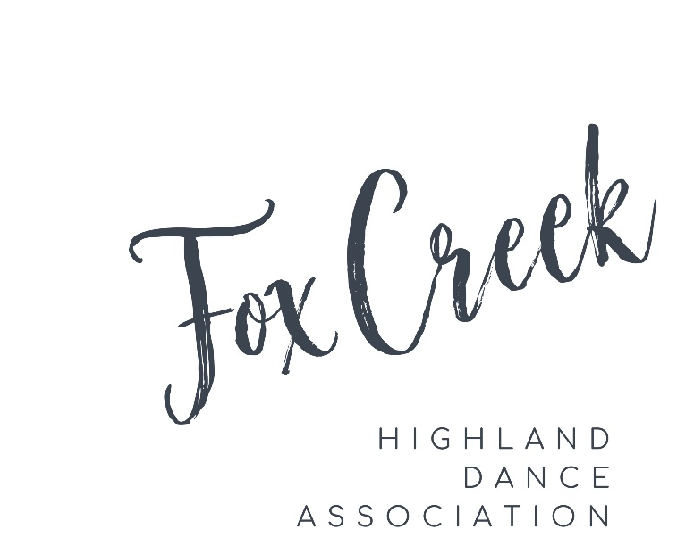

1st Annual Fox Creek Highland Dance Association Open Competition

May 27, 2023

Fox Creek Greenview Multiplex (Shell Fieldhouse)

103-2A Ave Fox Creek, Alberta T0H 1P0

Judges: Katie Gardner (Calgary, AB)

Keltie MacKenzie (Calgary, AB)

***Registration begins at 8:00***

|  |  |  |
| --- | --- | --- |
| Primary | Beginner/Novice | Intermediate/Premier |
|  |  |  |
| Commences 9:30am | Commences 9:30am | Commences 1:30pm |
| Fling (4)  Sword (2 + 1)  Pas de Bas  Pas de Bas & H/C | Fling (4)  Sword (2 + 1)  Seann Triubhas (3 + 1)  Scottish Lilt (4)  Flora MacDonald (4) | Fling (4)  Sword (3 + 1)  Seann Triubhas (3 + 1)  Barracks Johnnie (4)  Irish Jig (3 + 1) |
|  | **BEGINNER AND NOVICE – Trophy Fling (4)** |  |
| Open Competition sanctioned by the Royal Scottish Official Board of Highland Dancing:  C-AB-CO-23-1027 | | |

Acceptance Date : March 13, 2023—Online Entries Only

Closing Date: May 1st, 2023 NO LATE ENTRIES ACCEPTED

**Competition Rules and Regulations**

1. Competition will be governed by the rules and regulations of the Royal Scottish Official Board of Highland Dancing.
2. Age as of 00:01 hrs May 27, 2023.
3. The Organizing Committee reserves the right to combine, split or delete/cancel classes according to the entries received.
4. Entries will only be accepted online. Online entry receipt serves as official confirmation of entry.
5. All competitors must present their 2023 RSOBHD Dancer Registration cards to pick up their numbers and to receive awards. Dancers without a card must fill out “No Card” form and pay the fee. Awards won will remain with organizers till proof of card is shown.
6. All competitors must remain in their costumes for award presentation.
7. Prize money will be awarded to premier dancers 16 years and older – 1st -$40; 2nd - $30; 3rd - $20; 4th, 5th, 6th - $10
8. All status changes must be reported no later than 6 days prior to the competition. Please send status changes to [foxcreek.highland.dance@gmail.com](mailto:foxcreek.highland.dance@gmail.com)
9. The judge’s decision is final. Any protests must be in writing, signed and handed to the Organizing Committee before the end of the competition day, accompanied by a fee of $35.00 that will be refunded if the protest is sustained.
10. Additional adjudicators may be added at the discretion of the Organizing Committee, without any advance public notice.
11. Beginner and Novice Trophy Fling is its own separate event. Scoring from this will not be put towards overall score for aggregate or Dancer of the Morning/Afternoon.
12. Awards for Dancer of the Morning/Afternoon will be based on total number of points. (Not including Beginner and Novice Trophy Fling.)

Notice from ScotDance Canada RE: Fox Creek Highland Open Competition AB-CO-23-1027.

This event is being held in compliance with all provincial health and safety

orders in effect at the time of the entry being posted, as well as facility

requirements for COVID-19.

Our goal is to provide a safe, calm, inclusive and positive environment

for all participants. We appreciate unexpected situations could arise on

the day that may require action that is meant to protect our dancers,

judges, volunteers and other participants.

Covid-19 Guidelines:

1. Public Health requirements will be continuously evaluated, and

participants will be informed of any Covid-19 protocols prior to the event

through social media and email.

2. For all participants attending our sanctioned events, generally,

there will be 4 guidelines we encourage participants to follow in the

absence of any local, provincial or national government health orders:

- wearing a mask for your own protection and of others

- maintain physical distancing wherever possible

- sanitizing hands often

- staying home if you feel sick

3. Upon registering for this event and immediately prior to the event,

you agree to the requirements and recommendations of any National,

Provincial and local Public health and other governmental authorities as well as any requirements from Fox Creek Greenview Multiplex which may be in effect at the time of the event, as it pertains to the Covid-19 Coronavirus and to adopt all necessary measures to those effects.

4. Participants are required to agree to the COVID-19 Other

Contagions General Assumption of Risk and Waiver of Liability at the time of registration.