Little Bitty City Enrichment Center

ANNUAL REPORT
2024-25
Head Start Program Annual Report to the Public
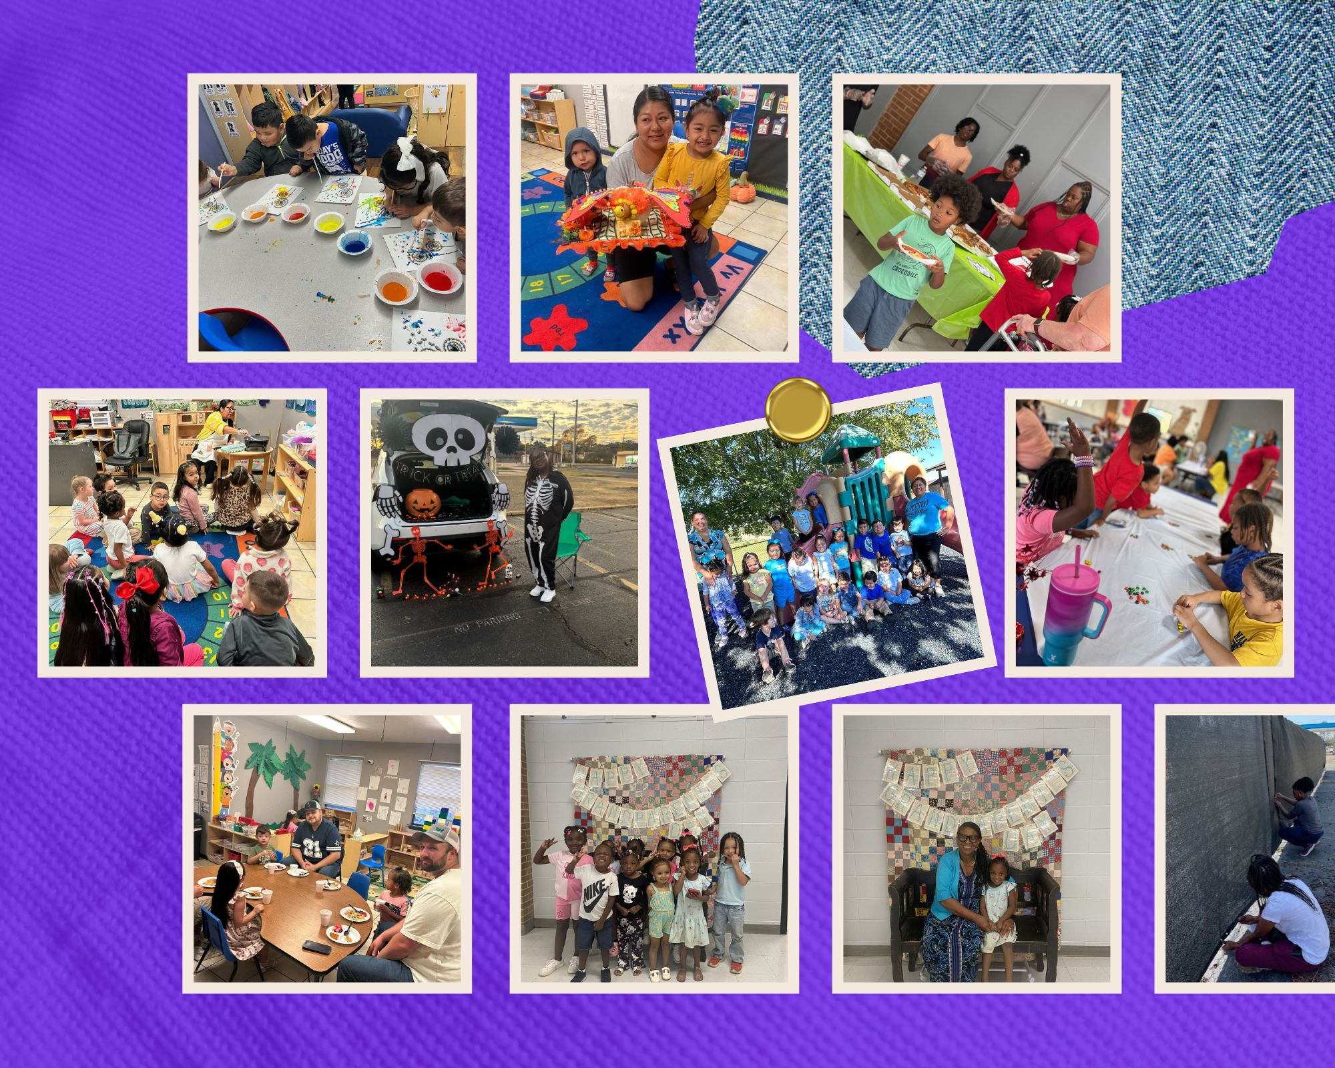

“We are committed to transparency. This Annual Report is available on our website and in print at our administrative office for families, staff, and community members.”
Reflections

The 2023-24 school year was a year of stretching and pushing. Our priority is always to provide the children in our care with the highest level of support to help them become “kindergarten ready”. This year, we also had the added responsibility of demonstrating to the Office of Head Start just how we do this by participating in a CLASS review and Focus Area 2 Review. These opportunities required us to look inward and rise to meet the challenges, ultimately strengthening our program in the process.

As we closed out the 2023–24 school year, a group of dedicated teachers came together to create a school-wide motto that would reflect our shared purpose and spirit. The result: “Believe, Achieve, Succeed. We enter to learn, leave to achieve!” This powerful statement was proudly displayed throughout our centers, serving not only as daily affirmation for the children but also as a source of motivation and direction for our staff. It became a unifying message that reminded us of all the transformative work happening in our classrooms each day.

We continued our efforts to strengthen community partnerships, recognizing that when these connections are strong and consistent, our children and families thrive. This year, we proudly partnered with another local school district to provide transportation for one of our school trips. In previous years, this opportunity was limited to families who could bring their children themselves. As a result, more children were able to participate and enjoy the experience. We are elated to open new doors for our students through meaningful partnerships that expand access and create lasting memories.

As I reflect on this year, I am overtaken with gratitude. Grateful for the parents who trust us to help mold and shape their children, and who partner with us to enrich their own lives by allowing us to walk alongside them as they set personal goals and celebrate their successes. Grateful for the resilience of our staff, who work tirelessly to meet the high standards set both internally by our agency and externally by our funding partners. And grateful to our communities, who continue to extend themselves in support of the families we serve.

As we look ahead to the new school year, we remain committed to staying deeply connected to the people we serve. We want to ensure that everything we do is a meaningful response to the true needs of our community. Together, we will continue to build a brighter future for our children.
Cadesha Benson Whitaker
Senior Director of Operations, LBCEC

Who We Are
Little Bitty City Enrichment Center is a non-profit organization serving children throughout the state of Arkansas through funding from Head Start, Arkansas Better Chance, and the state voucher program. We are united by a shared mission: to empower every child we serve with the tools, support, and care they need to grow, learn, and thrive.

Service Areas
Little Bitty City Enrichment Center serves 189 Head Start children across the southwestern Arkansas counties of Miller, Little River, Howard, and Sevier. We operate stand-alone centers in Miller and Sevier counties, while partnering with local school districts to house our classrooms in Howard and Little River counties. Our service area is predominantly rural, with the exception of Texarkana, home to our largest Head Start center.

Miller County:
3432 Jefferson Avenue
Texarkana, AR 71854

Sevier County:
1429 W. Collin Raye Dr
DeQueen, AR 71832

Howard County:
410 N. 6th Street
Nashville, AR 71852

Little River County:
410 Burke St.
Ashdown, AR 71822

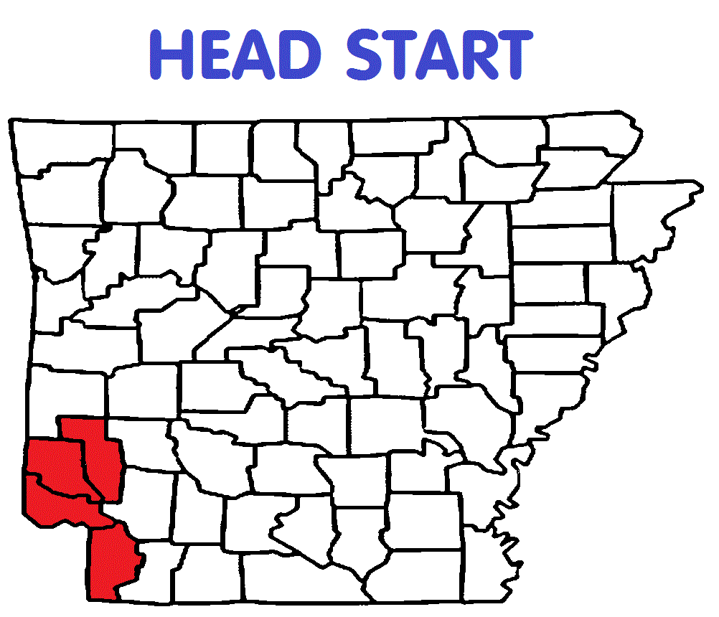

Program Highlights
- Increased staff support and resilience through targeted coaching, mentoring, and the addition of a full-time Mental Health Assistant at our largest center.
- Advanced children’s learning outcomes with continued growth in literacy, numeracy, and social-emotional skills, as measured by Teaching Strategies GOLD and other assessments.
- Expanded family engagement supports by partnering with parents to set and celebrate personal goals that strengthen both families and children.
- Strengthened community partnerships with schools, agencies, and local organizations to ensure services respond to the true needs of our rural and urban families.
- Enhanced whole-child wellness with stronger health initiatives, including immunization compliance 💉, nutrition and growth monitoring 🥦, and oral health education 🦷.

ERSEa & FCP
Enrollment
During the 2024–25 school year, we served 198 children. We did not reach full enrollment, which drove a stronger focus on recruitment. To address this, we connected with local news outlets to celebrate Head Start’s 60th anniversary, making our program more visible in the community. We also hired a Family Engagement Advocate at our largest site to help strengthen family connections, knowing that word of mouth continues to be our most effective recruitment tool.

Family Income Eligibility (2024–25):
- 37% met the income guidelines for Head Start.
- 40% qualified through Public Assistance, SNAP, Foster Care, or Homelessness.
- 22% fell within 101%–130% of the poverty guidelines.

Avg. Monthly Enrollment as a % of Funded Enrollment

Goals & Referrals
At the start of the new year, we work closely with families to identify their needs and set goals during the intake process. Throughout the year, we provide referrals to community resources for housing and utility assistance, healthcare, GED classes, emergency crisis support, and job training. We are grateful to our community partners who provide support and opportunities for enrichment for our families.

Family Engagement
Throughout the 2024–25 school year, we also saw robust parent engagement across a wide variety of activities, totaling 3,143 instances of involvement. Key highlights included:
Activity | Instances
Reading at home | 558
Family Learning Parties | 94
Family Engagement Network Meetings | 168
Community Advocacy/Leadership | 109
Male Involvement | 37
PEER Activity Cards | 448
Volunteering in the Classroom | 442
Family Relationships Activity | 280
Parent Committee Meeting | 201
Parent/Child Home Activity | 672
Preschool Transition Meeting | 132

medical & healthservices
Our primary goal in Health Services is to partner with families to create and maintain healthy lifestyles for their children. This includes keeping immunizations current, ensuring annual well-child checkups, promoting nutritious eating habits, and supporting regular dental care. Strong collaboration among families, providers, and community partners led to measurable gains across key health indicators this year. At enrollment, 67 children were up to date on preventive and primary health care per the state’s EPSDT guidelines; by year’s end, that number more than doubled to 141, reflecting the power of coordinated follow-up and family support.

📏 Growth & Nutrition:
- Children identified as underweight decreased from 33 at enrollment to 19 by year’s end.

- The number of children at a healthy weight increased by 14, showing progress through early intervention and family nutrition education.

💉 Immunizations:
- 100% of enrolled children were determined by a healthcare professional to be up to date on all age-appropriate immunizations.
- This success reflects consistent outreach, reminders, and the removal of access barriers.

🦷 Oral Health & Preventive Dental Care:
- The percentage of children completing a preventive dental visit increased from 79% last year to 87% this year.
- Dental caries remained the most common health condition but strengthened referral partnerships supported earlier treatment.

🩺 Health Advisory Committee Highlights:
- Expanded collaboration with local pediatricians and dental clinics.
- Improved follow-up processes for elevated lead levels and growth concerns.
- Added mental health and physical wellness topics to family workshops.
- Recommended on-site vision and hearing screening support.

⚠️ Challenges & Opportunities:
- Some families still face barriers to timely dental treatment beyond initial screenings.
- Lead screening follow-up requires targeted tracking and case management.
- Transportation and scheduling conflicts remain obstacles for some families.

🎯 Looking Ahead — 2025–2026 Goals:
- Maintain 100% immunization compliance.
- Increase timely follow-up treatments for identified health concerns.
- Continue reducing the number of underweight or overweight children through targeted nutrition education.
- Enhance staff training in trauma-informed care and health equity.

KINDERGARTEN READINESS
Kindergarten readiness is a vital milestone in a child’s academic journey, ensuring they possess the skills and abilities needed for a successful start. Well-planned transitions lead to smoother adjustments and promote continuous developmental progress. This year, 90 children graduated from Head Start and are embarking on their elementary school years as they enter kindergarten this fall. Here are some of the ways we supported both children and families in preparing for this important step:

📊 TS GOLD Data:
From Fall to Spring, data showed the following growth for children meeting or exceeding expectations in each domain:
- 84% growth in Social-Emotional
- 77% growth in Approaches to Learning and Play
- 60% growth in Language
- 52% growth in Literacy
- 64% growth in Math and Science

At the Spring checkpoint, 40% of all children were on target for their age group—an increase from 9% at the Fall checkpoint.

Strengths:
- Phonological Awareness – Segmenting: 97%
Growth Areas:
- Print: Print Concepts: 69%

(Data reflects the percentage of children who met the benchmark for that objective in their respective age groups.)

🩺 Special Needs Services:
- 21 children received special needs services during the year.
- Local LEA staff screened children within 45 days of enrollment and provided one-on-one therapy services in each center.
- LBC therapists provided Speech, OT, and PT services for 40 children to promote learning and development.

📈 Classroom Assessment Scoring System (CLASS):
Fall 2024 Program Average:
- Emotional Support: 6.66
- Classroom Organization: 6.41
- Instructional Support: 5.69
Spring 2025 Results (OHS Video Submissions):
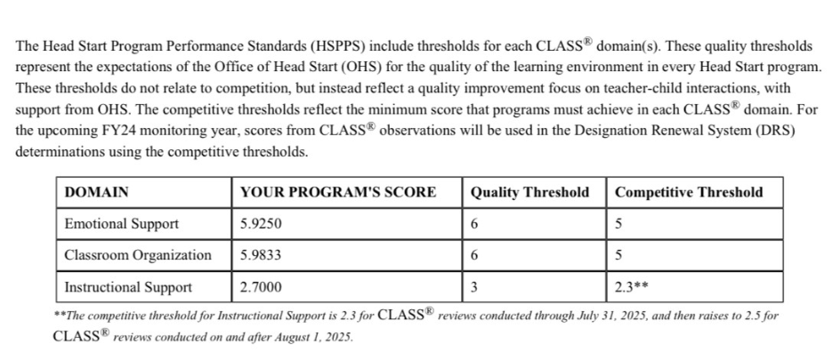

📚 LITERACY & NUMERACY:
Average Score by Age Group
Quarter 1
- 3YO Numeracy: 17
- 3YO Literacy: 11
- 4YO Numeracy: 28
- 4YO Literacy: 23
Quarter 2
- 3YO Numeracy: 20
- 3YO Literacy: 15
- 4YO Numeracy: 33
- 4YO Literacy: 35
Quarter 3
- 3YO Numeracy: 26
- 3YO Literacy: 28
- 4YO Numeracy: 37
- 4YO Literacy: 48

Disabilities
Number of children enrolled in the program who had an IEP at any time during the program year.
# of children: 21 % of children: 11.11%

A deeper focus on literacy & numeracy
We want to give our students the greatest head start possible. We understand that all children are unique and have different needs, but ultimately, our goal is to take them as far as they can go on the journey toward school readiness.

Literacy and numeracy skills are critically important for children entering kindergarten in Arkansas, as they form the foundation for future academic success and overall development.
The Literacy and Numeracy Games and Routines (LNGR) program is a play-based approach integrated into daily classroom activities to strengthen children's foundational reading, writing, and math skills. By using engaging games and adaptable tasks, children consistently practice and reinforce key concepts.

Teachers assess each child's skills at the start and continually monitor progress through both informal and formal evaluations. The data collected throughout the year is analyzed to measure growth, with results informing instructional strategies and ensuring that each child receives the support needed to thrive in literacy and numeracy.

The LNGR Annual Assessment Summary Report for 2024–2025 reflects significant improvement in children’s skills compared to the prior year:

3- & 4-year-old cap for numeracy is 45
3- & 4-year-old cap for literacy is 70
For both age groups, the consistent quarter-over-quarter growth is shown.
MENTAL HEALTH MATTERS

We are now in our third year of using the e-DECA screeners, and we are pleased with the valuable supports this program provides for children, families, and staff. The e-DECA process, which includes both teacher and parent ratings, allows us to identify children’s social-emotional strengths and areas of need, and to implement strategies that promote positive development.
To support this effort, our full-time Mental Health Assistant collaborates with teachers and parents to select and implement effective behavioral strategies. The Assistant works directly with students in small groups or one-on-one, focusing on building essential social-emotional skills. This approach not only helps children develop in these areas but also equips teachers and parents with the tools and understanding necessary to support their growth at home and in the classroom.

Narrative Summary of Progress
The 2024–2025 e-DECA data show clear improvements in children’s social-emotional development:
- Protective Factors: Teacher ratings of total protective factors increased, and the percentage of children in the “need” category decreased. Parent ratings mirrored this trend, showing more children demonstrating strengths in initiative, self-regulation, and attachment.
- Initiative and Self-Regulation: Both teachers and parents observed growth in children’s initiative and self-regulation skills, highlighting the effectiveness of individualized strategies and small-group interventions.
- Attachment/Relationships: Significant gains were noted in children’s ability to form positive relationships, particularly as reported by parents, where 90% of children were rated typical or strong post-screening.
- Behavior Concerns: There was a notable reduction in behavioral concerns, indicating that targeted supports are helping children manage their behavior more effectively.

The 2024–2025 e-DECA data reflect measurable progress in the children we serve:

Overall, these results underscore the positive impact of our third year of e-DECA implementation. The combined efforts of our Mental Health Assistant, teachers, and parents are creating a stronger foundation for children’s social-emotional growth, school readiness, and long-term well-being.

Financials

Funding Sources
FUNDING SOURCE | AMOUNT FUNDED
HEAD START GRANT | $1,782,867
CACFP | $281,800.51
CCDF | $212,666.29

Audit Report
INDEPENDENT AUDITOR’S REPORT
To the Board of Directors:
Little Bitty City Enrichment Center, Inc.
Report on the Audit of the Financial Statements
Opinion
I have audited the accompanying financial statements of Little Bitty City Enrichment Center, Inc. which comprise the statement of financial position as of December 31, 2024, and the related statements of activities, and cash flows for the year then ended, and the related notes to the financial statements. In my opinion, the financial statements present fairly, in all material respects, the financial position of Little Bitty City Enrichment Center, Inc as of December 31, 2024, and the changes in its net assets and its cash flow for the year then ended in accordance with accounting principles generally accepted in the United States of America.
Basis for Opinion I conducted my audit in accordance with auditing standards generally accepted in the United States of America and the standards applicable to financial audits contained in Government Auditing Standards, issued by the Comptroller General of the United States. My responsibilities under those standards are further described in the Auditor’s Responsibilities for the Audit of the Financial Statements section of my report. I am required to be independent of the Little Bitty City Enrichment Center, Inc. and to meet my other ethical responsibilities, in accordance with the relevant ethical requirements relating to my audit. I believe that the audit evidence we have obtained is sufficient and appropriate to provide a basis for my audit opinions.
Responsibilities of Management for the Financial Statements
Management is responsible for the preparation and fair presentation of the financial statements in accordance with accounting principles generally accepted in the United States of America, and for the design, implementation, and maintenance of internal control relevant to the preparation and fair presentation of financial statements that are free from material misstatement, whether due to fraud or error.
In preparing the financial statements, management is required to evaluate whether there are conditions or events, considered in the aggregate, that raises substantial doubt about the Little Bitty City Enrichment Center, Inc.’s ability to continue as a going concern within one year after the date that the financial statements are available to be issued.
Auditor’s Responsibilities for the Audit of the Financial Statements
My objectives are to obtain reasonable assurance about whether the financial statements as a whole are free from material misstatement, whether due to fraud or error, and to issue an auditor’s report that includes my opinion. Reasonable assurance is a high level of assurance but is not absolute assurance and therefore is not a guarantee that an audit conducted in accordance with generally accepted auditing standards and Government Auditing Standards will always detect a material misstatement when it exists. The risk of not detecting a material misstatement resulting from fraud is higher than for one resulting from error, as fraud may involve collusion, forgery, intentional omissions, misrepresentations, or the override of internal control. Misstatements are considered material if there is a substantial likelihood that, individually or in the aggregate, they would influence the judgment made by a reasonable user based on the financial statements.
In performing an audit in accordance with generally accepted auditing standards and Government Auditing
Standards, I: • Exercise professional judgment and maintain professional skepticism throughout the audit.
• Identify and assess the risks of material misstatement of the financial statements, whether due to fraud or
error, and design and perform audit procedures responsive to those risks. Such procedures include
examining, on a test basis, evidence regarding the amounts and disclosures in the financial statements.
• Obtain an understanding of internal control relevant to the audit in order to design audit procedures that
are appropriate in the circumstances, but not for the purpose of expressing an opinion on the effectiveness
of the Little Bitty City Enrichment Center, Inc.’s internal control. Accordingly, no such opinion is
expressed.
• Evaluate the appropriateness of accounting policies used and the reasonableness of significant accounting
estimates made by management, as well as evaluate the overall presentation of the financial statements.
• Conclude whether, in my judgment, there are conditions or events, considered in the aggregate, that raise
substantial doubt about the Little Bitty City Enrichment Center, Inc.’s ability to continue as a going
concern for a reasonable period of time. I am required to communicate with those charged with governance regarding, among other matters, the planned scope and timing of the audit, significant audit findings, and certain internal control-related matters that I identified during the audit.
Supplementary Information
My audit was conducted for the purpose of forming an opinion on the financial statements as a whole. The
accompanying schedule of expenditures of federal awards and schedule of units provided as required by Title 2
U.S. Code of Federal Regulations Part 200, Uniform Administrative Requirements, Cost Principles, and Audit
Requirements for Federal Awards, is presented for purposes of additional analysis and is not a required part of the financial statements. Such information is the responsibility of management and was derived from and relates directly to the underlying accounting and other records used to prepare the financial statements. The information has been subjected to the auditing procedures applied in the audit of the financial statements and certain additional procedures, including comparing and reconciling such information directly to the underlying accounting and other records used to prepare the financial statements or to the financial statements themselves, and other additional procedures in accordance with auditing standards generally accepted in the United States of America. In my opinion, the schedule of expenditures of federal awards and schedule of units of service provided are fairly stated, in all material respects, in relation to the financial statements as a whole.
Other Reporting Required by Government Auditing Standards
In accordance with Government Auditing Standards, I have also issued my report dated July 19, 2024 on my
consideration of the Little Bitty City Enrichment Center, Inc.’s internal control over financial reporting and on my tests of its compliance with certain provisions of laws, regulations, contracts, and grant agreements and other matters. The purpose of that report is solely to describe the scope of my testing of internal control over financial reporting and compliance and the results of that testing, and not to provide an opinion on the effectiveness of the Little Bitty City Daycare, LLC’s internal control over financial reporting or on compliance. That report is an integral part of an audit performed in accordance with Government Auditing Standards in considering the Little Bitty Enrichment Center, Inc internal control over financial reporting and compliance.
Eric J. Scism, C.P.A.
Benton, Arkansas

