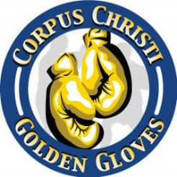

**82nd Annual Corpus Christi Golden Gloves**

**Elite Boxer Weigh In**

**Coaches Meeting**

**February 15, 2025**

**Weigh Ins - Elite Boxers Only**

**9am – 10am**

**Coaches meeting**

**10am**

1. **All boxers will be allowed into the building up to 30 minutes prior to the start of the physical.**
2. **Pre -bout Physical start times**

**Fri 02.21.2025 – 6pm.**

**Sat 02.22.2025 – 6pm.**

**Sun 02.23.2025 – 12noon**

1. **When coaches arrive at the venue on the day(s) of the tournament, GG Staff will be at the door to hand out wristbands for your registered coaches and boxers who signed up for the tournament. The color of the wrist bands will change daily.**
2. **Two Team Trophies – Elite Division and Matched Bout Division to presented on Sunday 02.23.2025 at the conclusion of the tournament. Also, one outstanding boxer will be named.**
3. **Respect the Field of Play and do not enter unless you are approaching the ring with your boxer who is scheduled to fight.**
4. **Unopposed winners will be presented with their awards on Saturday night prior to the first match.**
5. **Prior to the start of each night’s bouts, there will be a coaches’ meeting to provide tournament updates.**
6. **Tournament updates can be found at: kiwanisclubofccbay.com**