|  |
| --- |
|  |
| **The SafetyFirst**  **SecurityPod System™** |

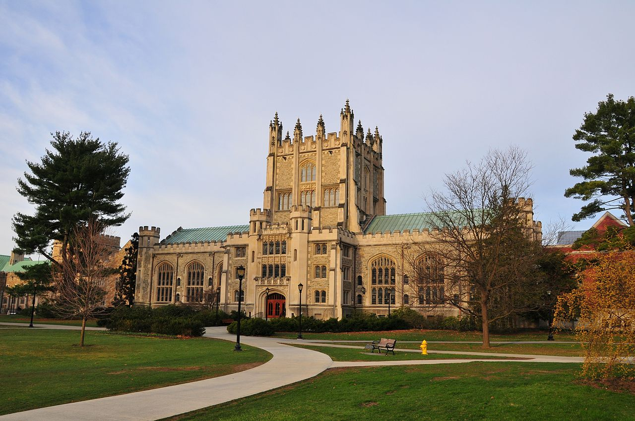

Breaking News:

“FOND LLC, MRS LLC, Witt Global, and our Product Partners take charge of safe, secure, resilient schools across the nation.”

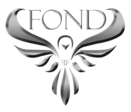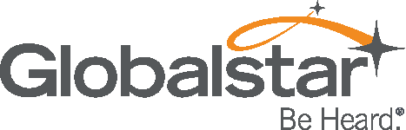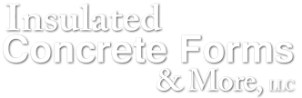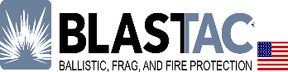

THE FOND DEVELOPMENT GROUP

A JV Division of FOND LLC & MRS LLC

## SafetyFirst

The inconceivable tragedy in Parkland, Florida is an opportunity to set a new standard for holistic, resilient solutions. In a world where the ‘status quo’ is the norm, it becomes almost second nature to do things one way because that’s the way it’s always been done. However, the world is changing; technology is advancing at an alarming rate, weather patterns are increasing in size, duration and strength, and school shootings are becoming more prevalent each year.

As a society and a nation, we can no longer afford the ‘status quo’ band-aid fix mentality. It is our duty to preserve, protect, and defend life and property, and our honor to leave a legacy of a safe, secure, and more resilient future for our children.

### **COLLABORATION = CHANGE**

### As we move toward the future, safety and security must be the forefront of building holistic, resilient, sustainable communities. Today is not the day to argue about firearms. Today is the day to protect our nation’s children, teachers, and schools. In partnership, The Fond Development Group (FOND LLC / MRS LLC), Witt Global Partners, Globalstar, GEOSResponse, Breton Industries, and ICF and More LLC (Quad-Lock) present the SafetyFirst SecurityPod System™.

#### The HOW

The SafetyFirst SecurityPod System provides a shelter in any storm, whether natural or man-made as its multi-functionality and design-build parameters are focused on safety, security, and durability. Each system is custom built with flexibility in mind and constructed using the patented Quad-Lock® system making it virtually indestructible. When combined with the Globalstar satellite platform, DigiGone Satellite-compatible CCTV, GEOSResponse emergency communications, and Breton Industries tested and proven blast/fire platforms; your schools could not be safer.

#### product partners

***ICF and More, LLC*** provides the patented Quad-Lock system, tested and approved by the United States Armed Forces as blast resistant, and 50-caliber machine gun resistant. Not to mention, numerous independent testing protocols showed flood resistance, tornado resistance, hurricane resistance, seismic resistance, and much more. Each system may be attached to an existing facility as real property (similar to a tornado safe room), constructed as a stand-alone module near a stadium, or manufactured as a mobile unit, just to name a few. The exterior is also custom designed and can be almost any color or material, including logos, mascots, or other applicable themes.

***Globalstar*** offers satellite voice & data products and services that are interoperability-rated and fully compliant with public safety wireless communications standards to include: FEMA SAFECOM Guidance for Emergency Communications Grants, FEMA National Emergency Communications Plan (NECP), National Incident Management System (NIMS), and the U.S. Department of Health & Human Services HPP/PHEP Cooperative Agreement Guidance on Interoperable Redundant Communications. Globalstar provides instant infrastructure, temporary network solutions, rapid provisioning of services, and is independent of terrestrial infrastructure. Each system will be design-specific and equipped with voice and data products to facilitate flawless communications in the event of a crisis.

***DigiGone*** is a Globalstar, Inmarsat, Thuraya, Iridium Business Solution Provider featuring DigiView, a product specifically designed for satellite communications, which allows for remote viewing and recording-equipped control cameras or easy integration into existing CCTV systems, as well as high-level encryption and proprietary compression algorithms. DigiMed, a remote medical care delivery system is also available and literally brings the doctor to the remote location. The doctor can remain at the hospital and manage multiple medical events at the same time using the various medical devices provided.

***GEOS Response – Home of the IERCC,*** The GEOS International Emergency Response Coordination Center (IERCC) brings 24 x 7 monitoring solutions for Incident Alerting and Response, Communications, Incident Command and more, as well as medical alert monitoring, seamless satellite integration, just to name a few. GEOS has a long and dedicated history of school safety and security protocols, and an impeccable record during any natural or man-made disaster.

***Breton Industries*** delivers the world’s most efficient solution in blast blankets and curtains for ballistic, frag, arc, and high-temperature protection; BlastTac®. BlastTac products offer UL 752 Certification for bullet resistance for Levels 1, 2, 3 and higher, defense against fire, heat, and arc with a Category 4+ rating, are Made in the USA using 9853, 9865, 9870, 9875, 9887, and 9890 matrix materials, and features ArmourCore™ 121 and 127. BlastTac’s flexibility and world-renowned durability will provide a design-specific retrofit for unparalleled safety and maximum security to the interior of any structure.

Each SafetyFirst SecurityPod System will be design-specific to meet the needs of each school or business, and any or all of the products highlighted above may be included. Sliding doors in classrooms allow for easy installation while keeping classrooms and offices square feet effectively unchanged. When the alarm is activated, an automated system will begin the lockdown process, which will automatically unlock and open the SecurityPod doors, lock classroom doors, and initiate the dropdown blast blankets/curtains. A backup, dual authentication system will also be installed for emergency override procedures. Restrooms, HVAC, Solar Lighting and more are also available for each unit and may qualify for funding through Clean Energy Lending. Exterior SecurityPod doors enter manual status when teachers or administrators type in the access code. Once Crisis HQ deems the area “safe,” students may exit the pods without further physical or psychological incident.

#### The team

FOND LLC and MRS LLC, collectively The Fond Development Group, joined with Witt Global Partners in 2018 to deliver state-of-the-art, self-sustaining resilience projects and disaster-resistant inventions that provide solutions to many of today’s most horrific crises. Our combined products and services, as well as our Executive Leadership Teams, are here to serve our communities with over 150 years combined experience. We will stand by you in any situation and bring you the solutions you need to make your schools, businesses, and infrastructure the safest, most secure, and resilient structures, now and for the foreseeable future.

#### The why

The future is “the why;” the future of our children’s safety, the future of sustainability, the future of disaster resistance, and the future of safe, secure, resilient communities. As citizens of this great nation, we not only have the right to create change, but also the obligation to create change that is lasting. The ‘status quo’ is not a permanent solution, it is just more of the same, and the same is clearly not working.

As seen in 2017, and already in 2018, the time is now to band together to provide feasible, cost-effective, holistically resilient, hardened solutions to residential, commercial, industrial, and governmental property, not to mention, our nation’s crumbling infrastructure. Active shooter scenarios are becoming more prevalent than ever before, and Mother Nature is refusing to give up the fight.

We invite you to join The Fond Development Group, Witt Global Partners, and our product partners; Globalstar, DigiGone, GEOSResponse, Breton Industries, and ICF and More, LLC in our quest to deliver the solutions needed to ensure the safety of America’s children. We may not be able to fix gun violence, but we can certainly make sure our children, our schools, our businesses, our government entities, and our critical infrastructure are safe from harm.

**Together, we can make a difference and bring a legacy of lasting change to our great nation.**