The Scissortail Concept
ICF and More llc | the fond development group
Welcome to the New Kind of Resilient Community
A Small-Town Feel in a Modern World
This Photo by Unknown Author is licensed under CC BY-ND

A Matchless Partnership for a Resilient Future

The Fond Development Group (FOND LLC and MRS LLC) and ICF and More LLC partner to bring resilient, disaster-resistant solutions to communities across the nation. As more stories appear on our morning news channels about extreme weather, drivers colliding into homes, earthquakes, and more, we can no longer ignore continuing devastation.

We hope you will join us on our path to leaving a legacy for future generations by bringing a new level of resilient, renewable, self-sustaining solutions to our homes, businesses, and communities.

Scissortail
The community of tomorrow with the look and feel of yesteryear

Welcome to the planned, self-contained Scissortail community; a place where homes and businesses intermingle with the idyllic feel of a small-town community from the 1930’s and 1940’s. A place where memories harken back to a time when life was more meaningful; where the community was more than just the town where you lived, it was the place where everyone was a family. Neighborhoods were a place where neighbors called each other by their first name and hailed to passersby from their front porches.

The Scissortail community is disaster-resistant, blast-resistant, collision-resistant, fire-resistant, and designed to be self-sustaining. Each neighborhood is based on traditional home designs with open floor plans, ranging from 1000 to 1600 square feet, while incorporating the look and feel of yesteryear, resilient energy-efficient planning, and practical 21st century amenities. Homes of varying elevations, sizes, shapes, and colors add to the neighborhood’s unique charm as design teams work diligently with each homeowner and business owner to deliver custom build plans. The principle idea is to position a limited number of dwellings around a shared common or green space. When the ideal number is achieved, usually 8 to 12. Other groupings will form around separate shared commons, which are then connected by welcoming tree covered walkways. Multiple groups will form the larger aggregate, and will contribute to the overall life and character of the community.
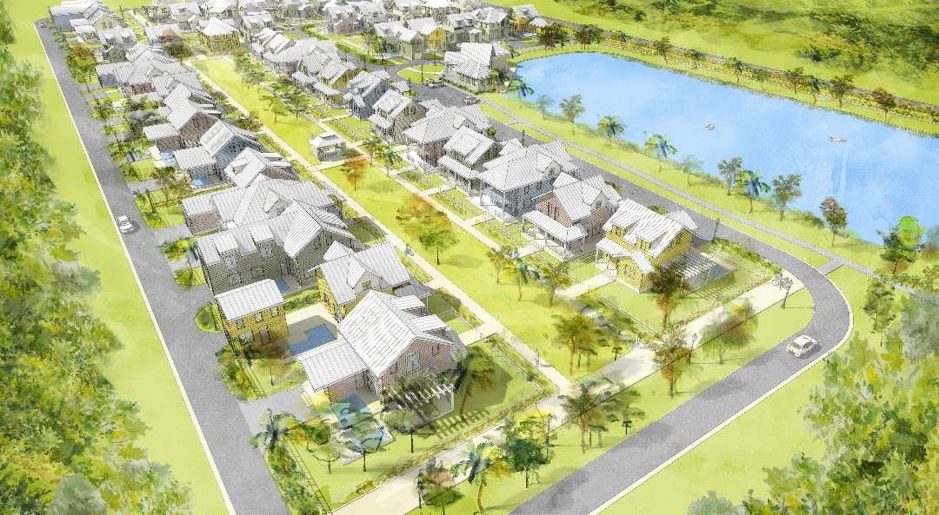
It is essential that cars and traffic not be allowed to invade the shared pedestrian spaces and are routed to alleyways and garages found at the back of homes. A strong emphasis to encourage walking or bike riding, not driving, into the nearby business area and to interact with neighbors is the goal.

Shared outdoor spaces will be designed to bring people together where they are more likely to communicate and interact with one another. The tightknit community of Scissortail will encourage a support system filled with belonging, care, and support where protected settings encourage informal interaction among neighbors; laying the groundwork for deeper, more meaningful relationships. Each of these encounters will strengthen the network of support and friendship; the very basis for happy, healthy, livable communities.

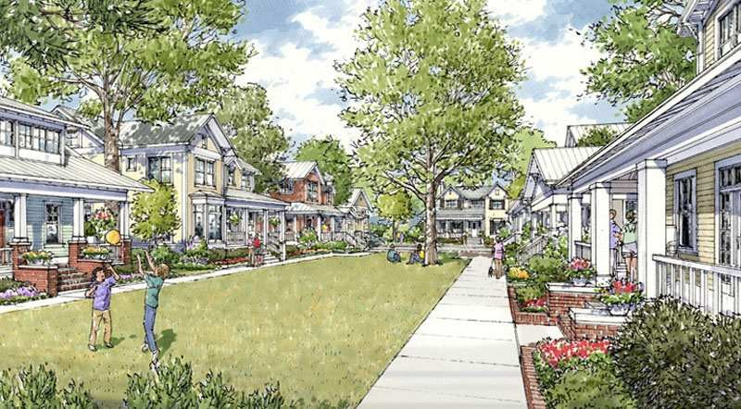

While many unique design-build options are available, privacy and safety are of utmost concern and one of the most essential ingredients, yet allows residents to have a positive and healthy experience within the community. For example, a classic cottage-style courtyard community, could incorporate several private layers of ‘personal space’ between shared commons and the front door. Perhaps, a meandering sidewalk with a vibrant, perpetual floral border tucked against a low fence with a swinging gate, accompanied by a private front and side yard with a choice of landscaping, followed by a large covered porch adorned with overflowing flower boxes.

Inside the home the layering continues as active spaces (living rooms/kitchens/dens) are positioned toward the courtyard, and private spaces (bedrooms/bathrooms) are found toward the back of the house or upstairs. To ensure privacy between neighbors, the homes ‘nest’ together: the open side of one house faces the closed side of the next. You might say, “The Houses are Spooning!” The open side has large windows facing the side yard (extending to the face of the neighboring house), and the closed side has high windows that allow for light and fresh air. The result: closeness combined with common sense privacy.

That said, the first line of defense for personal and community safety is a strong network of neighbors who know and care for each other. This community design brings safety and security to the forefront, so that each resident and business owner can feel protected in their community. It also eases the mind of a busy mother with an active 6-year-old who feels the need to explore the world beyond the front gate.

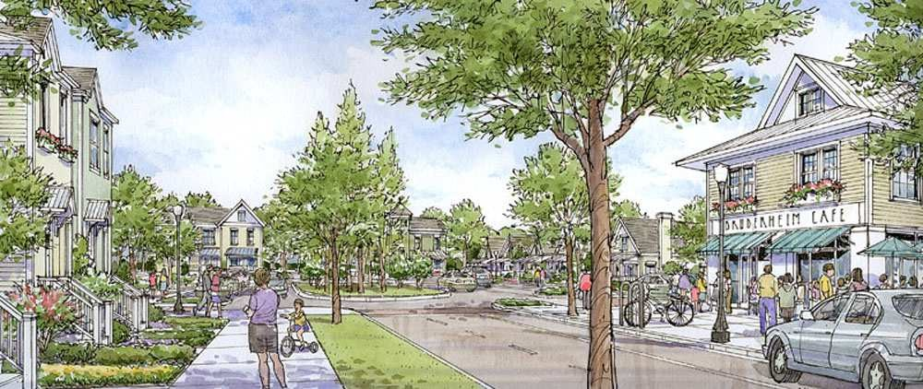
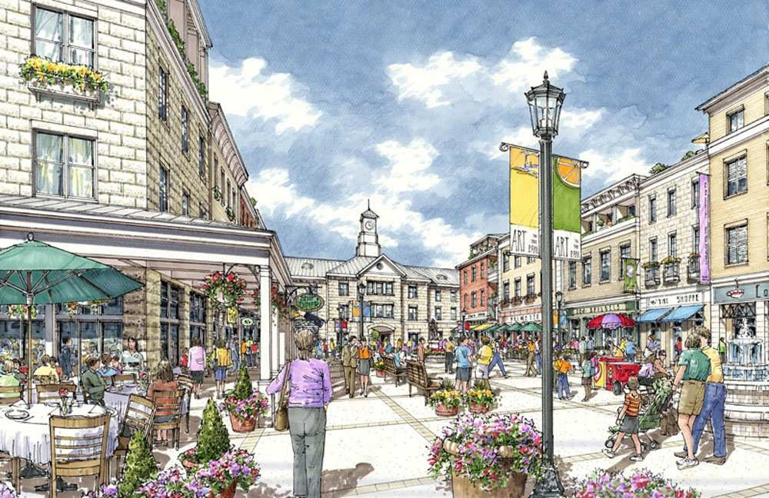

The target market in similar communities proves to be most attractive with middle-aged and retiring couples wanting to downsize, young married couples, and single women. However, new data shows not only acceptance of this type of community, but also preference. People are looking for alternatives to the sprawl of the modern suburban model, and tend to identify with smaller, smarter, community-oriented living environments.

The value of nearby shops, markets, and medical facilities are a huge asset. Imagine the convenience of being able to walk or ride your bicycle to a small, organic market, or stroll into an ice cream shop to enjoy a sweet treat on a warm summer night, or simply relax near a large fountain in the town plaza while enjoying the comradery of good friends.
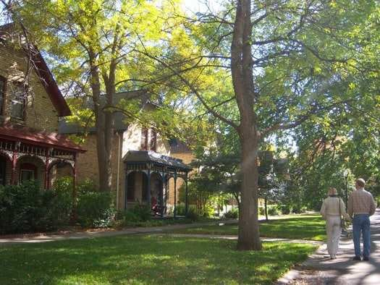
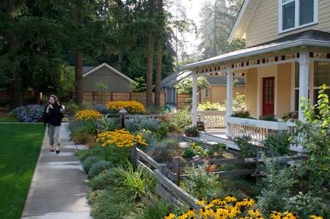

Homes and businesses are constructed with the strongest, healthiest, most energy-efficient materials available in today’s market. ICF systems are utilized for all structures from basements to roofs and everything in between, which will insure survivability and reduced energy usage in any environment. High strength concrete and steel inside the ICF systems are tested and proven to withstand hurricane/tornado force winds and associated flying debris, as well as a 4-hour fire rating, energy rate reductions of 70% or more, and a mold-resistant environment. While this is only a small portion of the advantages of using ICF systems over existing building practices. Stick and brick construction has a long history of easy devastation and destruction costing over a billion dollars annually from tornado damage alone. Oklahoma’s infamous and notorious weather patterns have proven a worthy adversary to many cities, which is where this concept was born as those few structures made from ICF construction were the only few to survive what first responders compare to an explosion.

Homes and businesses constructed using the Quad-Lock R-28 ICF method can expect heating/cooling costs to be reduced as much as 80% while still maintaining a stable, draft free environment. And, if you suffer from allergies and respiratory issues, you can feel assured that an ICF home is nearly air-tight, and pollen and dust intrusion is reduced to near zero.

Solar and geo thermal energy, as well as other self-sustaining, renewable energy solutions are provided by Preferred Product Partners, and available for custom design. Energy storage and management systems are used to store energy in batteries and used as needed to operate homes and businesses. Residents purchasing homes, which start @ $249,000.00, will enjoy the small, tight-knit community lifestyle, as well as the benefits arrived from practically zero energy costs, greatly reduced insurance premiums and a greater amount of safety and security.
Welcome home to Scissortail, a small-town community with the convenience and amenities of a big city.
Welcome home!

