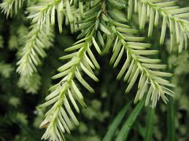

**Village Pines of Greenwood  
Homeowner’s Association**

**RENTAL FORM**

Owner’s Name

­­­­­­­­­­­­­­­­­­­­­­__________________________________________________

Owner’s Address

__________________________________________________

Owner’s phone number

__________________________________________________

Owner’s email address

__________________________________________________

Property address

__________________________________________________

Name of Property Management company, if applicable

__________________________________________________

Contact at Property Management company, if applicable

__________________________________________________

Phone number at Property Management company, if applicable

__________________________________________________

Name of tenant (s)

________________________________________ ______________________________________

________________________________________ _______________________________________

Number of tenants

__________________________________________________

Phone number of tenant

__________________________________________________

Email of tenant

__________________________________________________

Point of contact for issues with the property

__________________________________________________

Point of contact for notices of changes HOA is making in the property

__________________________________________________

Point of contact for payment issues

__________________________________________________

Point of contact for information regarding the annual meeting/budget change

__________________________________________________

Do you authorize your tenant to have access to the pool?

__________________________________________________

PLEASE MAKE SURE YOUR TENANT IS AWARE OF THE COVENANTS OF THE PROPERTY. YOU ARE ULTIMATELY RESPONSIBLE FOR ANY VIOLATIONS THAT OCCUR. PLEASE ENSURE THAT YOUR TENANT IS AWARE OF THE MAINTENANCE THEY ARE RESPONSIBLE FOR AND WHAT AREAS THE HOA WILL MAINTAIN.