Tabitha’s Gowns of Honor

Basic Mom Bracelet INSTRUCTIONS

1. Bracelets should have 7 to 7 ½ inches of beads on the elastic string. Add about 3 extra inches on each end. Pre-stretch the elastic string before starting.
2. Creativity is encouraged. You may use supplies provided or add your own beads and/or elastic string
3. Take the time to research diy videos. Also if you use keywords Angel gown or Angel gown bracelet you could get ideas on what other organizations have created. Don’t hesitate to reach out to other organizations. This is a wonderful community. Most major cities in USA and Canada have Angel Gown groups
4. Our hospital we are partnering with has asked us not to use the Angel symbol or word due to the bible interpretation that we actually go to heaven not as an Angel but a heavenly being. The emotions are usually pretty high so we will not have that discussion with the parents.
5. Please be creative. Stick to white, off-white, pastels, gold or silver. If you want to experiment with wooden beads, that is fine with me. Just make sure on the bracelet that it is the obvious that one bead represents the mother and another bead or charm represents the baby.
6. Be very careful on the final knot. After visiting with many organizations, that seems to be the biggest problem. I did post on our Facebook page a video showing you how to tie a secure not. Also some people use a glue. I am not familiar with the glue, so I cannot comment on that. I trust your expertise and experience. How do you start making these you will figure out what works best.
7. Currently, we are not set up for donations, but if someone wants to donate beads or supplies to you that is fine. We do not need to document.
8. 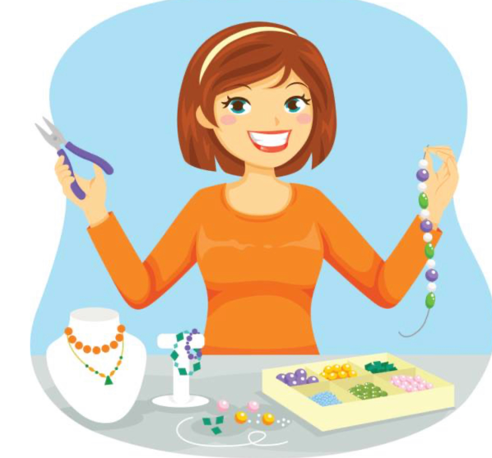Please post pictures of your bracelets on our Facebook page! . This is fun and we will enjoy watching you create your bracelets. And there will be a team. Praying for you. Not only on your craft bet over your life as well. Thank you very much for your volunteer work.
9. Text or message me any questions and if I do not know the answer I will search for it. And if you have anything that you feel like would help the other bracelet crafters please please share.

Dee Ann