**Okinawan Kobudo** (This is a Japanese term that can be translated as "old martial way of Okinawa)

In the 17th century the people of Oninawa were prohibited from using weapons such as knives, swords and spears.

There was also a lack of workable metal in the area which added to the scarcity and availability of weapons.

As a result of the need for personal protection the Okinawan martial arts of Karate and Kobudo were developed.

The majority of the Kobudo weapons were originally farm implements which were ingeniously converted into effective weapons.

**Tonfa**

The Tonfa , sometimes referred toifa is one such example.

This was originally a handle that was fitted into the side of a millstone which was used for milling grain. This handle was easily disengaged from the millstone and became a very effective weapon of defence and attack.

The early practitioners of karate used the tonfa as an extension of their hand techniques.

**The Tonfa**

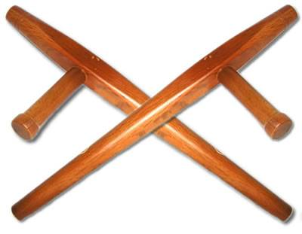

**The grip**

The tonfa is normally held by the grip section of the weapon. The thumb should be on top of the forefinger as if making a karate fist.

**Stances**

All the normal karate stances are utilised in the use of the tonfa

**Punches and strikes**

All the karate punching and hand striking techniques have tonfa equivalent moves.

**Blocks**

All the karate blocks have tonfa equivalent moves.

**Flips**

It should be noted that during combat with tonfa flips and grip changes are not usually performed as doing so would allow the weapon to be easily removed by an opponent. They are however sometimes performed during displays and some Katas.

**Mae –Furi** (Partial front flip down)

**Furi-Otoshi** (Downward flip and back )

**Yoko-Furi** (Sideways flip and back)

**Uchi-Mae-Furi** (Inside front flip and back)

**Hachiji-Mawashi-Furi** (Figure Eight flip)

This combines two downward flips , one palm up and the other palm down

**Furi-Barai** (Accross and down)

**Grip changes**

Simple slides (Up, down and sideways)

**Complex Flips**

**Yoko-Kote-Gaesh i** (Side flip with grip change)

**Mae-Kote-Gaeshi** (Front flip with grip change

**Morote-Kote-Mawashi** (Two-hand circular Flip)

**Morote-Mae-Furi (**Double front flip)

**Morote-Yoko-Furi** (Double side Flip)

**Morote-Hachiji-Mawashi-Furi** (Double figure eight flip)

**Morote-Kosa-Furi** (Double side flip)

**Courses**

Karl Brookes 6th Dan (karl.brookes@outlook.com) is available to provide tonfa courses at club level and will provide all the equipment for use on the courses. (wooden Tonfa for adults and safety foam tonfa for children)